Developmental Invite
November 17, 18, and 19th 2017
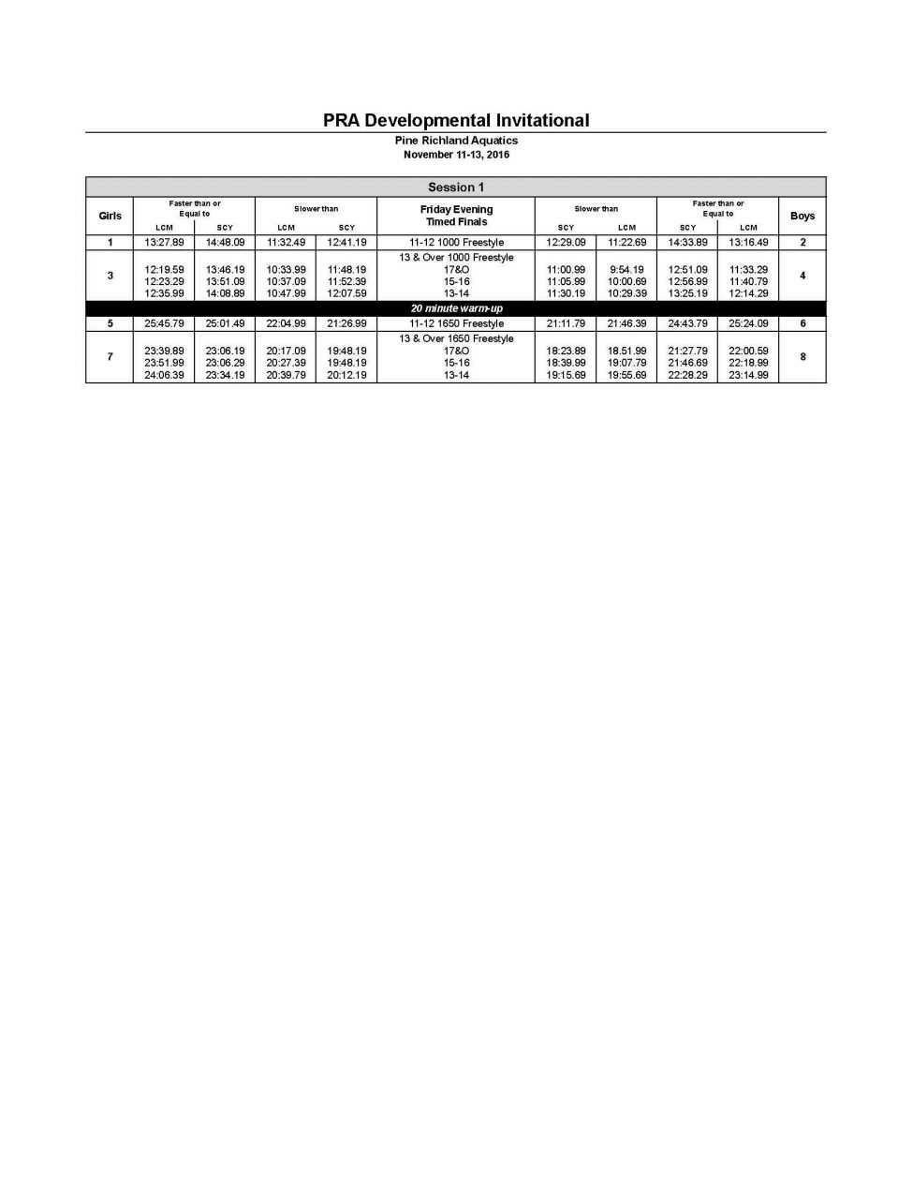

PRA Developmental Invitational
Pine Richland Aquatics November 17-19, 2017

ter than or qual to
 |  |  |  |  | Session 2
Girls | Faster than or Equal to  LCM SCY |  |  | Slowe  Saturday AM  SCY
13 & Over - Prelims
9 |  | — | — — |  | 400 Freestyle Relay — | — |  |  |  |  |  | 10
11 | 1:28.09 | 1:17.69 | 1:13.39 1:04.29 |  | 100 Butterfly 57.69 | 1:05.39 1:12.19 |  |  |  |  | 1:22.19 | 12
13 | 2:55.19 | 2:33.89 | 2:26.49 2:07.89 |  | 200 Freestyle 1:56.59 | 2:14.69 2:24.49 |  |  |  |  | 2:45.69 | 14
15 | 37.59 | 32.89 | 31.49 27.49 |  | 50 Freestyle 24.79 | 27.99 30.39 |  |  |  |  | 34.39 | 16
17 | 1:30.09 | 1:18.29 | 1:15.29 1:04.59 |  | 100 Backstroke 58.09 | 1:08.69 1:13.59 |  |  |  |  | 1:24.99 | 18
19 | 3:42.59 | 3:25.79 | 3:04.09 2:40.19 |  | 200 Breaststroke 2:23.29 | 2:49.99 3:00.49 |  |  |  |  | 3:29.49 | 20
21 | 7:00.49 | 6:28.59 | 5:48.99 5:04.99 4 |  | 00 Individual Medley 4:37.29 | 5:24.49 5:44.99 |  |  |  |  | 6:37.09 | 22

LCM

Boys

er than or
 |  |  |  |  | Session 3
Girls | LCM I SCY |  |  | Slow  Saturday PM  SCY
10 & Under - Timed Finals
25 | — |  | — |  | 200 Freestyle Relay — |  |  |  |  |  | — | 26
29 |  | 1:43.39 | 1:21.39 1 |  | 00 Individual Medley 1:20.39 | — 1:40.39 |  |  |  |  |  | 30
33 | 3:48.49 | 3:20.19 | 2:58.39 2:36.39 |  | 200 Freestyle 2:31.29 | 2:51.89 3:09.09 |  |  |  |  | 3:34.79 | 34
37 | 2:01.89 | 1:45.09 | 1:34.79 1:21.79 |  | 100 Backstroke 1:20.09 | 1:31.69 1:41.39 |  |  |  |  | 1:56.09 | 38
41 | 54.39 | 47.99 | 41.49 36.69 |  | 50 Butterfly 36.19 | 40.89 46.69 |  |  |  |  | 52.79 | 42
45 | 44.99 | 39.49 | 36.29 31.89 |  | 50 Freestyle 31.39 | 35.69 38.49 |  |  |  |  | 43.79 | 46
49 | 2:16.89 | 1:58.79 | 1:46.49 1:32.39 |  | 100 Breaststroke 1:30.19 | 1:44.69 1:53.69 |  |  |  |  | 2:11.99 | 50
11-12 - Prelims
23 | — |  | — |  | 200 Medley Relay — |  |  |  |  |  | — | 24
27 |  | 1:25.29 | 1:13.09 1 |  | 00 Individual Medley 1:11.09 | — 1:23.19 |  |  |  |  | — | 28
31 | 3:37.89 | 3:25.79 | 3:12.69 2:56.39 |  | 200 Breaststroke 2:49.39 | 3:17.09 3:17.69 |  |  |  |  | 3:49.99 | 32
35 | 1:31.09 | 1:26.29 | 1:19.39 1:12.69 |  | 100 Backstroke 1:10.79 | 1:22.39 1:24.09 |  |  |  |  | 1:37.79 | 36
39 | 45.59 | 43.69 | 40.39 37.49 |  | 50 Breaststroke 36.89 | 41.99 43.79 |  |  |  |  | 49.89 | 40
43 | 35.99 | 34.09 | 31.99 29.39 |  | 50 Freestyle 28.39 | 32.49 33.09 |  |  |  |  | 37.79 | 44
47 | 1:29.69 | 1:26.29 | 1:17.99 1:12.49 |  | 100 Butterfly 1:10.59 | 1:20.39 1:24.49 |  |  |  |  | 1:36.19 | 48
51 | 3:13.49 | 3:02.49 | 2:51.19 2:36.39 2 |  | 00 Individual Medley 2:33.79 | 2:55.89 3:00.99 |  |  |  |  | 3:26.99 | 52
53 | 5:56.49 | 7:09.29 | 5:15.39 6:07.99 |  | 500 Freestyle 6:02.59 | 5:21.89 7:02.99 |  |  |  |  | 6:15.49 | 54

I LCM

Boys

All relays will swim in Prelim sessions.

ORDER OF EVENTS FOR SATURDAY FINALS
53/54, 27/28, 11/12, 47/48, 43/44, 15/16, 39/40, 13/14, 31/32, 19/20, 35/36, 17/18, 51/52, 21/22

There will be 2 heats of 11-12, 1 heat of 13-14, and 1 heat of 15&0.

Meet Name – page 7

PRA Developmental Invitational
Pine Richland Aquatics November 17-19, 2017

er than or qual to
 |  |  |  |  | Session 5
Girls | Faster than or Equal to  LCM SCY |  |  | Slow  Sunday AM  SCY
13 & Over - Prelims
55 | — |  | — |  | 400 Medley Relay — |  |  |  |  |  | — | 56
57 | 3:13.29 | 2:52.39 | 2:41.59 2:21.09 |  | 200 Butterfly 2:08.69 | 2:25.99 2:40.39 |  |  |  |  | 3:02.59 | 58
59 | 1:42.89 | 1:29.39 | 1:25.29 1:13.59 |  | 100 Breaststroke 1:06.29 | 1:17.09 1:22. |  |  | 59 |  | 1:34.89 | 60
61 | 3:19.49 | 2:53.19 | 2:45.49 2:23.39 2 |  | 00 Individual Medley 2:09.09 | 2:30.19 2:41.89 |  |  |  |  | 3:07.09 | 62
63 | 3:13.29 | 2:48.39 | 2:41.59 2:19.39 |  | 200 Backstroke 2:06.29 | 2:28.29 2:38.39 |  |  |  |  | 3:02.99 | 64
65 | 1:21.29 | 1:11.39 | 1:08.29 59.49 |  | 100 Freestyle 53.19 | 1:01.29 1:06.29 |  |  |  |  | 1:16.19 | 66
67 | 6:07.39 | 6:51.79 | 5:07.69 5:42.29 |  | 500 Freestyle 5:15.69 | 4:45.09 6:29.49 |  |  |  |  | 5:53.19 | 68

LCM Boys

er than or qual to
 |  |  |  |  | Session 6
Girls | Faster than or Equal to  LCM SCY |  |  | Slow  Sunday PM  SCY
10 & Under - Timed Finals
71 | — |  | — |  | 200 Freestyle Relay — |  |  |  |  |  | — | 72
75 | 55.69 | 48.59 | 43.49 37.99 |  | 50 Backstroke 37.79 | 43.29 48.59 |  |  |  |  | 55.69 | 76
79 | 2:16.89 | 1:58.79 | 1:46.89 1:32.79 |  | 100 Breaststroke 1:30.19 | 1:44.69 1:53.69 |  |  |  |  | 2:11.99 | 80
83 | 3:48.49 | 3:20.19 | 2:58.39 2:36.39 |  | 200 Freestyle 2:31.29 | 2:33.39 3:09.09 |  |  |  |  | 2:58.99 | 84
89 | 54.39 | 47.99 | 41.49 36.69 |  | 50 Butterfly 36.19 | 40.89 46.69 |  |  |  |  | 52.79 | 90
93 | 1:43.09 | 1:30.69 | 1:21.29 1:11.39 |  | 100 Freestyle 1:10.19 | 1:20.39 1:28.49 |  |  |  |  | 1:41.29 | 94
11-12 - Prelims
69 | — |  | — |  | 200 Freestyle Relay — |  |  |  |  |  | — | 70
73 | 3:29.09 | 3:02.39 | 2:52.29 2:36.39 |  | 200 Butterfly 2:32.69 | 2:53.59 2:58.09 |  |  |  |  | 3:22.49 | 74
77 | 44.89 | 38.79 | 38.49 33.29 |  | 50 Backstroke 33.09 | 37.99 38.99 |  |  |  |  | 44.89 | 78
81 | 1:49.99 | 1:35.79 | 1:33.79 1:21.69 |  | 100 Breaststroke 1:19.29 | 1:31.69 1:33.59 |  |  |  |  | 1:48.29 | 82
85 | 3:03.79 | 2:41.19 | 2:37.59 2:18.19 |  | 200 Freestyle 2:14.79 | 2:33.39 2:37.19 |  |  |  |  | 2:58.99 | 86
87 | 41.79 | 37.29 | 35.79 31.89 |  | 50 Butterfly 31.69 | 35.89 37.69 |  |  |  |  | 42.69 | 88
91 | 3:27.69 | 2:59.49 | 2:57.99 2:33.79 |  | 200 Backstroke 2:30.29 | 2:53.79 2:55.29 |  |  |  |  | 3:22.79 | 92
95 | 1:24.99 | 1:13.59 | 1:12.89 1:03.09 |  | 100 Freestyle 1:01.89 | 1:10.49 1:12.19 |  |  |  |  | 1:22.19 | 96
97 | 7:23.79 | 6:28.59 | 6:20.39 5:33.09 4 |  | 00 Individual Medley 5:25.79 | 6:11.49 6:20.09 |  |  |  |  | 7:13.49 | 98

LCM

Boys

All relays will swim in Prelim sessions.

ORDER OF EVENTS FOR SUNDAY FINALS

67/68, 73/74, 57/58, 85/86, 63/64, 95/96, 65/66, 77/78, 81/82, 59/60, 91/92, 87/88, 61/62, 97/98

There will be 2 heats of 11-12, 1 heat of 13-14, and 1 heat of 15&0.

