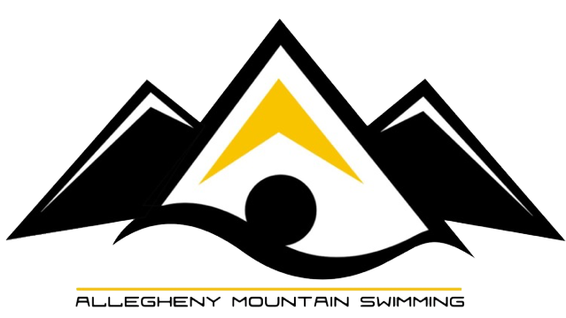
LAST SPLASH
March 17, 18th 2018

Session 1
Girls | Saturday AM | Boys
11-12
2 | 200 Freestyle Relay | 3
5 | 200 Freestyle | 6
7 | 50 Backstroke | 8
10 | 200 Butterfly | 11
13 | 100 Breaststroke | 14
15 | 50 Butterfly | 16
18 | 100 Freestyle | 19
21 | 200 Backstroke | 22
23 | 400 Individual Medley | 24
13 & Over
 | 200 Medley Relay | 1
 | 200 Individual Medley | 4
 | 100 Breaststroke | 9
 | 200 Butterfly | 12
 | 100 Freestyle | 17
 | 200 Backstroke | 20
 | 500 Freestyle | 25

Session 3
Girls | Sunday AM | Boys
11-12
48 | 200 Medley Relay | 49
51 | 100 Butterfly | 52
54 | 100 Individual Medley | 55
56 | 50 Breaststroke | 57
59 | 50 Freestyle | 60
61 | 200 Breaststroke | 62
64 | 100 Backstroke | 65
67 | 200 Individual Medley | 68
70 | 500 Freestyle | 71
13 & Over
 | 200 Freestyle Relay | 47
 | 200 Freestyle | 50
 | 100 Butterfly | 53
 | 50 Freestyle | 58
 | 200 Breaststroke | 63
 | 100 Backstroke | 66
 | 400 Individual Medley | 69

Session 2
Girls | Saturday PM | Boys
10 & Under
27 | 200 Freestyle Relay | 28
30 | 100 Butterfly | 31
33 | 50 Backstroke | 34
36 | 200 Individual Medley | 37
39 | 100 Freestyle | 40
42 | 50 Breaststroke | 43
44 | 500 Freestyle | 45
13 & Over
26 | 200 Medley Relay
29 | 200 Individual Medley
32 | 100 Breaststroke
35 | 200 Butterfly
38 | 100 Freestyle
41 | 200 Backstroke
46 | 500 Freestyle

Session 4
Girls | Sunday PM | Boys
10 & Under
73 | 200 Medley Relay | 74
76 | 200 Freestyle | 77
79 | 100 Backstroke | 80
82 | 50 Butterfly | 83
85 | 50 Freestyle | 86
88 | 100 Breaststroke | 89
90 | 100 Individual Medley | 91
13 & Over
72 | 200 Freestyle Relay
75 | 200 Freestyle
78 | 100 Butterfly
81 | 50 Freestyle
84 | 200 Breaststroke
87 | 100 Backstroke
92 | 400 Individual Medley

