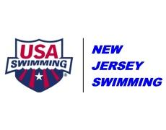
NJ SWIMMING TECHNICAL PLANNING COMMITTEE
AGENDA
January 18, 2017

- Call to Order
- Additions to Agenda (New Business)
- 13&O Silv/Bronze “South” Championships
- 2018 Winter Champs Meet Formats
- 2018 Summer Qualifying Standards
- 2018 Summer Champs Meet Formats
- Review of Policy & Procedure Updates
- New Business
- Next Meeting Date & Time – Wed, Feb. 14th
- Adjournment

