USA SWIMMING 2022 FLEX ATHLETE REGISTRATION APPLICATION
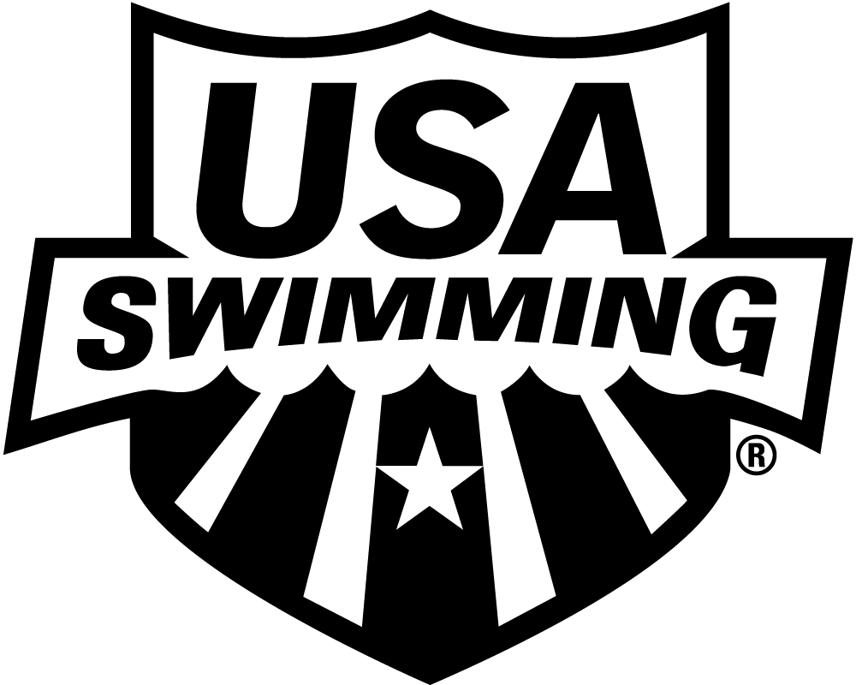
LSC: NEW JERSEY SWIMMING
Athlete must be 18-Under
There is a two (2) sanctioned meet limit
THIS MEMBERSHIP IS ONLY FOR MEETS THAT ARE BELOW THE LSC CHAMPIONSHIP, ZONE, SECTIONAL AND NATIONAL LEVELS.
PLEASE PRINT LEGIBLY COMPLETE ALL INFORMATION:

LAST NAME LEGAL FIRST NAME MIDDLE NAME

PREFERRED NAME DATE OF BIRTH (MM/DD/YY) SEX (M/F) AGE CLUB CODE NAME OF CLUB YOU REPRESENT

(Bill, Beth, Scooter, Liz, Bobby) If not affiliated with a club, enter “Unattached”

NOTE: If you are 18 years of age or older, you are required to abide by the Minor Athlete Abuse Prevention Policy. In addition, in order to be a member in good standing you must complete the Athlete Protection Training. The training can be accessed at www.usaswimming.org/apt

GUARDIAN #1 LAST NAME GUARDIAN #1 FIRST NAME GUARDIAN #2 LAST NAME GUARDIAN #2 FIRST NAME

MAILING ADDRESS

CITY STATE ZIP CODE

–

AREA CODE TELEPHONE NO. FAMILY/HOUSEHOLD EMAIL ADDRESS MEMBER’S EMAIL ADDRESS

ARE YOU A MEMBER OF ANOTHER FINA
FEDERATION? ☐ YES ☐ NO
IF YES, WHICH FEDERATION:

HAVE YOU REPRESENTED THAT
FEDERATION AT INTERNATIONAL
COMPETITION? ☐ YES ☐ NO
U.S. CITIZEN: YES NO

OPTIONAL

DISABILITY: RACE AND ETHNICITY (You may

A. Legally Blind or Visually Impaired check up to two choices):

B. Deaf or Hard of Hearing Q. Black or African American
C. Physical Disability such as R. Asian

2022 REGISTRATION FEE
Sepetember 1, 2021 through December 31, 2022

USA Swimming Fee + LSC Fee (max $10) = TOTAL DUE

$10.00 + 10.00 = $20.00

amputation, cerebral palsy, S. White

dwarfism, spinal injury, T. Hispanic or Latino
mobility impairment U. American Indian & Alaska Native
D. Cognitive Disability such as V. Some Other Race
severe learning disorder, W. Native Hawaiian & Other Pacific
autism Islander

MAIL APPLICATION & PAYMENT TO:

New Jersey Swimming
1933 Rt 35 Ste 105 PMB 349
Wall, New Jersey 07719

HIGH SCHOOL STUDENTS – Year of high school graduation:
Check if you would like to learn more about the USA Swimming Foundation’s initiatives
Check if you would like to receive the electronic USA Swimming Newsletter (must be 13 years of age or older)
YEAR LAST REGISTERED: . IF YOU REGISTERED WITH A DIFFERENT USA SWIMMING CLUB IN 2021, ENTER THAT
CLUB CODE: LSC CODE: AND THE DATE OF YOUR LAST COMPETITION REPRESENTING THAT CLUB: .

SIGN
HERE x
SIGNATURE OF ATHLETE, PARENT OR GUARDIAN DATE REG. DATE/LSC USE ONLY

