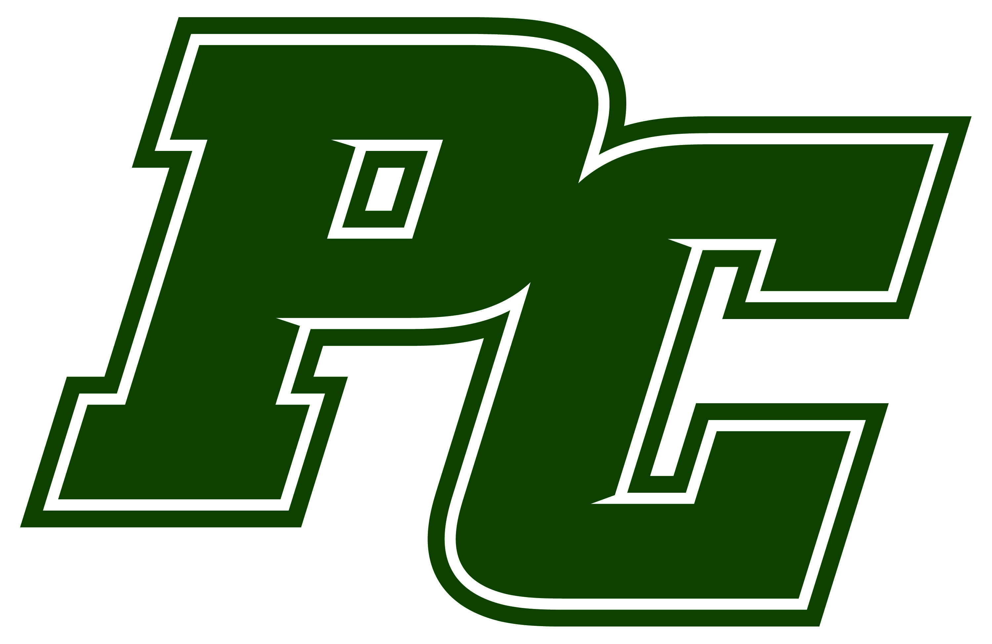
PINE CREST SCHOOL
Revised 9/2015
STUDENT TRANSPORTATION PERMISSION AND RELEASE FORM

Student:

Parent(s)/Guardian(s):

Activity/Event: Effective Date(s):___________________________

Students are required to travel on school provided transportation to all school-related activities and events. However, at certain times, parents may transport students or a student may drive himself/herself. By signing this permission and release form, I/we understand the inherent risks and liabilities involved in the transportation of students and agree to the following:
- The student and Parent(s)/Guardian(s) are required to notify the administrator/teacher that they will be providing their own transportation and/or the transportation of another student at least 24 hours in advance of the school-related activity.
- If the administrator/teacher decides that self-transportation for this particular event is inappropriate, the student and parent agree that the student will use the transportation provided by the school.
- It is understood and agreed that permission to provide the student’s own transportation is conditionally approved by the administrator/teacher and can be revoked at any time at their discretion.
- It is understood and agreed that a student will not transport any other students in his/her vehicle, except for his/her siblings who are also students at the school.

RELEASE
As the Parent(s)/Guardian(s) of Student and by my/our signature below, I/we recognize that the driver (student or the driver, as applicable) will be the primary insurer in the event of personal injury, death, or property loss. By signing below, Parent(s)/Guardian(s) and Student agree to hold Pine Crest School, and its employees, staff, directors, officers, trustees, agents, and volunteers harmless from and against any and all liabilities, claims, suits, damages, injury or death or persons, damage to or destruction of property, fees, costs and expenses whatsoever (including reasonable attorneys’ fees and court costs), arising out of, resulting from, pertaining to, attributed to, or in any way relating to Student being transported by himself/herself or the driver, as applicable. This document also evidences my/our waiver and release of all and any claims, damages, liabilities, actions, costs, or expenses which I/we or Student may have against Pine Crest School arising in any way out of Student’s travel to/from the school-related activities. The types of claims hereby released include contract claims, statutory claims, and torts of any kind, negligence, intentional acts, economic and non-economic damages, expenses, costs, insurance claims, attorneys’ fees, or any other type of claim. If Student violates any of the provisions of this release form, he/she forfeits the right to drive to and from school-related activities.

I have carefully read this form and fully understand its contents and voluntarily consent to terms and conditions.

Student Signature: Date:

Parent/Guardian Signature: Date:

Driving Parent/Guardian Signature: Date:

Please initial on the provided line as applicable (or all 4):
I/we accept the responsibility of driving my student to and/or from school-related activities.
I/we grant my permission for my student/sibling to use his/her own vehicle for transportation.
I/we grant my permission for my student to ride with a driving parent in his/her vehicle. At such time, my student and the driving parent will communicate with the administrator/teacher and must notify them at least 24 hours prior to the event.
I/we accept responsibility of driving (name of student) to/or from school-related activities.

PINE CREST APPROVAL: Administrator

