**Saint Andrews Water Polo Club Apparel**

Below is the club apperal design for this club season. For your convenience, we will bill this directly to your account and it will be added to your next months bill, OR please make checks payable to **Saint Andrews Aquatics**. **Return this form** with payment and indicate size* by using the chart below. ***Orders will be due 15 May 2015***

**Girls Suit: $70.00**

**Size_________**



[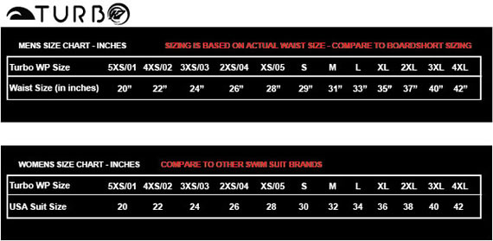](javascript:void(0))

Please fill out the form below.

1. Suit+$________ Size_____

Total+$________ ***Orders will be due 15 May 2015***

Please provide a check made payable to “Saint Andrews Aquatics” **or by signing below you allow billing through your aquatics account and will show up on you next monthly statement**. By signing you are responsible for sizing and spelling. We cannot exchange or change names once order is completed.

Signature___________________________________________________Date__________________