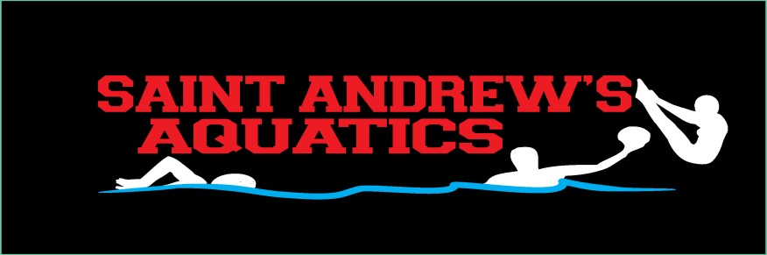

Athlete Behavior Contract

In order to reap the benefits of international exposure, instruction and competition through team travel trips, I,______________________________, and my parent(s) or legal guardian(s) agree to the following conditions regarding my participation and behavior.

1. I will obey all laws, statutes, rules, regulations and policies of whatever country, state, hotel, restaurant, transport, competition, venue, school or any other public place I visit.
2. I will willingly comply with all rules and regulations set by the staff of Saint Andrew’s Aquatics and any coach or guide assigned to me. I will be in appointed places in a prompt and orderly fashion, honor all curfew and room limitations and be in the presence of three other members of the traveling group at all times.
3. I will not use the telephone, without the specific permission from the staff, after the set curfew.
4. I will not use any alcoholic beverage, tobacco product, illegal drug or any other illegal substance AT ANY TIME. I understand that if I participate in any of the above referenced activities, I will be immediately sent home from the competition at my own expense.
5. I will keep my emotions in control and strive to prevent them from showing negatively on my teammates, Saint Andrew’s Aquatics coaching staff, or myself. I will not, at any time, make negative comments during the competition about any other athletes, coaches, officials or event directors.
6. I will not at any time visit the private hotel room of the opposite gender, either by myself or with a group of people.
7. I will not vandalize, destroy, deface or otherwise damage any property belonging to another, including hotel room furnishings, concert hall or center furnishings and accommodations, or air and land transportation vehicles and facilities.
8. I understand that violations of this agreement will allow the staff of Saint Andrew’s Aquatics to discipline me by:
• Withholding competition participation, sightseeing or other tour activity time
• Notifying my parents, legal guardians and/or school officials
• Notifying local officials, including police, hotel staff, tournament directors and competition officials
• Sending me home immediately from the competition

I look forward to this opportunity to experience the world through sports competition and acknowledge the need for my complete obedience to the above terms and conditions.

________________________ ____________________________ ______________

Athlete’s Signature Parent/Guardian Signature Date

