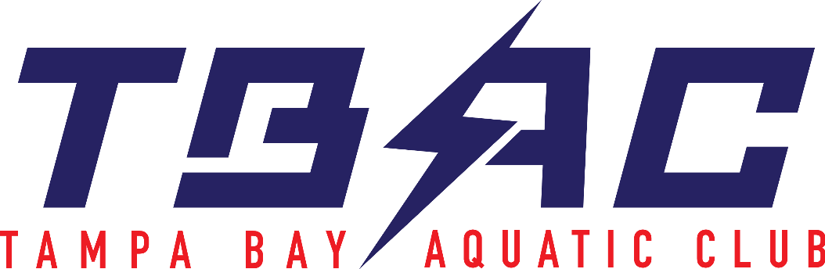
SAFE SPORT
REPORTING INFORMATION
Guidelines for Reporting a Safe Sport Concern

- Response & Resolution flow chart
https://uscenterforsafesport.org/wp-content/uploads/2019/06/Response-and-Resolution-Process-2.pdf

- How to deal with a Safe Sport Concern
https://www.usaswimming.org/news-landing-page/2017/05/08/safe-sport-report
- Other USA Swimming Resources
To deal with a Safe Sport concern, contact USA Swimming at (719) 866-4578
Contact the U.S. Center for Safe Sport to make a report. Call (720) 524-5640

TBAC SAFE SPORT COORDINATOR:
BRETT EWALD
mailto:brettewald@gmail.com
813-625-2683

