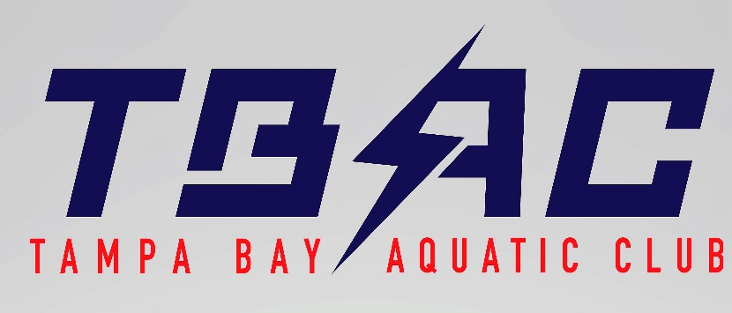

GRIEVANCE Policy

The Tampa Bay Aquatic Swim Club Grievance Policy outlines guidance and procedures to give swimmers, parents, coaches, Club leadership, and employees a way to address and report grievances in a productive, systematic way that allows the appropriate parties to investigate and intervene, and take disciplinary action when needed.

There are occasions when a problem arises in a club, for example fighting or bullying, where immediate action is required. A temporary suspension or exclusion from a single training session can be given by the coaches. A report should then be made, within 24 hours, to the coaches board (all the site coaches) ,who should follow the procedures outlined below.
With the exception of issues that immediately effect the health and safety of swimmers, all matters should be discussed before or after a coaching session and coaches should not be expected to deal with issues during water time.
1)If your concern relates to inappropriate behavior or activity that includes but is not limited to the following:
- Criminal activity
- Use, sale or distribution of illegal drugs
- Physical abuse
- Inappropriate touching
- Coaches sharing hotel rooms with athletes
- Rubdowns or massages performed by coaches
- Pictures and or videos taken in locker rooms or changing areas
- Violations of USA Swimming’s Minor Athlete Abuse Prevention Policy (MAAPP)
Please contact Liz Hahn ehahn@usaswimming.org at the National Office or complete the online reporting
LINK TO ONLINE REPORTING FORM
Anonymous reporting can be completed https://fs22.formsite.com/usaswimming/form10/index.html
2) If your concern relates to sexual misconduct, sexual harassment or sexually explicit communication through any media, please contact the U.S Center for SafeSport to make a report immediately. You can report your concern online or call 720-524-5640. More information can be found at www.uscenterforsafesport.org.
3 ) Any concerns dealing with deception or recruiting should be directed to the Southern Zone Board of Review:
Donna Williamson email: dwilliamsones@gmail.com

TYPES OF GRIEVANCES
- Swimmer conduct
- Assistant or Age Group Coach Conduct
- Head Coach Conduct
- Employee Conduct (non-swim team employees)
- Board of Director Member Conduct
- USA Swim Official or swim team parent conduct

WHOM TO NOTIFY OF A GRIEVANCE (The Grievance Chain-of-Command)
- Regarding the Conduct of a Swimmer - Contact the swimmer’s coach
Should a parent or swimmer feel another swimmer’s conduct is inappropriate or violates the Athlete Code of Conduct, the parent/swimmer should discuss these concerns with the coach of the swimmer responsible for the violation (Responsible Coach). This complaint should be made in person or in writing. The Coach(s) will schedule a confidential meeting between the 2 parties so that each will participate in assessing behavior.

- Regarding the Conduct of an Assistant or Age Group Coach - Contact the Head Coach
Should a parent or swimmer feel an Assistant or Age Group Coach’s conduct is inappropriate or in violation of any Club policies or procedures, the parent/swimmer should notify the Head Coach of this violation. This complaint should be made in person or in writing. The Head Coach will ensure schedule a confidential meeting and let the complainee be notified of the complaint, review the code of conduct and participate in assessing behavior.

- Regarding Conduct of Head Coach – Contact TBAC Safe Sport Director Brett Ewald brettewald@gmail.com or 813-625-2683 AND
ahoward@usaswimming.org or719-866-3529
Should a parent or swimmer feel the Head Coach’s conduct is inappropriate or violates any Club policies or procedures, the parent/swimmer should notify the TBAC Safe Sport Director and USA Swim Safe Sport coordinator of this violation. This complaint should be made in person or in writing. The Head Coach should also be made aware of the complaint. This complaint will be subject to review and discussion by all parties and all the different pool sites Head Coaches.

- Regarding Parent or Swim Official Conduct - Notify the Head Coach
Should a parent or swimmer feel another TBAC’s parent’s conduct is inappropriate or violates any Club policies or procedures, the parent/swimmer should notify the swimmer’s Head Coach of this violation in person or in writing. This complaint will be reviewed and discussed by both parties and all the pool sites Head Coaches.

HOW GRIEVANCES WILL BE HANDLED
The Head Coaches have the authority to impose penalties for infractions of the TBAC Athlete, Parent and Coaches Codes of Conduct or any behavior(s) they deem not conducive to the best interests of the Club or other swimmers. Consequences are at the sole discretion of the coaches and may include, but aren’t limited to, verbal warnings, dismissal from practice, contacting parents, and expulsion. USA Swimming and local law enforcement (if applicable) will be contacted within 24 hours if a coach, parent or swimmer violates the USA Swimming Code of Conduct, Athlete Protection Policy, or local laws.

- Gathering Information: The appropriate individuals will reach out to the person who filed the grievance and the person against whom the grievance is being filed to ask questions about what happened. Other witnesses may be contacted for more information, as well. All information will be recorded on the TBAC Incident Report Form
- Assessing Behavior: The behavior of the person(s) against which the grievance was brought will be assessed using Club policies and facility rules, USA Swimming Code of Conduct, USA Swimming Safe Sport policies, and applicable local and state laws. TBAC Safe Sport Coordinator and Florida Swimming Safe Sport Coordinator will be notified of the incident.
- Consequences Will be Given and Disciplinary Action Will be Taken if Appropriate. These consequences and disciplinary actions will be decided using the following general guidelines:
  - Nature of the misconduct
  - Severity of the misconduct
  - Prior disciplinary actions
  - Adverse effect of the misconduct
  - Application of the Code of Conduct

