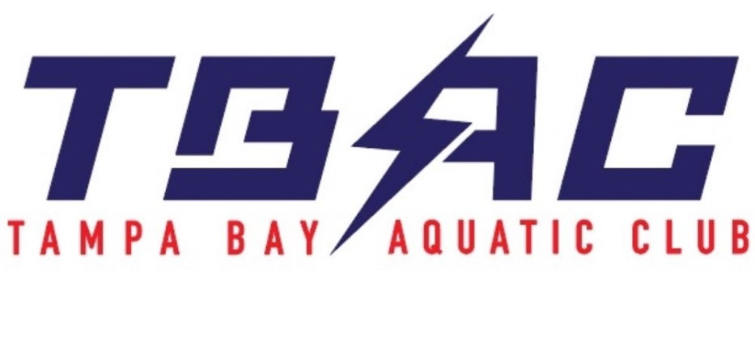

CODE OF CONDUCT

PURPOSE

The reputation and status of the Tampa Bay Aquatic Club (TBAC) is of utmost importance for the continued viability and growth of the organization. The conduct of the membership of TBAC directly impacts the reputation and status of the organization. This Code of Conduct provides the basic framework under which the organization and its membership shall operate.

PART I – GENERAL CODE OF CONDUCT RULES

- All members (both parents and swimmers) of TBAC shall abide by and acknowledge by their signature the established Code of Conduct.

- All members of TBAC and the organization are expected to act with integrity and demonstrate the utmost in sportsmanship at all times.

- Disrespectful, indiscreet or destructive behavior will not be tolerated. It is the responsibility of each member to make every effort to avoid association with such activities.

- Members shall adhere to all rules, regulations and instructions issued by the Coaching staff.

- Members shall adhere to all rules and regulations established for special events (e.g., team travel, team fundraisers, team sponsored social events, etc.).

- Members shall value and protect the reputation and status of TBAC in all venues, both public and private (including electronic and social media including, but not limited to, Facebook, Twitter, blogs, etc.), and shall do nothing purposefully to diminish, disparage, or otherwise harm and/or devalue said reputation and status.

- Members shall support their fellow teammates, Coaches and all other persons associated with TBAC in all efforts to enhance the viability and sustainability of the organization.

- Members shall value the achievements and accomplishments of the team and their teammates and shall support the goals of the team and teammates.

- In addition to the Codes of Conduct adopted by TBAC, all members of its organization must be familiar with and abide by the applicable Codes of Conduct of USA Swimming and Florida Swimming, any host competition venue, and any training venue utilized by TBAC.

Tampa Bay Aquatic Club 2
Code of Conduct

EXCLUSIVELY FOR PARENTS:

  - All fees and charges associated with TBAC membership must be paid when due or appropriate arrangements made with the TBAC Treasurer.

EXCLUSIVELY FOR SWIMMERS:

- Use of alcoholic beverages is unacceptable at any time.

- Use of drugs other than those prescribed by your physician, or over-the-counter medication, is unacceptable at any time.

- Use of tobacco products is unacceptable at any time.

- Failure to abide by disciplinary actions/instructions resulting from a breach of the Code of Conduct is unacceptable at any time.

PART II- VIOLATION OF THE CODE OF CONDUCT RULES

  - The Head Coach shall be charged with administering disciplinary actions for any violations of the Code of Conduct by any swimmer, parent, guardian, or coach
  - The normal course of disciplinary action shall consist of:
    - A verbal warning and written acknowledgement of an initial breach.
    - A suspension from team activities for a period up to 7 successive calendar days for a second breach.
    - A suspension from team activities for a period up to 31 successive calendar days for a third breach.
    - A removal (termination) from the organization for a fourth breach.
  - In conjunction with the above, additional activities and/or requirements may be provided to facilitate restitution or acknowledgment of the breach.
  - At the discretion of the Head Coach and based upon the severity of the infraction, one or more of the above detailed actions may be bypassed and a more advanced action taken.
  - Fees and charges that are due and owing or become due and owing, are not suspended or forgiven during any period of suspension resulting from a breach of the Code of Conduct.
  - The Head Coach shall be charged with administering corrective action for a breach of the Code of Conduct by any non-swimmer.
  - Corrective action may include temporary or permanent suspension/termination from team activities for members, including both the parent(s) and swimmer(s).
  - These policies apply to the TBAC organization as a whole. If a parent(s) and/or swimmer(s) is in breach of the code of conduct and is removed from their respective TBAC branch, they will not be able to compete and/or train for another branch of TBAC.

I hereby agree to abide by the rules of conduct as set forth in Part I above and acknowledge that, should I violate any provision in Part I, I will be subject to disciplinary action, as set forth in Part II, including the possibility of suspension and termination.

Name of Swimmer (Please Print) Signature of Swimmer Date (MM/DD/YYYY)

Name of Parent(s) (Please Print) |  | Signature of Parent/Guardian | Date (MM/DD/YYYY)
_______________________ |  | _______________________ | _________________

