Trinity Prep Aquatics

“Adidas Swim Team Challenge”
with
“Swim Your Own Age”
January 11-12, 2020
Indoor Pool!

Sanctioned By: Florida Swimming of USA Swimming –

“In granting this approval it is understood and agreed that USA swimming and Florida Swimming
shall be free and held harmless from any liabilities or claims from damages arising by reason of
injuries to anyone during the conduct of the event.” and Trinity Prep Aquatics, Trinity Preparatory School, YMCA of Central Florida, and YCF swimming accept no responsibility for liability or injuries sustained by any individual, athlete, coach, official, meet volunteer, or spectator while traveling to and from or while participating in the meet.

- Any swimmer entered in the meet, unaccompanied by a USA Swimming member coach, must be certified by a USA Swimming member coach as being proficient in performing a racing start or must start each race from within the water. It is the responsibility of the swimmer or the swimmer’s legal guardian to ensure compliance with this requirement

- The competition course has been certified in accordance with 104.2.2C(4). The copy of such certification is on file with USA Swimming.

- Except where venue facilities require otherwise, changing into or out of swimsuits other than in locker rooms or other designated areas is not appropriate and prohibited.

- Operation of a drone, or any other flying apparatus, is prohibited over the venue (pools,athlete/coach areas, spectator areas and open ceiling locker rooms) any time athletes, coaches, officials and/or spectators are present. Exceptions may be granted with prior written approval by the USA-S Vice President of Program Operations.

- All applicable adults ( 18 years and older) participating in or associated with this meet, acknowledge that they are subject to the provisions of the USA Swimming Minor Athlete Abuse Prevention Policy (“MAAPP”), and that they understand that compliance with the MAAPP policy is a condition of participation in the conduct of this competition.

Type of Meet: Adidas Swim Team Challenge:
25 Yard Course for Prelims & Finals.

Swim Your Own Age: separate sessions from Adidas Swim Team Challenge
25 Yard Course for both days

Sponsored By: Trinity Prep Aquatics, Trinity Preparatory School

Location: Rosen Aquatic Center, 8422 International Drive Orlando, FL 32819

Pool Specs: Two certified indoor, 25-yard, 8-lane competition pools with non-turbulent lane lines.
Water depth in the competition pool is 7 feet minimum at start & turn ends.

Timing System: Full Video Display Scoreboard. Colorado Automatic and/or Semi-Automatic Timing

Dates / Times:
Adidas Swim Saturday, January 11, 2020 - Preliminary session with one or two courses as needed.
Warm-up – 7:30am; Start – 8:30am.

SYOA Saturday, January 11, 2020 - One or two courses as needed.
Warm-Up- guaranteed 30 minutes. Start - not before 12:30

Adidas Swim Saturday, January 11, 2020 - Finals session with one course: 8 Lanes 25 yards
Warm-up – 5:00pm; Start – 6:00pm

Adidas Swim Sunday, January 12,2020- Preliminary session with one or two courses as needed.
Warm-up – 7:30am; Start – 8:30am.

SYOA Sunday, January ,– One or two courses as needed.
Warm-Up- guaranteed 30 minutes. Start - not before 12:30

Adidas Swim Sunday, January 13, 2020 – Finals session with one course: 8 Lanes 25 yards
Warm-up – 4:00pm; Start – 5:00pm

Format: The Adidas SWIM Team Challenge session will be Short Course Yards for Prelims and Finals

20 swimmers return from Prelims: The Bonus Final will have 8 swimmers (13th-20th), The consolation Final 6 swimmers (7th – 12th), the Super Final 4 swimmers (3rd – 6th), and Ultra Final (1st – 2nd) in all events. All swimmers in finals score points.

The Swim Your Own Age session will be single age brackets timed finals on Saturday and Sunday.

Eligibility: SYOA Entries will close upon receipt of the team that puts entries over the four hour time limit per session. Teams will be accepted by the post date of their entries. "Open to all currently registered 2020 USA Swimming athletes." "On deck registration will Not be allowed.

Deck Access: Only currently registered coaches and officials will be allowed access beyond the coaches, athletes & Officials entrance. Coaches and officials will be required to show their current USA Swimming registration card when asked by meet management/Security. Volunteers will be given a pass to access the deck and help for that specific purpose.

Any non-registered individuals not respecting these rules will be removed from that area or
from the facility at the discretion of the meet manager or the Director of Rosen Aquatic Center.

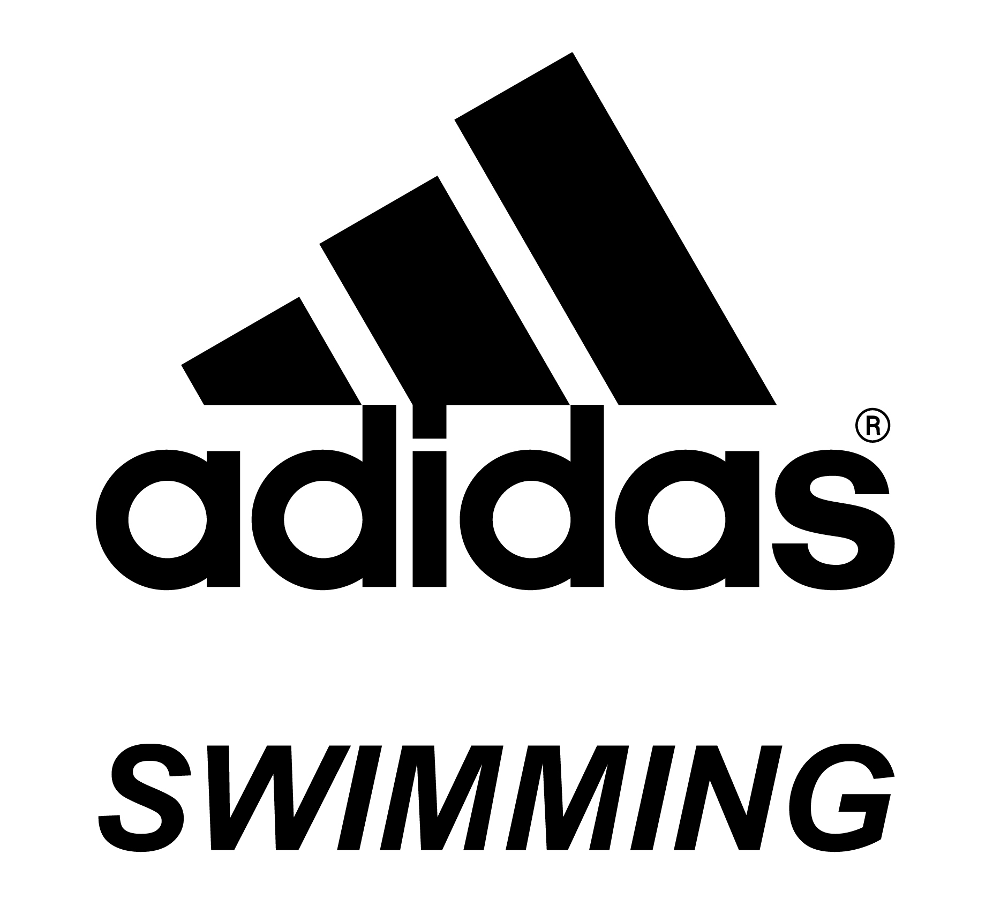

Seeding: 25 SCY will be used.

Entry Limit: The ADIDAS SWIM Team Challenge sessions will be limited to three (3) individual events per day. Swimmers over-entered will be considered as entered in the first three (3) individual events of each day.

The Swim Your Own Age sessions will have a limit of four (4) individual events per day. Swimmers over-entered will be considered as entered in the first four (4) individual events of each day.

Scratches Prelims- No penalty for scratches on the block during prelims or timed final events. However, as a courtesy, please notify the Admin or Meet Referee if you know any swimmers will not be competing in an event in advance.

Scratching From Finals: any swimmer who competes in a preliminary heat and qualifies as one of the 20 finalists, as originally seeded, must swim in that event in the final , or must notify the Clerk of Course that he/she intends to scratch from that final’s event within 30 minutes of the announcement of the qualifiers. Any swimmer seeded in a finals event who fails to swim that event shall be barred from their next event unless excused by the Meet Referee for illness or injury. **If a swimmer is "bumped" up into a final due to scratches above that swimmer's prelim finish, and does not know they have been bumped into a final, there is no penalty for that swimmer if they miss the final because they were not aware of the bump.

Entry Deadline: Monday, January 6, 2020 @ 5:00 pm. Eastern

Submit Entries To:
Go to www.sportstiming.com ,

Click on meets and click on the TPA Adidas Swim Team Challenge/SYOA. Complete the form, upload your entry file and click submit. You will receive an email confirmation. If you need to submit updated entry files prior to the deadline, you are able to submit a new form and file. Entry questions can be emailed to meet.support@sportstiming.com.

Entry Fee: ADIDAS Swim Team Challenge:
$6.10 per individual event. $15 Facility Fee + $2 Heat Sheet Fee

Swim Your Own Age:
$4.15 per individual event. $10 Facility Fee + $2 Heat Sheet Fee

Sportstiming Inc has 2 files to upload

Heat Sheet Fee: No Heat Sheets will be sold at the meet. Heat sheets will be provided to coaches & officials.

Deck Entries: NO Deck entries will be accepted.

Checks payable to: Trinity Prep Aquatics

Officials: Meet Managers: Rocco Aceto
Head Referee: David Nesper
Scoring and Timing Operators:Billy Culbertson,Victoria Culbertson
Starter: Susan Nesper
Stroke & Turn: Jim Myers
Head Marshall: Anne Marie Stricklin
Administrative Official: Keith Yannessa, Chuck Travers

All currently certified and in training USA Swimming officials are cordially invited to
participate. Apprentices will be assigned providing sufficient qualified mentors are available to supervise and instruct. All deck officials must be registered with USA Swimming and FL Swimming for
2020. Please email the Meet Referee, Dave Nesper dnesper68@gmail.com, with your certification level and availability so he can plan accordingly.

Rules: Current USA Swimming Rules will govern the meet. “No Recall” starting procedures in effect. Safety rules as outlined by USA Swimming and recommended by the Referee will be in effect.

NOTE: At the discretion of Meet Management : Fly over starts will be used and HEATS may be combined.

Awards: ADIDAS Swim Team Challenge
1st – 2nd – ADIDAS Ball Hats for Ultra Heat Winner and Runner up.

1st Place Combined Team Award

Swim Your Own Age:

- High Point Trophy places 1-3 in each age group based upon most points scored from the combined Saturday & Sundays events
- Ribbons 1-8 places

Scoring: Individual Events: 1st through 20th – 21,19,18,17,16,15,14,13,12,11,10,9,8,7,6,5,4,3,2,1

Concession: Available from Fire House Subs, SIMAX T’ Shirts, Swim Suit Vendor for all sessions

Info Update: Call Rocco Aceto at 321.282.2558 or check for updates to meet information on the TPA web site. Time Lines and Psyche Sheets will be available the Wednesday prior to the meet at http://www.tpaswim.org.

Supervision: Each swimmer participating in a Florida Swimming sanctioned meet must be supervised during warm-up and competition by a current Coach member of USA Swimming. An unattached athlete or an athlete not escorted by a Coach member must check in with the Meet Referee upon arrival at the meet. Such athletes must find a substitute Coach who will supervise him/her during warm-up and competition and must submit the enclosed Alternate Coaches Form (signed) to the Meet Referee.

Camera Zones: Per Florida Swimming Rule 223.12, meet management shall designate and inform the public of
“camera zones” at each swim meet where both still photography and video photography of a race or
a competitor in a race may be taken. Acceptable “camera zones” may include, but are not limited to,
the side courses of a pool, team gathering areas, concession area , turn end of competition course,
when not in use as a “start end” etc. Meet management shall also designate “non-camera zones.”
Under no circumstances will camera zones include the area immediately behind the starting blocks
at either end of the racing course when they are in use for “race starting purposes” during
competition and warm ups, locker rooms, rest rooms, or any other dressing area. Any individual
failing to abide by this rule could be subject to the Florida Swimming Code of Conduct
violation as defined in Rule 239.2

https://adidasswimming.com/

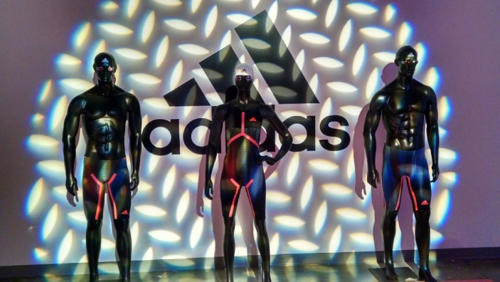

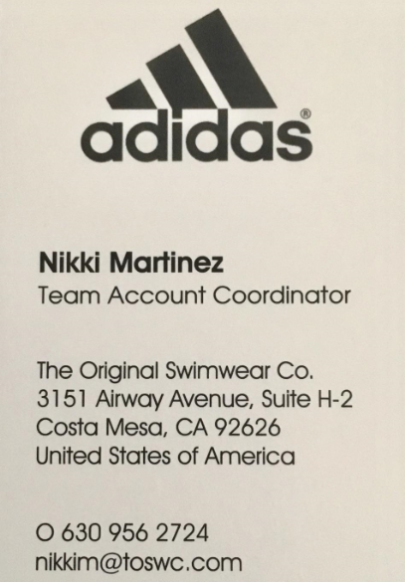

ADIDAS Swim Team Challenge Event List
Saturday January 11, 2020
Event # Women | Event # Men | Age Group | Event | Prelims/Finals
1 | 2 | 13 and Over | 200 Free | P
3 | 4 | 13 and Over | 100 Fly | P
5 | 6 | 13 and Over | 400 Ind. Med. | Preseeded
7 | 8 | 13 and Over | 200 Back | P
9 | 10 | 13 and Over | 100 Breast | P
11 | 12 | 13 and Over | 50 Free | P

Sunday January 12, 2020
Event # Women | Event # Men | Age Group | Event | Prelims
13 | 14 | 13 and Over | 200 Ind. Med. | P
15 | 16 | 13 and Over | 100 Back | P
17 | 18 | 13 and Over | 500 Free | Preseeded
19 | 20 | 13 and Over | 200 Breast | P
21 | 22 | 13 and Over | 200 Fly | P
23 | 24 | 13 and Over | 100 Free | P

Event # Women | Event # Men | Age Group | Event | Timed Finals
25 | 26 | 12 year old | 100 Backstroke | TF
27 | 28 | 11 year old | 100 Backstroke | TF
29 | 30 | 10 year old | 50 Backstroke | TF
31 | 32 | 9 year old | 50 Backstroke | TF
33 | 34 | 8 year old | 25 Backstroke | TF
35 | 36 | 7 & under | 25 Backstroke | TF
SYOA EVENTS – Saturday January 11, 2020

Event # Women | Event # Men | Age Group | Event | Timed Finals
37 | 38 | 12 year old | 100 Breast stroke | TF
39 | 40 | 11 year old | 100 Breast stroke | TF
41 | 42 | 10 year old | 50 Breast stroke | TF
43 | 44 | 9 year old | 50 Breast stroke | TF
45 | 46 | 8 year old | 25 Breast stroke | TF
47 | 48 | 7 & under | 25 Breast stroke | TF

Event # Women | Event # Men | Age Group | Event | Timed Finals
49 | 50 | 12 year old | 100 Fly | TF
51 | 52 | 11 year old | 100 Fly | TF
53 | 54 | 10 year old | 50 Fly | TF
55 | 56 | 9 year old | 50 Fly | TF
57 | 58 | 8 year old | 25 Fly | TF
59 | 60 | 7 & under | 25 Fly | TF

Event # Women | Event # Men | Age Group | Event | Timed Finals
61 | 62 | 12 year old | 100 Free | TF
63 | 63 | 11 year old | 100 Free | TF
65 | 66 | 10 year old | 50 Free | TF
67 | 68 | 9 year old | 50 Free | TF
69 | 70 | 8 year old | 25 Free | TF
71 | 72 | 7 & under | 25 Free | TF

Event # Women | Event # Men | Age Group | Event | Timed Finals
73 | 74 | 12 year old | 200 Backstroke | TF
75 | 76 | 11 year old | 200 Backstroke | TF
77 | 78 | 10 year old | 100 Backstroke | TF
79 | 80 | 9 year old | 100 Backstroke | TF
81 | 82 | 8 year old | 50 Backstroke | TF
83 | 84 | 7 & under | 50 Backstroke | TF
SYOA EVENTS – Sunday January 12, 2020

Event # Women | Event # Men | Age Group | Event | Timed Finals
85 | 86 | 12 year old | 200 Breast stroke | TF
87 | 88 | 11 year old | 200 Breast stroke | TF
89 | 90 | 10 year old | 100 Breast stroke | TF
91 | 92 | 9 year old | 100 Breast stroke | TF
93 | 94 | 8 year old | 50 Breast stroke | TF
95 | 96 | 7 & under | 50 Breast stroke | TF

Event # Women | Event # Men | Age Group | Event | Timed Finals
97 | 98 | 12 year old | 200 Fly | TF
99 | 100 | 11 year old | 200 Fly | TF
101 | 102 | 10 year old | 100 Fly | TF
103 | 104 | 9 year old | 100 Fly | TF
105 | 106 | 8 year old | 50 Fly | TF
107 | 108 | 7 & under | 50 Fly | TF

Event # Women | Event # Men | Age Group | Event | Timed  Finals
109 | 110 | 12 year old | 200 Free | TF
111 | 112 | 11 year old | 200 Free | TF
113 | 114 | 10 year old | 100 Free | TF
115 | 116 | 9 year old | 100 Free | TF
117 | 118 | 8 year old | 50 Free | TF
119 | 120 | 7 & under | 50 Free | TF

Alternate Coaches Form
January 11-12, 2020
The following swimmers are entered in the meet and are attending without a coach.
Swimmer's Name | USA # | Team | Age

I am a certified coach of USA Swimming in good standing and I agree to coach the above named swimmer(s) during all warm-ups and competitions in which they participate associated with this meet.

Signature ____________________________________________________________

Print Name______________________________________________________________

WARM UP SCHEDULE

A detailed warm-up assignment schedule will be provided via email and posted at tpaswim.org website prior to the meet.

* NO EQUIPMENT IS TO BE USED DURING WARM-UP.
* NO RACING STARTS IN WARMUP OR WARM DOWN LANES DURING THE MEET.
* ENTER THE WATER FEET FIRST

