Georgia Swimming will increase opportunity, recognition, and growth in competitive swimming. We believe that swimming provides life-changing experiences for young people.

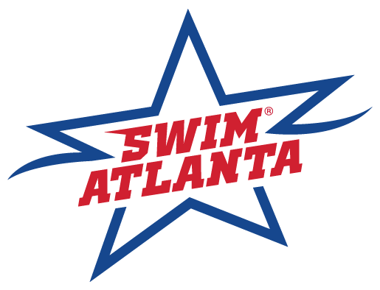 | 2022 Atlanta Classic  May 13-15, 2022
SANCTION:  ATTESTATION: | Held under the sanction of USA Swimming, issued by Georgia Swimming Inc.,  Sanction #: GA21-050  Sanction #:GA22-051/Time Trials  - Article 202.4.3: Granted sanctions are non-transferrable to other organizations or clubs. Any such transferred sanction shall be void and the Sanction Committee shall deny any further sanctions to the organization or club violating this provision.  - In applying for this sanctioned event, the SwimAtlanta agrees to comply and to enforce all health and safety mandates and guidelines of USA Swimming, Georgia LSC, the State of Georgia, and local jurisdiction.
MAAPP:  Minor Athlete Abuse Prevention Policy  Effective June 23, 2019 | - A USA Swimming club that hosts a sanctioned USA Swimming swim meet indicates acknowledgement of USA Swimming’s Minor Athlete Abuse Prevention Policy (“MAAPP”).  - All USA Swimming members including athletes 18 and older and adults who interact with minor athletes at swim meets are expected to comply with the MAAPP policy.  - All chaperones, team managers, adult swimmers, meet directors, officials, and non-member parents and meet volunteers are expected to understand and comply with MAAPP.  - As the host club, you are responsible for ensuring that these individuals know about and comply with MAAPP.
ELIGIBILITY FOR TIME RECOGNITION TO THE SWIMS DATABASE | Times achieved by an athlete member at a sanctioned competition who is 18 years of age (+30-day grace period) who have not completed the Athlete Protection Training OR (whose APT training had expired) by the date of the swim, WILL NOT be uploaded to the SWIMS database.
LIABILITY: | In granting this sanction it is understood and agreed that USA Swimming, Inc., Georgia Swimming, Inc., and SwimAtlanta, shall be free and held harmless from any liabilities or claims for damages or illnesses arising by reason of injuries to anyone during the conduct of the event.
REPORT DISCRIMINATION:  D, E, & I = Reference / Informational Section | The Georgia LSC believes that there is no place for discrimination in the sport of swimming.  If you believe you are the victim of discrimination, you are encouraged to report the incident to USA-Swimming’s Associate Counsel & Director of Safe Sport, Abigail Howard (ahoward@usaswimming.org or 719-866-3529). Please provide a complete description of the incident as well as a way to contact you and/or other parties involved.  For more information refer to gaswimming.org/diversity  Gaswim.org  Georgia Swimming LSC: D, E, & I (teamunify.com)
MEET DIRECTOR: | Chris Davis Jr. chrisjr@swimatlanta.com & Wil Bayer wil@swimatlanta.com
NATIONAL EVALUATOR: | Robert Broyles - robertbroyles9@gmail.com
MEET REFEREE: | Steve Potter – Stephen.potter@syf.com
ADMIN REFEREE | Eric B. Pingel –epingel.usaswimming@gamil.com
STARTER: | Nancy Harmon
STROKE AND TURN: | Astrid De Leon
ADMIN OFFICIAL: | Cheryl Loprinzo – Cheryl.loprinzo@comcast.net
FACILITY: | Georgia Tech - McAuley Aquatic Center  Campus Recreation Center  750 Ferst Drive  Atlanta, GA 30332  This facility seats 1,900 and contains both a competition pool and diving well. The competition pool is 50 meters by 10 lanes, with two movable bulkheads so that courses can be set up for 25 yards or 25 meters. The competition course has been certified in accordance with 104.2.2C(4). The copy of such certification is on file with USA Swimming & Georgia Swimming. The water depth of the pool is 9 1/2 feet at start end and 9 1/2 feet at turn end. (measured from 3’ 3 1/2" (1.0 mtr) to 16'5" (5mtrs) from both end walls).
SCHEDULE: | - Thursday Warm Up: 4:30PM - 7:30PM (5 lanes)  - Friday, Saturday & Sunday Prelims: Warm-up 7:00AM-8:45AM; Competition: 9:00AM  - Friday, Saturday & Sunday Finals: Warm-up 4:30PM-5:45PM; Competition: 6:00PM
MEET FORMAT: | All Technical Events will be Prelim/Final.  - The top 40 will advance to finals. The heat order at finals will be D, C, B and A.  - The D final will be restricted to 18 & under swimmers.  Seeding: Fast to Slow  Distance:  - 800 and 1500 free which will be a Time Final events with positive check in at the Clerk of Course by 10:00AM.  - Alternating events. 1500 Free then 800 Free  - Seeding Fastest to Slowest
ENTRY FEES: | - IND. EVENT FEE: $12.50 / Event  - LATE IND. ENTRIES: $25.00 / Event  - TIME TRIALS: $20.00 / Event  - SURCHARGE: $25.00  - $2.00 Ga travel surcharge applies to all non-Georgia LSC registered swimmers.
ELIGIBILITY: | MEET TYPE: (Open - Invitational)  Open to all 2022 swimmers registered with USA Swimming or their respective FINA Federation and who have achieved the published time standard for either short course yards, long course meters or short course meters in EACH event entered. Qualifying period is 24 months prior to the meet starts.  SwimAtlanta will not allow unregistered swimmers, coaches, officials, or teams to participate in this meet. No swimmer will be permitted to compete unless the swimmer is a member in as provided in Article 302.
ENTRIES: | Swimmers may swim a maximum of (3) individual events per day. Deck entries can be made with the clerk of course up to 30 minutes before the start of the session.  Any swimmer who has one or more qualifying standards may enter up to two (2) Bonus events.  Sessions may be limited to 600 swimmers; however, the meet management reserves the right to determine the final number.  Time Trial events will be included in daily individual event limits.
CHECK IN /  CLERK of COURSE: | - Positive check-in is required for all deck seeded events within 30 minutes after the start of the session in which THOSE events are scheduled.  - Positive check-in is required for the 800 free and 1500 free.  - 800 / 1500 Distance events check in closes at 10:00am  - Swimmers must sign up for Time Trial events with the Clerk of Course by:  10:00am - Friday, Saturday, and Sunday
ENTRY SUBMISSION: | ENTRY DEADLINE: Date: Sunday, April 20, 2022 Time: 11:59pm  Email entries: Cheryl Loprinzo - Cheryl.loprinzo@comcast.net  Submit entries using Hy-Tek team manager. Entries must include the USA Swimming Club Code and each swimmer’s USA Swimming number, first and last name, age, and seeding time for each event entered.
SCRATCH PROCEDURE: | Scratches and positive check-in for Day 1 events are due no later than 6:00 p.m. Thursday for Friday’s events. Day 1 of the competition and may be submitted by email to Cheryl Loprinzo – Cheryl.loprinzo@comcast.net  All subsequent day’s events scratches are due 30 minutes after the start of the previous evening’s finals. There is no penalty for failing to compete in a preliminary or timed final events. A swimmer qualifying for an A, B, C or D Final who fails to compete shall be barred from the remainder of the meet, unless excused by the Meet Referee.
TIME TRIAL: | - Time Trials may be conducted / combined at the discretion of the Meet Referee’s.  - Time Trials will be offered ONLY to Athletes entered in the meet.  - Events offered in Time Trials are ONLY those events offered within the meet.  - Time Trial – Distance – (400IM, 800 Free, 1500 Free) events will be ONLY on the day (s) the event is conducted.  - Athletes requesting Time Trials on the days the event are offered and prior to the check-in deadline will be assigned an Open Lane within an Open Heat during the Lowest Seeded Heats  - Time Trial events count towards the athlete’s daily limit. (3 per day)  - Time Trials will be planned for immediately after the completion of the morning sessions.  - Time Trials held after Finals will be open ONLY for swimmers attempting National or better cuts.  - Swimmers must sign up for time trial events with the clerk of course by 10:00am each day.  - Athletes may need to provide their own lane timer and lap counter for Time Trial events.
RULES: | Tech Suit Restriction for 12-and-Under Swimmers:  https://www.usaswimming.org/news/2020/08/24/tech-suit-restriction-for-12-and-under-swimmers  102.8 SWIMWEAR  .1 Design  F. No Technical Suit may be worn by any 12 & Under USA Swimming athlete member in competition at any Sanctioned, Approved or Observed meet.  1) A Technical Suit is one that has the following components:  a. Any suit with any bonded or taped seams regardless of its fabric or silhouette; or  b. Any suit with woven fabric extending past the hips.  (Note: WOVEN FABRIC-A suit with woven fabric and sewn seams that does not extend below the hips is permitted.)  (Note: KNIT FABRIC-A suit with knit fabric and sewn seams not extending below the knees is permitted.)  This rule is in effect for all USA Swimming competitions in the United States, so any manufacturer or vendor selling a suit in the United States is subject to the above rule. No Technical Suits may be worn by any 12-Under USA Swimming athlete member in competition at any Sanctioned, Approved or Observed meet.  Current USA Swimming Rules, including the Minor Athlete Abuse Prevention Policy (“MAAPP”), will govern this meet.  Use of audio or visual recording devices, including a cell phone, is not permitted in changing areas, behind the blocks (Including warm-up, warm-down, and Competition), rest rooms or locker rooms.  Any swimmer entered in the meet, must be certified by a USA Swimming member-coach as being proficient in performing a racing start or must start each race from within the water. When unaccompanied by a member coach, it is the responsibility of the swimmer or the swimmer’s legal guardian to ensure compliance with this requirement.  Deck changes are prohibited. (Defined as changing, in whole or in part, into or out of a swimsuit when wearing just one suit in an area other than a permanent or temporary locker room, bathroom, changing room or other space designated for changing purposes). Swimmers participating in deck changing could be subject to removal from further competition in the meet.  On deck registrations will not be permitted during this event.  Operation of a drone, or any other flying apparatus, is prohibited over the venue (pools, athlete/coaches’ areas, spectator areas and open ceiling locker rooms) any time athletes, coaches, officials and /or spectators are present. Exceptions may be granted with prior written approval by the Program Operations Vice Chair, Program & Events Committee Chair, or designee.  All referees, starters, administrative officials, chief judges, and stroke and turn judges, serving in an official capacity in a sanctioned event, must be non-athlete members of USA Swimming or members of other FINA-member organizations. All meet directors for meets sanctioned by USA Swimming must be members of USA Swimming. Except for coaches accompanying athletes participating under the provisions of 202.9 or USA Swimming’s “open border” policy, all persons acting in any coaching capacity in a sanctioned event must be coach members of USA Swimming.  Photos and videos may be taken of swimmers during the meet by parents or a professional photographer retained by the host club. All participants agree to be filmed or photographed by photographers designated by the meet host and to allow the meet host the right to use names, pictures, likenesses, and biographical information before, during, or after the period of participation in Georgia Swimming competitions to promote swimming and meets hosted by the meet organizer. If you do not wish to have your child(ren) photographed, you may withdraw your consent by informing the Meet Director before the start of the first day of the meet.  Deck Pass is acceptable proof of USA Swimming membership.  Swimmers participating under the provisions of 202.9 or USA Swimming’s “open border” policy must be under the supervision of their own coach or a USA Swimming member coach. The Meet Director or Meet Referee may assist the swimmer in deciding for such supervision, but it is the swimmer’s responsibility to make such arrangements prior to the start of the meet.
COACHES:  COACHES MEETING: | Coaches will be required to sign in and show their USA Swimming coaches registration card or DECK PASS for verification that all certifications are current.  A coaches meeting will be held Friday, May 13 at 8:30am.
OFFICIALS: | SwimAtlanta welcomes visiting officials and will appreciate help in officiating this competition. Any certified official or apprentice registered with USA swimming wishing to officiate or apprentice, at any session, must sign in prior to the required official meeting. There will be an officials’ meeting one (1) hour prior to the start of each session in Room 147. (Officials Briefing Room). All officials must present, at check-in, their current LSC Officials Certification Card; OR a recently completed Apprentice Form; AND proof of current USA Swimming Non-Athlete membership. Credentials may be required for deck access and hospitality.  - Starter Apprenticeship’s will not be offered at this meet.  - The application to officiate can be found:  https://www.esurveyspro.com/Survey.aspx?id=7d4c62ae-7c0d-45a4-b2bf-be4d37030ea0  - Applications for an assigned position must be received by Sunday, May 2, 2020. Deck officials are always welcome, simply fill-out the online application or please contact the Meet Referee – Steve Potter – spotter.usaswimming@yahoo.com  - The meet attire is blue slacks/skirt (shorts are fine for prelims), white polo, white shoes. No hats or visors.  - FINALS: White Polo, Navy pants, white shoes-socks. No hats or visors.
MEET COMMITTEE / MEET JURY: | The Meet Committee / Jury shall be established during the coaching meeting or prior to the competition and shall consist of the Meet Director, Meet Referee, Coaches, and athlete members, as appropriate. As defined in the Official Glossary  (2022 USA Swimming Rulebook)
AWARDS: | NO awards will be given
SCORING: | NO team scores will be kept at this meet
CONCESSIONS: | Concessions will be located upstairs in the café.
GEORGIA WARM-UP POLICY: | The Georgia Swimming approved warm-up guidelines will be followed for this meet. Warm-up lane assignments will be posted at the pool. USA Swimming Certified Coaches must supervise in the vicinity of all warm-up activities.  Refer www.gaofficials.org/documents > Sanctions
GEORGIA SCRATCH RULE: | Refer www.gaofficials.org/documents > Sanctions
MISC. INFORMATION: | For more information, to review psych sheets, check results.  VISIT - www.swimatlanta.com

Order of Events

Friday, May 13 Session 1: Prelims Warm up 7:00 AM / Session Start 9:00 AM
WOMEN EVENT MEN
1 200 Freestyle 2
3 100 Breaststroke 4
5 100 Butterfly 6
7 400 Individual Medley 8

Session 2: Finals Warm up 4:30 PM / Session Start 6:00 PM
WOMEN EVENT MEN
1 200 Freestyle 2
3 100 Breaststroke 4
5 100 Butterfly 6
7 400 Individual Medley 8

Saturday, May 14 Session 3: Prelims - Warm up 7:00 AM / Session Start 9:00 AM
WOMEN EVENT MEN
9 200 Butterfly 10
11 50 Freestyle 12
13 100 Backstroke 14
15 200 Breaststroke 16
17 400 Freestyle 18

Session 4: Finals Warm up 4:30 PM / Session Start 6:00 PM
WOMEN EVENT MEN
9 200 Butterfly 10
11 50 Freestyle 12
13 100 Backstroke 14
15 200 Breaststroke 16
17 400 Freestyle 18

Sunday, May 15 Session 5: Timed Finals Warm up 7:00 AM / Session Start 9:00 AM
WOMEN EVENT MEN
19 200 Individual Medley 20
21 200 Backstroke 22
23 100 Freestyle 24
5-minute break
*25 Mixed 800 Freestyle.
Mixed 1500 Freestyle 26*
* - Positive Check In required, deck seeded event.

Sunday, May 15 Session 6: Finals - Warm up 4:30 PM / Session Start 6:00 PM
WOMEN EVENT MEN
19 200 Individual Medley 20
21 200 Backstroke 22
23 100 Freestyle 24

Qualifying Standards
2022 Atlanta Classic
May 13-15, 2022
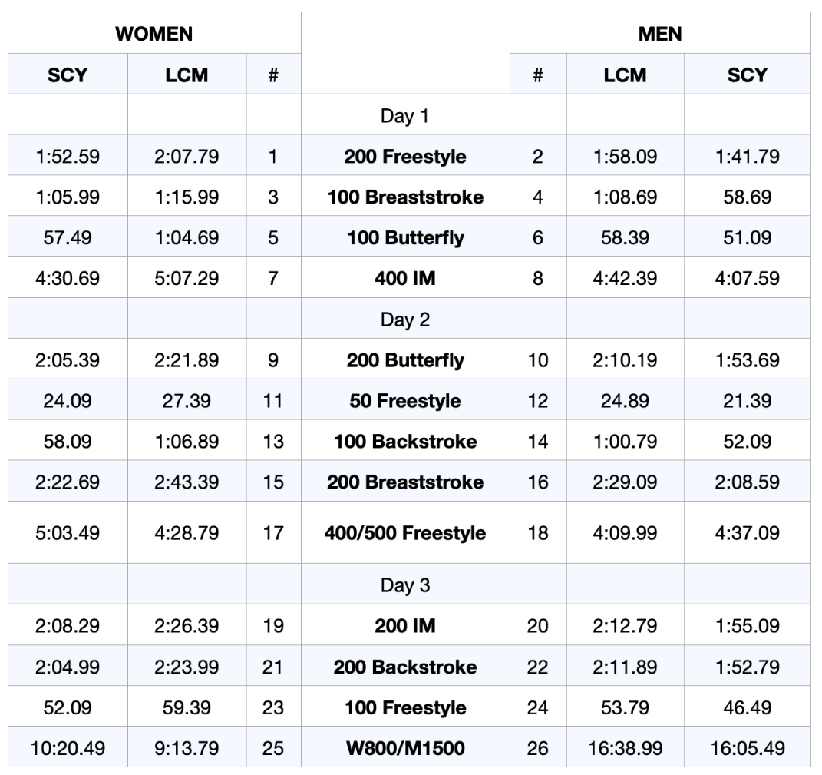

*Swimmers may qualify for the distance freestyle events with any of the 1650y, 1500m, 1000y, or 800m qualifying standards.

2022 Atlanta Classic
May 13-15, 2022

Team Name Team abbreviation _____

Team Address

City State Zip

Head Coach

Phone Home E-mail

For entry problems call or e-mail

All coaches from your team present at the meet, must be listed

- Coach 2. Coach

- Coach 4. Coach

Athlete Fee | $12.50 x (number of athletes) | =_________
Time Trial | $20.00 / Event
Facility Surcharge | $25.00 / Athlete
Non-Ga LSC registered athletes | $2.00 x (number of athletes) | =_________
TOTAL |  | =_________

Submit one check payable to: SwimAtlanta
Entries must be received on or before April 20, 2022.
Mail payment to: Megan Davis
5059 Post Road Cumming, GA 30040

WAIVER, ACKNOWLEDGMENT AND LIABILITY RELEASE
I, the undersigned coach, or team representative, verify that all swimmers and coaches listed on the enclosed entry are registered with USA Swimming.
I acknowledge that I am familiar with the safety rules of USA Swimming and Georgia Swimming regarding warm-up procedures and that I shall be responsible for the compliance of my swimmers with those rules during this meet.
In granting this sanction it is understood and agreed that USA Swimming, Georgia LCS, and SwimAtlanta shall be free and harmless from any liabilities or claims for damages arising by reason of injuries to anyone during the conduct of the event.

I have reviewed RULE 302.4 FALSE REGISTRATION and understand that if a swimmer who is not properly registered with USA Swimming competes in a sanctioned competition, Georgia Swimming Inc. may impose a fine of up to $100.00 per event against the individual, member coach or member club submitting the entry.

Signature/Title Date
COVID 19:
An inherent risk of exposure to COVID-19 exists in any public place where people are present. COVID-19 is an extremely contagious disease that can lead to severe illness and death. According to the Centers for Disease Control and Prevention, senior citizens and individuals with underlying medical conditions are especially vulnerable.

USA Swimming, Inc., cannot prevent you (or your child(ren)) from becoming exposed to, contracting, or spreading COVID-19 while participating in USA Swimming sanctioned events. It is not possible to prevent against the presence of the disease. Therefore, if you choose to participate in a USA Swimming sanctioned event, you may be exposing yourself to and/or increasing your risk of contracting or spreading COVID-19.

BY ATTENDING OR PARTICIPATING IN THIS COMPETITION, YOU VOLUNTARILY ASSUME ALL RISKS ASSOCIATED WITH EXPOSURE TO COVID-19 AND FOREVER RELEASE AND HOLD HARMLESS USA SWIMMING AND [THE LSC] AND EACH OF THEIR OFFICERS, DIRECTORS, AGENTS, EMPLOYEES OR OTHER REPRESENTATIVES FROM ANY LIABILITY OR CLAIMS INCLUDING FOR PERSONAL INJURIES, DEATH, DISEASE OR PROPERTY LOSSES, OR ANY OTHER LOSS, INCLUDING BUT NOT LIMITED TO CLAIMS OF NEGLIGENCE AND GIVE UP ANY CLAIMS YOU MAY HAVE TO SEEK DAMAGES, WHETHER KNOWN OR UNKNOWN, FORESEEN OR UNFORESEEN, IN CONNECTION WITH EXPOSURE, INFECTION, AND/OR SPREAD OF COVID-19 RELATED TO PARTICIPATION IN THIS COMPETITION.

