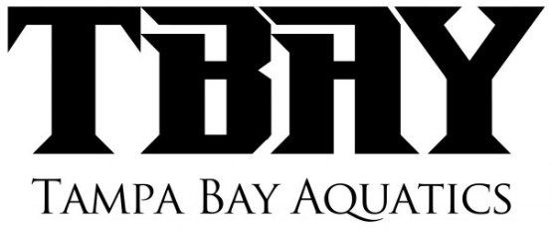
TEAM RECOMMENDED TRAINING GEAR
(Please make sure all equipment has name on it)
TBAY is not responsible for lost or stolen equipment!
NATIONAL GROUP/NATIONAL DEVELOPMENT/SENIOR 1
- TBAY Swim Cap – Wear at all Swim Meets, and at practice!(See Coach Dave for caps)

The following equipment can be found at our Preferred Vendor: All American Swim supply (click on the Logo from our Homepage to visit our TBAY portal. A portion of each purchase is returned back to the program!

http://www.allamericanswim.com/team_store.php?team_id=TBA23&Enter_Team_Store=Enter%20Team%20Store&status=1&sort=products_sort_order&page=2

- Fins – Arena Tech Pro Fins(Check size, they stretch and run big)

- Hand Paddles – TYR Catalyst, Finis

In addition to regular Hand paddles
Freestyle paddles (working on EVF) - http://www.swimoutlet.com/product_p/7616.htm

Finger paddles (Great for IM’ers and Breastrokers) –
http://www.swimoutlet.com/product_p/3968.htm

- Kickboard – Pull/Kick
- Pull Buoy – Pull/Kick
- Swimmer Snorkel – Arena or finis
- Mesh Bag – TBAY Mesh bag
- Finis Tempo Trainer
- Swim Parachute - (16”)

- Drag Socks - http://aquavolo.bigcartel.com/product/dragsox

