

**USA SWIMMING SAFE SPORT**

**REPORTING FORM**

__________________________________________________________________________________________________________

**Reporting**

USA Swimming requires reporting of sexual misconduct by any member and strongly encourages reporting of any

concerns relating to safe sport. USA Swimming appreciates your willingness to report inappropriate behavior. By

submitting this form, you are giving permission to USA Swimming's Safe Sport Program staff to contact you.

Out of respect for the importance of this issue and to encourage honest and effective reporting, knowingly making a

false or vindictive report will not be tolerated and may be a violation of USA Swimming's Code of Conduct.

__________________________________________________________________________________________________________

**Person Being Reported**

***Provide as much information as possible about the person you are reporting.***

First name

**\***



Last name

**\***



Age or Approximate Age

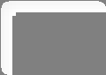

Gender

Club Affiliation (

*or None*

)

**\***



Position(s) this individual holds or

held

**\***



__________________________________________________________________________________________________________

**Alleged Offense Information**

***Provide as much specific information as you are able.***

Type of Offense (

*select all that*

*apply*

)

**\***



Location that the incident(s) took

place.

Enter Unknown or city,

state, specific location, etc

**\***



Dates(s) of Alleged Offense



Female

⚪

Male

⚪

🛈

Head Coach

☐

Assistant Coach

☐

Athlete

☐

Official

☐

Other

☐

Physical Abuse

☐

Inappropriate Communication

☐

Sexual Abuse

☐

Inappropriate Touching

☐

Travel Policy Violation

☐

Other

☐

🛈

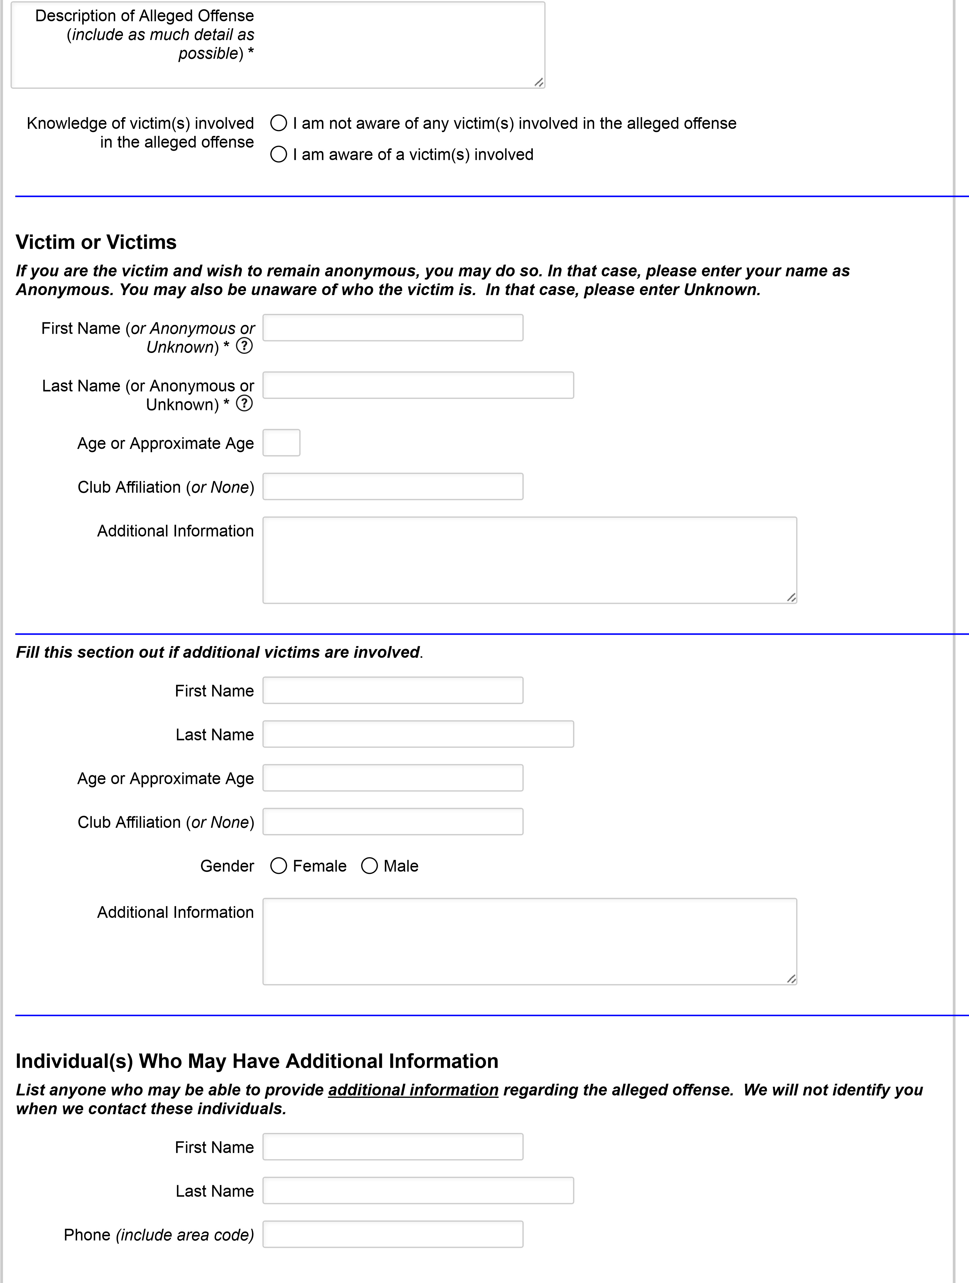

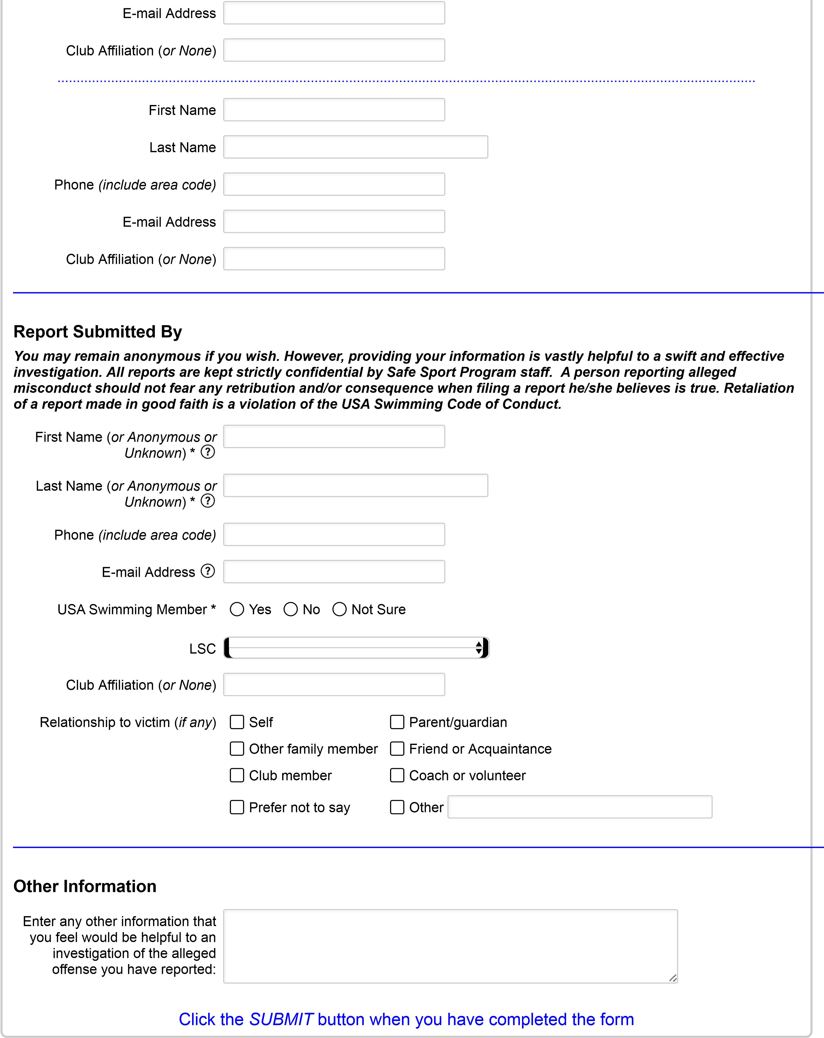

(Page 1 / 1)

Submit