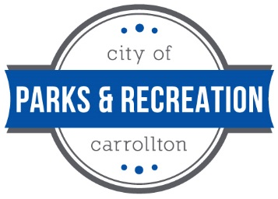
Carrollton Parks and Recreation Department

Waiver Form
ADM 70

Waiver/Release for the Carrollton Parks and Recreation Department:
The undersigned, assume all risks and hazards incidental to participation, including transportation to and from activities and do hereby, for myself, all dependent children, my heirs, executors, and administrator, waive, release, absolve, indemnify and agree to hold harmless the City of Carrollton, Carrollton Parks and Recreation Department (CPRD, and its representatives, sponsors, affiliated associations, organizers, officers, officials, and participants for any and all damages and/or injury suffered by myself or any child or other participant that I may register in connection with any activity with CPRD). Also, I agree that I and the person/persons registered for the programs will abide by all the rules, and policies outlined in the local, state, and national rules adopted as governing policies and rules by the Carrollton Parks and Recreation Department.
In consideration of being allowed to participate on behalf of the Carrollton Parks and Recreation Programs and related events and activities, the undersigned acknowledges, appreciates, and agrees that:
- Participation includes possible exposure to and illness from infectious diseases including but not limited to MRSA, Influenza, and Covid-19. While particular rules and personal discipline may reduce this risk, the risk of serious illness and death does exist, and,
- I knowingly and freely assume all such risks both known and unknown, even if arising from the negligence of the releases or others, and assume full responsibility for my participation; and,
- I willingly agree to comply with the stated and customary terms and conditions for participation as regards to protection against infectious diseases. If, however, I observe any unusual or significant hazard during my presence or participation, I will remove myself from participation and bring such to the attention of the nearest official immediately; and,
- I, for myself and on behalf of my heirs, assigns, personal representatives and next of kin, hereby release and hold harmless Carrollton Parks and Recreation Department their officers, officials, agents, and/or employees, other participants, sponsoring agencies, sponsors, advertisers, and if applicable, owners and lessors of premises used to conduct their events. With respect to any and all illness, disability, death, or loss or damage to person or property, whether arising from the negligence of releases or otherwise, to the fullest extent permitted by law.
I have reads this release of liability and assumption of risk agreement, fully understand its terms, understand I have given up substantial rights by signing it, and agreeing to it freely and voluntarily without any inducement.
Name of participant: __________________________________ Date signed: ____________________

Participant signature: __________________________________

