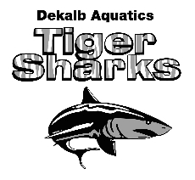
Long Course Schedule- March 2021 - August 2021

DATE | MEET | LOCATION | NOTES
March 29 - April 11 | DAQ Spring Break | No practice | n/a
May 14 - 16 | GOLD Invite | Cumming | n/a
June 18 - 20 | Chattahoochee GOLD Invite | Cumming | n/a
June 25 - 27 | Tommy Jackson Diversity Invite | C.T. Martin Aquatic Center | Gold & Below
July 9 - 11 | Dynamo End of Season Meet | R.A. Bussard Aquatic Center | n/a
July 15 - 18 | 14 & Under State Meet | Georgia Tech | 10 and older
July 23 - 25 | Senior State Meet | Athens | 15 & Older

