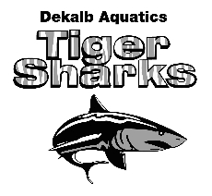
Long Course Schedule

April 2022 - August 2022

DATE | MEET | LOCATION | NOTES
March 28 – April 10 | DAQ Spring Break | No practice
April 24 | CWGA Waves LC Invite | Cumming
April 30 – May 1 | GA LC Invite | Georgia Tech Aquatics Center
May 13 - 15 | Chattahoochee GOLD Invite | Cumming
June 3-5 | Carol Tate Invite | Emory University | DAQ HOSTED; All swimmers should participate
June 23 - 26 | Bahamas National | Bahamas | TBD (pending COVID-19 situation)  Qualifiers Only
July 14-17 | GA 14 & Under  Age Group State | Georgia Tech | Qualifiers Only
July 22 - 24 | GA Senior State Meet | Georgia Tech | Qualifiers Only
DATES TBA | CAD End of Season Meet | C.T. Martin Aquatic Center
July 25 – August 14 | DAQ Summer Break | No practice

