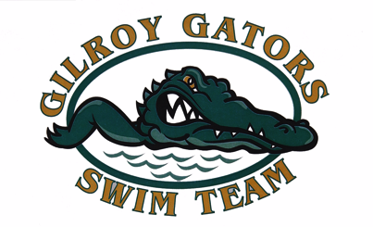
Advertising and Sponsorhip Information

The Gilroy Gators Swim Team (GGST) is a year round swimming organization affiliated with USA Swimming. In 1981 the team was incorporated as a non-profit corporation "to promote and encourage grade school and high school children to compete in swimming athletics…for their own athletic and educational advancement."

Please sponsor our team with a flat donation or by placing an advertisement with us. Your ad will appear in our hosted meet programs this year. Email your artwork to gilroygatorsswimteam@yahoo.com or send it to the address below. You may also call the Gator contact below for pick up. Make checks payable to GGST.

Flat Sponsorship Amount:____________ OR Advertisement Amount:_____________Check No.:________

Business / Sponsor Name:________________________________________________________________

Contact Name:____________________________________________Phone:_______________________

Address:___________________________________________ City, State, Zip_______________________

Email:________________________________________Website:_________________________________

_______Business card size ad………………………………….$75
_______Quarter page ad…………………………………….…..$125
_______Half page ad………………………………………….....$225
_______Full page ad……………………………………………..$350
_______Corporate Sponsor* (full page ad).……………………$550

* A Corporate Sponsorship includes: Full page ad in our meet programs, ads in our monthly newsletter, on our website and your 3x6 banner displayed at the Gilroy High School pool.

Gator Contact:_________________________________________________________________________

Phone:_____________________________Email:_____________________________________________

Swimmer’s Name(s): ________________________________________________Age(s):_______________

WE SWIM WITH PRIDE, WE WIN WITH HONOR, WE BUILD CHARACTER.
THANK YOU FOR SUPPORTING THE GILROY GATORS!

GGST, 777 First Street, PMB 183, Gilroy, CA 95020

