Georgia Swimming will increase opportunity, recognition, and growth in competitive swimming. We believe that swimming provides life-changing experiences for young people.

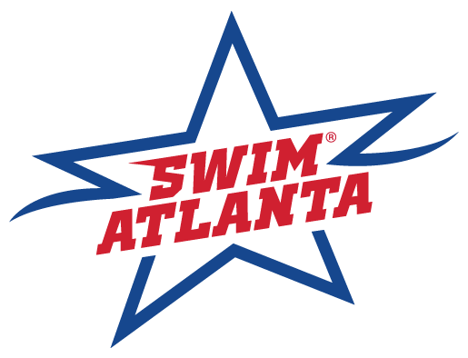 | Swim Atlanta - (SA)  Hereafter known as “Host Club.”  2023 Speedo Atlanta Classic  May 12-14, 2023
SANCTION:  ATTESTATION: | Held under the sanction of USA Swimming, issued by Georgia Swimming Inc.,  Sanction #: GA23-033/STT (Rev1)  - Article 202.4.3: Granted sanctions are non-transferrable to other organizations or clubs. Any such transferred sanction shall be void and the Sanction Committee shall deny any further sanctions to the organization or club violating this provision.  - In applying for this sanctioned event, the “Host Club” agrees to comply and to enforce all health and safety mandates and guidelines of USA Swimming, Georgia LSC, the State of Georgia, and local jurisdiction.
MAAPP:  Minor Athlete Abuse Prevention Policy | This meet will adhere to the current Minor Athlete Abuse Prevention Policy (“MAAPP) set forth by USA Swimming.  - A USA Swimming club that hosts a sanctioned USA Swimming swim meet indicates acknowledgement of USA Swimming’s Minor Athlete Abuse Prevention Policy (“MAAPP”).  - All USA Swimming members including athletes 18 and older and adults who interact with minor athletes at swim meets are expected to comply with the MAAPP policy.  - All chaperones, team managers, adult swimmers, meet directors, officials, and non-member parents and meet volunteers are expected to understand and comply with MAAPP.  - As the host club, you are responsible for ensuring that these individuals know about and comply with MAAPP.
ELIGIBILITY FOR TIME RECOGNITION TO THE SWIMS DATABASE | Effective September 1, 2022, there will no longer be a 30-day administrative grace period. Going forward, any 17-year-old athlete who has not completed the APT requirement by their 18th birthday will not be a USA Swimming member in good standing unless or until the APT requirement is completed.  This includes eligibility to compete in USA Swimming sanctioned meets, club practices and all other related.  activities Athletes will continue to receive an email notification reminder of the APT requirement 30 days prior.  to their 18th birthday as well as a reminder on their 18th birthday.  All USA Swimming members aged 18 years old and older are required to complete APT annually.  This is the individual’s responsibility and includes both athlete and non-athlete members.
LIABILITY: | In granting this sanction it is understood and agreed that USA Swimming, Inc., Georgia Swimming, Inc., and “Host Club,” shall be free and held harmless from any liabilities or claims for damages or illnesses arising by reason of injuries to anyone during the conduct of the event.
REPORT DISCRIMINATION:  D, E, & I = Reference / Informational Section | The Georgia LSC believes that there is no place for discrimination in the sport of swimming.  If you believe you are the victim of discrimination, you are encouraged to report the incident to USA-Swimming’s Associate: Michelle Steinfeld, msteinfeld@usaswimming.org. Please provide a complete description of the incident as well as a way to contact you and/or other parties involved.  For more information refer to gaswimming.org/diversity.  Starting on September 1, 2022, USA Swimming members can submit anonymously or on the record through plain text messaging at 888-270-SWIM (7946).  Georgia Swimming LSC: D, E, & I (teamunify.com)
MEET DIRECTOR: | Chris Davis Jr. chrisjr@swimatlanta.com & Wil Bayer wil@swimatlanta.com
MEET REFEREE: | Steve Potter spotter.usaswimming@gmail.com
ADMIN REFEREE: | Eric B. Pingel – epingel.usaswimming@gmail.com
STARTER: | Cami Stein
STROKE AND TURN: | Kathy Clark
ADMIN OFFICIAL: | Cheryl Loprinzo – Cheryl.loprinzo@comcast.net
FACILITY: | Georgia Tech - McAuley Aquatic Center  Campus Recreation Center  750 Ferst Drive  Atlanta, GA 30332  This facility seats 1,900 and contains both a competition pool and diving well. The competition pool is 50 meters by 10 lanes, with two movable bulkheads so that courses can be set up for 25 yards or 25 meters. The competition course has been certified in accordance with 104.2.2C(4). The copy of such certification is on file with USA Swimming & Georgia Swimming. The water depth of the pool is 9 1/2 feet at start end and 9 1/2 feet at turn end. (Measured from 3’ 3 1/2" (1.0 mtr) to 16'5" (5mtrs) from both end walls).
SCHEDULE: | - Thursday Warm Up: 4:30PM - 7:30PM (5 lanes)  - Friday, Saturday & Sunday Prelims: Warm-up 7:00AM-8:45AM; Competition: 9:00AM  - Friday, Saturday & Sunday Finals: Warm-up 4:30PM-5:45PM; Competition: 6:00PM
MEET FORMAT: | - LCM  - Slow to Fast  - Combined (P/F + TF)  - All events will be prelim/final with the exception of 800 and 1500 Free which will be Timed Finals.  - The top 40 will advance to finals. The heat order at finals will be D, C, B, and A.  - The D final will be restricted to 18 & Under swimmers.  - 10 Lanes used for competition.  - Diving well available for warmup/warm down
ENTRY FEES: | - IND. EVENT FEE: $20.00 / Event  - LATE IND. ENTRIES: $40.00 / Event  - TIME TRIALS: $30.00 / Event  - FACILITY SURCHARGE: $21.00  - GA LSC Travel Fund - $3.00/athlete  - GA travel fee applies to all non-Georgia LSC registered swimmers - $6.00/athlete
ELIGIBILITY: | MEET TYPE: (Open - Invitational)  Invitational to all 2023 swimmers registered with USA Swimming or their respective FINA Federation that are in good standing with their local national federation.  All foreign delegations must submit documentation from their federation indicating athletes, coaches, and team support are members in good standing of their FINA affiliated federation.  - Open to all 2023 swimmers registered with USA Swimming or their respective FINA Federation and who have achieved the published time standard for either short course yards, long course meters or short course meters in EACH event entered. Qualifying period is 24 months prior to the meet starts.  - SwimAtlanta will not allow unregistered swimmers, coaches, officials, or teams to participate in this meet. No swimmer will be permitted to compete unless the swimmer is a member in as provided in Article 302.  - The age of a swimmer on the first day of the respective meet shall determine the swimmer’s age for that meet
ENTRIES: | - This meet will not be pre-seeded.  - Swimmers may swim a maximum of (3) individual events per day. Deck entries can be made with the clerk of course up to 30 minutes before the start of the session.  - Any swimmer who has one or more qualifying standards may enter up to two (2) Bonus events.  - Sessions may be limited to 600 swimmers; however, the meet management reserves the right to determine the final number.  - Time Trial events will be included in daily individual event limit.
CHECK IN:  CLERK of COURSE: | - We ask all coaches and/or athletes to declare any scratches to the Clerk of Course before 6PM the day prior to Prelims on Thursday through Saturday to insure full heats and the best competition opportunities.  - Positive check-in is required for the 800 free and 1500 free. Check in closes at 10:00am  - Swimmers must sign up for Time Trial events with the Clerk of Course by:  10:00am - Friday, Saturday, and Sunday
ENTRY SUBMISSION: | ENTRY DEADLINE: Date: Monday, May 1, 2023 Time: 11:59pm  Submit one check payable to: Swim Atlanta  Entries must be received on or before: May 1, 2023  Email entries to: Cheryl Loprinzo – Cheryl.loprinzo@comcast.net  Submit entries using Hy-Tek team manager. Entries must include the USA Swimming Club Code and each swimmer’s USA Swimming number, first and last name, age, and seeding time for each event entered.
SCRATCH PROCEDURE / PENALTIES: | This meet will follow USA Swimming procedures specified in rule 207.11.6 except where exceptions are stated.  According to the scratch rule, a swimmer who is properly checked in for a positive check in event, been seeded, and fails to compete in said event, shall be barred from his/her next individual event unless excused by the Meet Referee. There is no penalty for failure to compete in pre-seeded preliminary heats of individual events except that an individual event from which a swimmer has not scratched prior to the appropriate deadline will be counted toward that swimmer’s events per day limit. There is no penalty for failure to compete in relay events.  A swimmer qualifying for a Final who neither scratches with the Administrative Referee nor declares his intent to scratch within 30 minutes after the announcement of qualifiers for that event is considered checked in. If a checked in swimmer fails to compete in Finals, that swimmer shall be barred from further competition unless excused by the Meet Referee. In order to field full Finals heats, it is requested that swimmers who qualify and have no intention of swimming in Finals indicate this by scratching.  Scratches and positive check-in for Day 1 events are due no later than 6:30 p.m. Thursday for Friday’s Preliminary events. Day 1 of the competition and may be submitted by email to Cheryl Loprinzo – Cheryl.loprinzo@comcast.net /  A scratch box will be located at the clerk of course desk which will close 30 minutes after the start of Finals.
TIME TRIAL: | - Time Trials may be conducted / combined at the discretion of the Meet Referee’s.  - Time Trials will be offered ONLY to Athletes entered in the meet.  - Events offered in Time Trials are ONLY those events offered within the meet.  - Time Trial – Distance – (400IM, 800 Free, 1500 Free) events will be ONLY on the day (s) the event is conducted.  - Athletes requesting Time Trials on the days the event are offered and prior to the check-in deadline will be assigned an Open Lane within an Open Heat during the Lowest Seeded Heats  - Time Trial events count towards the athlete’s daily limit. (3 per day)  - Time Trials will be planned for immediately after the completion of the morning sessions.
RULES: | Current USA Swimming Rules will govern this meet.  Tech Suit Restrictions for 12-and-Under Swimmers  (Note: WOVEN FABRIC-A suit with woven fabric and sewn seams that does not extend below the hips is permitted.)  (Note: KNIT FABRIC-A suit with knit fabric and sewn seams not extending below the knees is permitted.)  This rule is in effect for all USA Swimming competitions in the United States, so any manufacturer or vendor selling a suit in the United States is subject to the above rule. No Technical Suits may be worn by any 12-Under USA Swimming athlete member in competition at any Sanctioned, Approved or Observed meet.  Use of audio or visual recording devices, including a cell phone, is not permitted in changing areas, behind the blocks (Including warm-up, warm-down, and Competition), rest rooms or locker rooms.  Any swimmer entered in the meet, must be certified by a USA Swimming member-coach as being proficient in performing a racing start or must start each race from within the water. When unaccompanied by a member coach, it is the responsibility of the swimmer or the swimmer’s legal guardian to ensure compliance with this requirement.  Deck changes are prohibited. (Defined as changing, in whole or in part, into or out of a swimsuit when wearing just one suit in an area other than a permanent or temporary locker room, bathroom, changing room or other space designated for changing purposes). Swimmers participating in deck changing could be subject to removal from further competition in the meet.  On deck registrations will not be permitted during this event.  Operation of a drone, or any other flying apparatus, is prohibited over the venue (pools, athlete/coaches’ areas, spectator areas and open ceiling locker rooms) any time athletes, coaches, officials and /or spectators are present. Exceptions may be granted with prior written approval by the Program Operations Vice Chair, Program & Events Committee Chair, or designee.  All referees, starters, administrative officials, chief judges, and stroke and turn judges, serving in an official capacity in a sanctioned event, must be non-athlete members of USA Swimming or members of other FINA-member organizations. All meet directors for meets sanctioned by USA Swimming must be members of USA Swimming. Except for coaches accompanying athletes participating under the provisions of 202.9 or USA Swimming’s “open border” policy, all persons acting in any coaching capacity in a sanctioned event must be coach members of USA Swimming.  Photos and videos may be taken of swimmers during the meet by parents or a professional photographer retained by the host club. All participants agree to be filmed or photographed by photographers designated by the meet host and to allow the meet host the right to use names, pictures, likenesses, and biographical information before, during, or after the period of participation in Georgia Swimming competitions to promote swimming and meets hosted by the meet organizer. If you do not wish to have your child(ren) photographed, you may withdraw your consent by informing the Meet Director before the start of the first day of the meet.  Swimmers participating under the provisions of 202.9 or USA Swimming’s “open border” policy must be under the supervision of their own coach or a USA Swimming member coach. The Meet Director or Meet Referee may assist the swimmer in deciding for such supervision, but it is the swimmer’s responsibility to make such arrangements prior to the start of the meet.
USA SWIMMING MEMBER VERIFICATION: | September 22, Deck Pass and Deck Pass Plus are no longer available. To access USA Swimming member benefits, including your USA Swimming member card, download the USA Swimming app. Present this card to verify USA-S and GA LSC credentials valid
COACHES:  COACHES MEETING: | Coaches will be required to sign in at the Clerk of Course desk to verify their credentials, via SWIMS 3.0, are in good standing with USA-S and their respective LSC.  Define Coaches Meeting Friday, May 12 at 8:30am
OFFICIALS: | Swim Atlanta welcomes visiting officials and apprentices and will appreciate help in officiating this competition. There will be an official’s meeting 60 minutes prior to the start of each session. The official’s uniform will consist of a white polo collared shirt, navy blue shorts (prelims only), skirts or slacks with white socks and shoes. All officials must present at check in, their current LSC Officials Certification Card; OR a recently completed Apprentice Form; AND proof of current USA Swimming Non-Athlete membership. Credentials may be required for deck access and hospitality.  Officials or apprentices requesting certain positions may contact the Meet Referee as early as possible prior to the meet. Note that apprenticing as a Starter will not be allowed at this meet.  Note: This will be an OQM for N2 or N3 advancement or renewal for all positions. If interested in being evaluated, please complete the Application to work the meet:  - Starter Apprenticeship’s will not be offered at this meet.  - The application to officiate can be found:  https://www.esurveyspro.com/Survey.aspx?id=d68c52b8-7ffa-4e01-9ab2-38a84c10806f  - Applications for an assigned position must be received by Sunday, April 1, 2023. Deck officials are always welcome, simply fill-out the online application or please contact the Meet Referee – Steve Potter – spotter.usaswimming@yahoo.com
MEET COMMITTEE / MEET JURY: | The Meet Committee / Meet Jury shall be established during the coaching meeting or prior to the competition and shall consist of the Meet Director, Meet Referee, 2 Coaches, and 1 athlete member, as appropriate. As defined in the Official Glossary  (2023 USA Swimming Rulebook)
AWARDS: | NO awards will be given
SCORING: | NO team scores will be kept at this meet
CONCESSIONS: | Concessions will be located upstairs in the café.
GEORGIA WARM-UP POLICY: | The Georgia Swimming approved warm-up guidelines will be followed for this meet. Warm-up lane assignments will be posted at the pool. USA Swimming Certified Coaches must supervise in the vicinity of all warm-up activities.
GEORGIA SCRATCH RULE: | Georgia Swimming Scratch Rule
MISC. INFORMATION: | For more information, to review psych sheets, check results.  VISIT - www.swimatlanta.com

Friday, May 13
Session 1: Prelims Warm up 7:00 AM / Session Start 9:00 AM
WOMEN MEN
1 200 Freestyle 2
3 100 Breaststroke 4
5 100 Butterfly 6
7 400 Individual Medley 8

Session 2: Finals Warm up 4:30 PM / Session Start 6:00 PM
WOMEN MEN
1 200 Freestyle 2
3 100 Breaststroke 4
5 100 Butterfly 6
7 400 Individual Medley 8

Saturday, May 14
Session 3: Prelims Warm up 7:00 AM / Session Start 9:00 AM
WOMEN MEN
9 200 Butterfly 10
11 50 Freestyle 12
13 100 Backstroke 14
15 200 Breaststroke 16
17 400 Freestyle 18

Session 4: Finals Warm up 4:30 PM / Session Start 6:00 PM
WOMEN MEN
9 200 Butterfly 10
11 50 Freestyle 12
13 100 Backstroke 14
15 200 Breaststroke 16
17 400 Freestyle 18

Sunday, May 15
Session 5: Timed Finals Warm up 7:00 AM / Session Start 9:00 AM
WOMEN MEN
19 200 Individual Medley 20
21 200 Backstroke 22
23 100 Freestyle 24
5-minute break
25 800 Freestyle 26
27 1500 Freestyle 28
* - Positive Check In required, deck seeded event.

Sunday, May 15
Session 6: Finals - Warm up 4:30 PM / Session Start 6:00 PM
WOMEN MEN
19 200 Individual Medley 20
21 200 Backstroke 22
23 100 Freestyle 24

Qualifying Standards
2023 Speedo Atlanta Classic
May 12-14, 2023
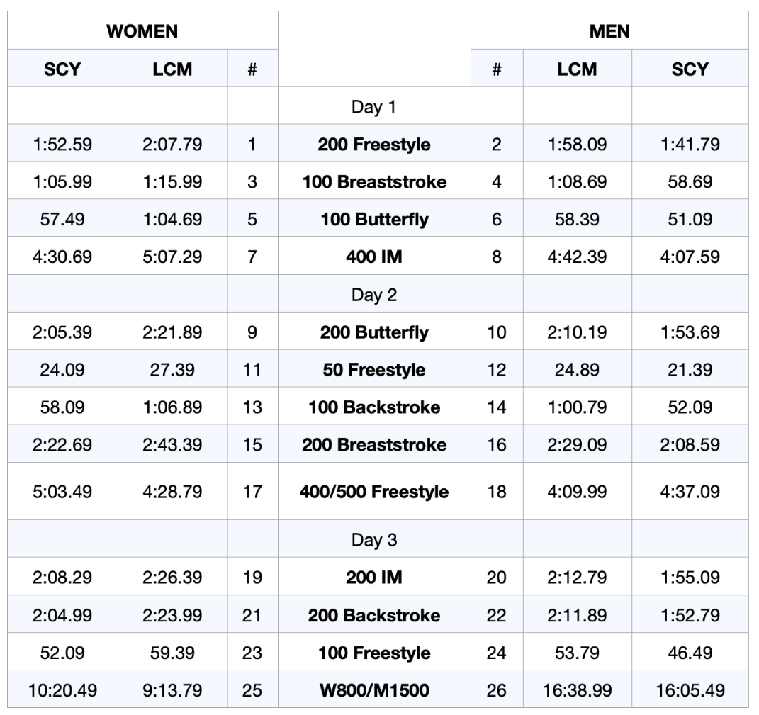

*Swimmers may qualify for the distance freestyle events with any of the 1650y, 1500m, 1000y, or 800m qualifying standards.

2023 Speedo Atlanta Classic
May 12-14, 2023

Team Name Team abbreviation

Team Address

City State Zip

Head Coach

Head Coach E-mail Head Coach Cell

All coaches from your team must be listed and have valid USA Swimming credentials.

1st Coach 2nd Coach

3rd Coach 4th Coach

Individual Event | $20.00 x per event | =_________
Time Trial Events | $30.00 x per event | =_________
Facility Charge | $21.00 | =_________
GA LSC Travel Fund | $3.00 x (number of athletes) | =_________
I’m Non-GA LSC registered athletes | $6.00 x (number of athletes) | =_________
 | TOTAL | =_________

Submit one check payable to: Swim Atlanta
Entries must be received on or before May 1, 2023
Email entries to: Cheryl Loprinzo – Cheryl.loprinzo@comcast.net

WAIVER, ACKNOWLEDGMENT AND LIABILITY RELEASE:
I, the undersigned coach, or team representative, verify that all swimmers and coaches listed on the enclosed entry are registered with USA Swimming.
I acknowledge that I am familiar with the safety rules of USA Swimming and Georgia Swimming regarding warm-up procedures and that I shall be responsible for the compliance of my swimmers with those rules during this meet.

I have reviewed RULE 302.4 FALSE REGISTRATION and understand that if a swimmer who is not properly registered with USA Swimming competes in a sanctioned competition, Georgia Swimming Inc. may impose a fine of up to $100.00 per event against the individual, member coach or member club submitting the entry.

Signature/Title Date

COVID 19:
An inherent risk of exposure to COVID-19 exists in any public place where people are present. COVID-19 is an extremely contagious disease that can lead to severe illness and death. According to the Centers for Disease Control and Prevention, senior citizens and individuals with underlying medical conditions are especially vulnerable. USA Swimming, Inc., cannot prevent you (or your child(ren)) from becoming exposed to, contracting, or spreading COVID-19 while participating in USA Swimming sanctioned events. It is not possible to prevent against the presence of the disease. Therefore, if you choose to participate in a USA Swimming sanctioned event, you may be exposing yourself to and/or increasing your risk of contracting or spreading COVID-19.
BY ATTENDING OR PARTICIPATING IN THIS COMPETITION, YOU VOLUNTARILY ASSUME ALL RISKS ASSOCIATED WITH EXPOSURE TO COVID-19 AND FOREVER RELEASE AND HOLD HARMLESS USA SWIMMING AND [THE LSC] AND EACH OF THEIR OFFICERS, DIRECTORS, AGENTS, EMPLOYEES OR OTHER REPRESENTATIVES FROM ANY LIABILITY OR CLAIMS INCLUDING FOR PERSONAL INJURIES, DEATH, DISEASE OR PROPERTY LOSSES, OR ANY OTHER LOSS, INCLUDING BUT NOT LIMITED TO CLAIMS OF NEGLIGENCE AND GIVE UP ANY CLAIMS YOU MAY HAVE TO SEEK DAMAGES, WHETHER KNOWN OR UNKNOWN, FORESEEN OR UNFORESEEN, IN CONNECTION THEREWITH.
This statement shall also be included in heat sheets.

