BLAST – OnDeck Parent App Installation Instructions
- Go to Google Play Store OR Apple App Store and search for “OnDeck Parent”.
You may see an App called “OnDeck”, this is for Coaches, please use OnDeck
Parent as shown to the right.

- Download the free application and open it on your mobile device.

- Username and Password are what you use to log into the BLAST website.
Team Alias (case-sensitive): gubast

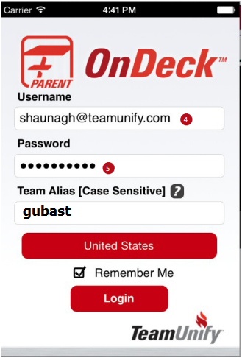
Please see reverse side for OnDeck Parent FAQs

