SAFE SPORT FOR PARENTS ONLINE COURSE
Parent’s Guide to Misconduct in Sport

SIGN IN to your USAS account
CLICK ON Education at the top right of the page, then CLICK ON Course Catalog
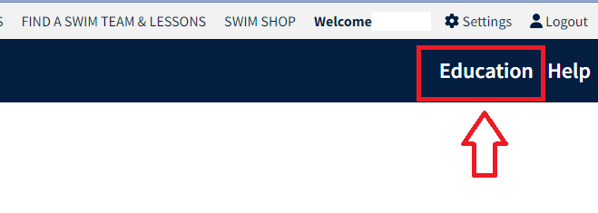
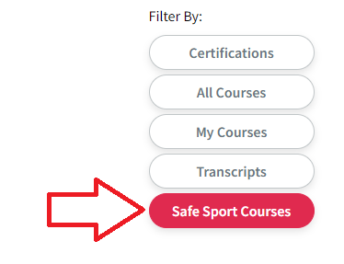
CLICK ON Safe Sport Courses

CHOOSE Parents Guide to Misconduct in Sport, then CLICK ON GO TO COURSE
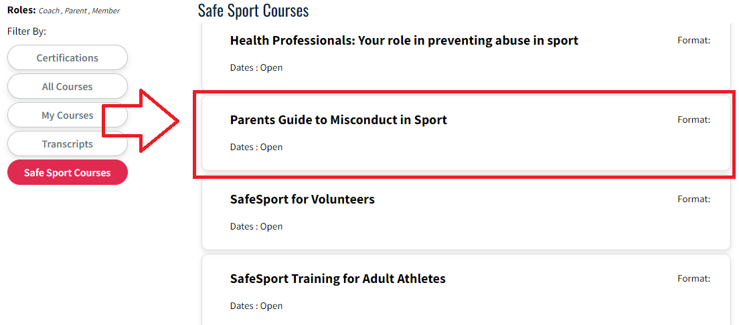
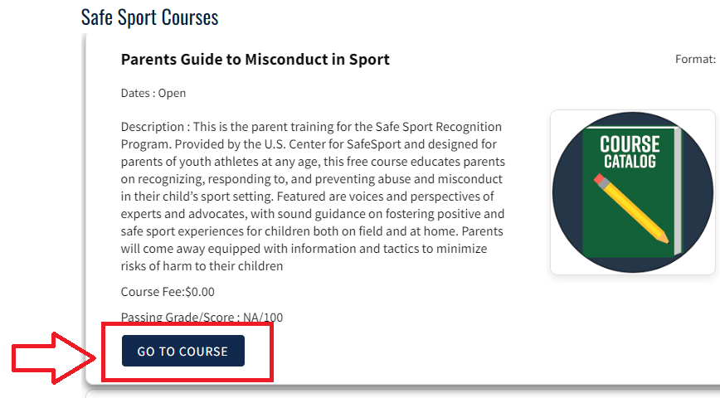

If the system doesn’t take you directly to the course, CLICK ON My Courses, CLICK ON THE Parents Guide to Misconduct in Sports again, and then GO TO COURSE again. Sometimes you need to do this a few times before the system will take you to the course.
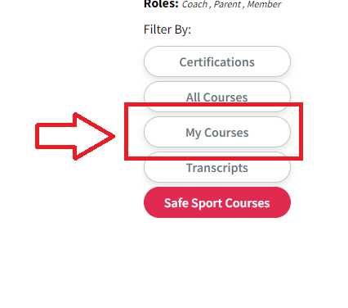

The course landing page looks like this. Proceed through the course by clicking the arrow at the bottom right of the screen.
