Parent and Swimmer Homework for this Week
This picture is what I am wanting parents to place on their swimmers. but with the Event, Heat, and Lane that I specify for each group. This is made so both parents and swimmers learn how to mark their event, heat and lane to keep track of the races they are swimming. If the swimmers come to practice this week with it on, they will be able to choose a prize from our treasure box.
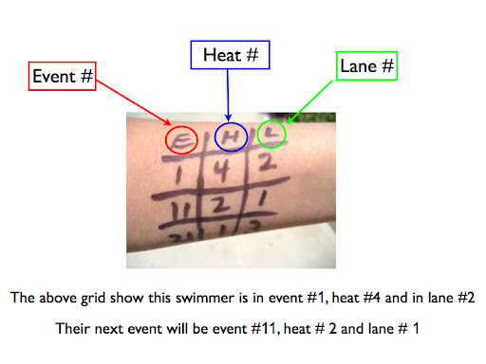
Below is an example of the heat sheet with labels of Event, Heat and Lane.
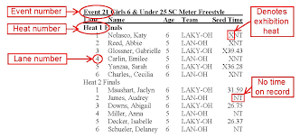

Please use this heat sheet to write your event, heat and lane with the heat sheet below. It is an instructional assignment to see if parents understand how to mark their swimmer for meets.
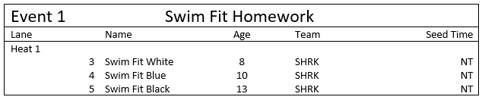
Sincerely,
Coach Stephanie

