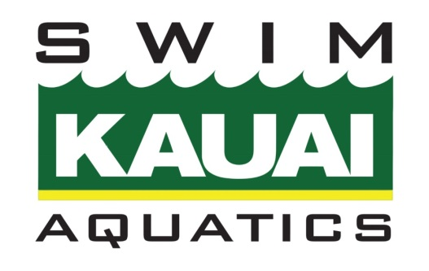

Electronic Communication Policy

SKA recognizes the prevalence and value of electronic communication (email, text, chat, social media, etc.) in our society as well as their potential risks.
All electronic communication between team members (swimmers, coaches, parents, board members) should be respectful. Inappropriate language or messages shared via public communications (Remind, Email, Facebook, Chat, SMS, etc.) will be removed.
For electronic communications between a coach or other adult related to SKA and a swimmer, ALL the following must be met:
● Communication must be professional and solely for the purpose of communicating swim-related information.
● Communication SHALL NOT include content related to: drug or alcohol use; sexually explicit language, activity, or photos/videos; family/relationship issues; personal problems; or the adult personal social activities.
● Electronic communication must include another adult (assistant coach, parent) as a co-recipient of the email or text.
● Communication must occur between the hours of 8am-8pm.
Parent(s)/Guardian(s) may request in writing or via email that their child not be contacted by coaches through any form of electronic communication.
Coaches are not permitted to “friend” or “follow” swimmers via their personal profiles/accounts on social media or other messaging apps (Facebook, Instagram, Snapchat, etc.). Likewise, swimmers are not permitted to “friend” or “follow” a coach’s personal profile. Adult team members (parents, board members, coaches) may “friend” or “follow” a coach’s personal social media profile/account.

