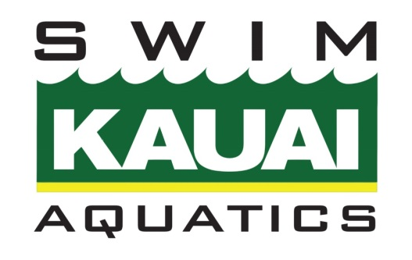

LOCKER ROOM MONITORING POLICY

PURPOSE

The following guidelines are designed to maintain personal privacy as well as to reduce the risk of misconduct in locker rooms and changing areas.

FACILITIES

The following is a description of our practice and competition facilities to allow athletes and their families to plan their use:

We practice at YMCA Kauai Pool located in Puhi.
This location has restrooms connected with locker rooms available for both swim team and YMCA patrons. Swim team changing area is shared with the general public. As such, there are likely to be people who are not associated with SKA in the changing area around the time of practice.

MONITORING

General Policy Considerations
Coaches and staff make every effort to recognize when an athlete goes to the locker room or changing area during practice and competition and, if they do not return in a timely fashion, we will check on the athlete’s whereabouts and will notify the parent(s) or primary contact if we cannot locate the athlete.

Only same-sex genders are allowed in each gender bathroom/locker room. If an athlete needs assistance with his or her uniform or gear (for example, a child under the age of eight), or an athlete’s disability warrants assistance, then we ask that parents let the coach or an administrator know beforehand that he or she will be helping the athlete.

SKA has staggered practices, with different groups arriving and departing throughout the day. We share facilities with all YMCA members. It is therefore not practical to constantly monitor locker rooms and changing areas over this extended course of time. While we do not post [staff, coach, parent, other adult] inside or at the doors of the locker rooms and changing areas, we do make occasional sweeps of these areas. [Staff, coach, parent, other adult] conduct these sweeps, with women checking on female locker rooms, and men checking on male locker rooms.

USE OF CELL PHONES AND OTHER MOBILE RECORDING DEVICES
Cell phones and other mobile devices with recording capabilities, including voice recording, still cameras and video cameras increase the risk for different forms of misconduct in locker rooms and changing areas. The USA Swimming Athlete Protection Policies prohibit the use of such
devices in the locker room or other changing area:

305.3 Use of audio or visual recording devices, including a cell phone camera, is not allowed in changing areas, rest rooms or locker rooms.

