This document is designed to walk a brand new official candidate through the process of becoming a Hawaiian Swimming Official.
Benefits of Becoming a Hawaiian Swimming Official
- Help support an excellent sport for children and promote a healthy lifestyle for children.
- Gain a more thorough understanding of swimming in particular, and sports in general.
- Fulfill volunteer obligations at club meets.
- Get closer to the action; know what’s happening on deck with the “best seat” in the pool.
- Get mentally and physically engaged during the meet rather than merely “spectating.”
- Making new friends.
- Great hospitality food.
Once you have decided you want to become a Stroke and Turn Judge, Timing Judge, or an Administrative Official, the following steps will help get you there.
Step 1: Background Check
As part of the USA Swimming Safe Sport Program, all officials and trainees are required to undertake a criminal background check. You need to have this completed before we can process your certification once all required training sessions are complete.
For more information on the reason for the background check and to submit your background check, please go to the USA Swimming website.
https://www.usaswimming.org/background-checks
The Level 2 background check will take about 15 minutes to submit your application online. Our LSC (Hawaiian Swimming) will reimburse you for the cost of the background check. You will receive an e‐mail confirmation upon completion of the application and when the results are available (may take up to 2 weeks). Do not send these results to the Hawaiian Swimming. They will receive notification directly from Sterling Infosystems within 7-10 days of the completed check. Be aware, in the months of November and December, results may take longer as at the end of the year is when everyone’s BGC expires.
Background checks must be renewed every 24 months. If you do not renew your background check within 30 days of its expiration, you will need to complete the new member background check.
To submit a reimbursement form for your paid Background check, go here for the reimbursement form:
https://www.teamunify.com/hslsc/UserFiles/File/Payment-Reimbursement%20Request%20Form%20%20rev_04-2017.pdf
You must fill this out and include a printed receipt of your payment you received via email from Sterling Infosystems.
Step 2: USA Swimming Non‐Athlete Memberships
Next, you must become a member of USA Swimming. Fill out the apprentice application registration available here and send it to the address on the form:
https://www.teamunify.com/hslsc/UserFiles/File/Documents/Reg/2018/2018%20Application%20-%20Apprentice%20Official-s.pdf
Note: this is good for only 60 days. After the 60 days or immediately after you have completed your required training sessions, you must have your Non-Athlete registration form turned in to the Hawaiian Swimming registrar. Fill out the registration form and return it to your club registrar. You can find the Non-Athlete form here:
https://www.teamunify.com/hslsc/UserFiles/File/Documents/Reg/2018/2018%20Application%20-%20Non-athlete_rev-s.pdf
Step 3: Complete your Athlete Protection Training
Once you are set up in the USA Swimming Database (assume two weeks from the date you send in Step 2), you will need to take the USA Swimming Athlete Protection Course for Coaches and Non‐Athlete Members. This is a one‐hour online tutorial which can be taken before or after your training sessions, but cannot be taken until you are registered with USA Swimming. The training and an explanation regarding why USA Swimming is offering this training can be found at:
https://www.usaswimming.org/utility/landing-pages/safe-sport/apt
Fill in your name and birth date, select Locate. If you are registered with USA Swimming, you will receive a response to your request, and you will simply select your name from the list. If you are not in the list, please wait a few more days and try again. If you fail a second time, please contact Gwenn Tomiyoshi, Hawaiian Swimming Registrar, to check on your registration from Step 2. (Remember to wait two weeks from the date you sent this in.)
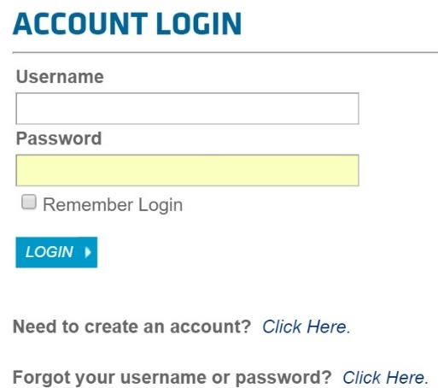
Step 4: Create a USA Swimming Account
Once you have completed the Athlete Protection course, you create an online account with USA Swimming that will link to your registration records. This account will be used to track all of your activities with Hawaiian Swimming and USA Swimming in the Officials Tracking System (OTS). It will track meets you have attended, tests you have taken, evaluations you have completed and educational and mentoring events. To begin, on top right of USASwimming.org, click sign in.
Step 5a: Online Test
In addition to on deck training sessions, you will need to take an online open book certification test. You can access the online rulebook by going here: https://www.usaswimming.org/rulebook
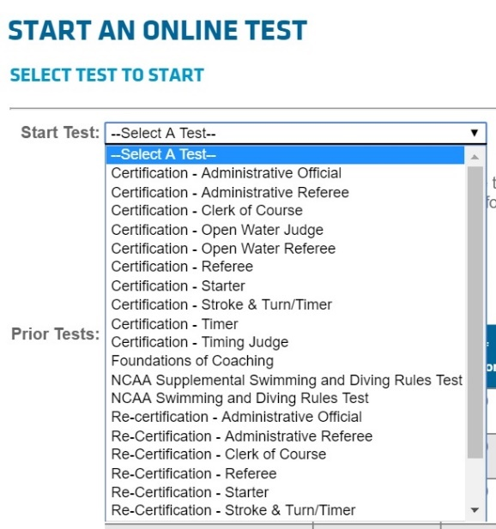
The test is designed to help you understand the rules, and know where they are located in the rulebook. It will take about 100 minutes to complete. You will need to take either the Certification ‐‐ Stroke and Turn/Timer test or the Certification – Administrative Official test. It is recommended that the test be taken prior to or in close proximity to your first or second training session. You will need to complete Step 4 before taking the test.
The test(s) can be found at:
https://www.usaswimming.org/utility/landing-pages/officials/officials-online-testing
Click choose to start a test.

Step 5b: On Deck Training
You will need to be mentored on deck during swim events. The requirements are below:
POSITION | # TRAINING SESSIONS | MIN # OF MEETS | MIN # OF TRAINERS
Stroke & Turn | 4 | 2 | 2
Timing Judge | 3 | 2 | 2
Administrative Official | 4 | 3 | 2

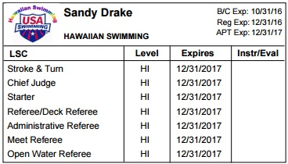
Before you end your on-deck training, you must have completed your background check, USA Swimming registration, and Athlete Protection Course. To document that you have completed these, please print your Certification Card from the USA Swimming Officials Tracking System. Notice on the upper right shows the required BGC, APT, and REG completed.

To ensure that the meet will be staffed appropriately to train you, it is highly recommended that each trainee contact the Meet Referee, one to two weeks in advance of a meet to let her know your training needs and the sessions you will attend. The name of the meet referee may be found on the meet information or ask your club coach.
This is an important pre‐meet contact. There have been cases where officials show up expecting to be trained and the deck is already oversubscribed with trainees, or qualified trainers are not available. Once accepted for training, please be on deck in appropriate attire one hour before the meet starts. Find the Meet Referee and introduce yourself. Find the sign‐in sheet and sign in for the meet, stating you want to be trained. Attend the officials meeting for your assignment and trainer.

Step 6: Certification
When you have completed all of the steps above:
- Background Check
- USA Swimming Registration
- Athlete Protection Course
- USA Swimming Certification Test
- On Deck Training Sessions
Please let your island’s referee know you have completed all the requirements. They should then let the Official’s Chair, Sandy Drake, know you are ready to be certified. Sandy will go into the OTS and give you your certification. You will then receive an email from USA Swimming stating your certification.

Step 7: Credentials

Once you are certified, please print out your Certification Card from OTS and carry it with you when on deck. This card shows your level of certification (or training) within Hawaiian Swimming and any certifications at the USA Swimming level. It also shows the expiration date of your background check, annual USA Swimming registration and status of your Athlete Protection Training. Meet Referees may ask you to show this credential when you first sign in to work a meet.

Step 8: Uniform

Once you have completed all of the above, you will now be expected to wear a specific uniform. For our meets, we require a white polo type shirt, khaki shorts, skort, skirt, or long pants, and white shoes and socks. Often at our championship meets, there will be a session or two where we will wear an Aloha style shirt.

WELCOME TO OUR HAWAIIAN SWIMMING OFFICIAL’S OHANA!!!!

