CONSENT FOR
DUAL RELATIONSHIP ONE-ON-ONE INTERACTIONS ON SPECIFIC DATES
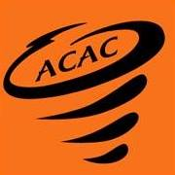

I, , as the parent/legal guardian of , a minor athlete, am advising ACAC that the minor athlete has a dual relationship with , an Adult Participant. The dual relationship is as follows: .
I hereby authorize and consent that said Adult Participant can have in-program one-on-one interactions where consent is allowed with said minor athlete at ACAC for the following occasion:
Date | Event/Occasion Name | Location

Parent/Legal Guardian Name Printed:
Parent/Legal Guardian Signature:

Date:

