CONSENT FOR
DUAL RELATIONSHIP LOCKER ROOMS ON SPECIFIC DATES
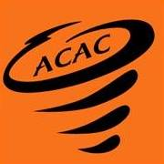

I, , as the parent/legal guardian of , a minor athlete, am advising ACAC that the minor athlete has a dual relationship with , an Adult Participant. The dual relationship is as follows: .
I hereby authorize and consent that said Adult Participant can have one-on-one interactions with said minor athlete in the locker room during in-program sport activities related to ACAC for the occasions detailed below. I understand this consent does NOT allow said Adult Participant to shower with said minor athlete.
Date | Event/Occasion Name | Location

Parent/Legal Guardian Name Printed:
Parent/Legal Guardian Signature:

Date:

