ANNUAL CONSENT FOR
DUAL RELATIONSHIP LOCKER ROOMS
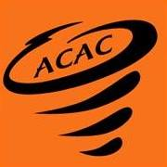

I, , as the parent/legal guardian of , a minor athlete, am advising ACAC that the minor athlete has a dual relationship with , an Adult Participant. The dual relationship is as follows: .
I hereby authorize and consent that said Adult Participant can have one-on-one interactions with said minor athlete in the locker room during in-program sport activities related to ACAC for one year from the date of this consent. I understand this consent does NOT allow said Adult Participant to shower with said minor athlete.
I am aware that I can withdraw consent at any time.

Parent/Legal Guardian Name Printed:
Parent/Legal Guardian Signature:

Date:

