CONSENT FOR
IN-PROGRAM LODGING: CLOSE-IN-AGE EXCEPTION ON SPECIFIC DATES
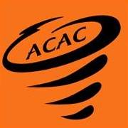

I, , as the parent/legal guardian of , a minor athlete, hereby authorize and consent to , an Adult Participant that is no more than four years older than said minor athlete; with NO authority over said minor athlete; TO share a hotel room or otherwise sleep in the same room with said minor athlete for in-program lodging arrangements related ACAC during the occasions detailed below.
Date | Event/Occasion Name | Location

I am aware that I can withdraw consent at any time.

Parent/Legal Guardian Name Printed:
Parent/Legal Guardian Signature:

Date:

