ANNUAL CONSENT FOR
INDIVIDUAL TRAINING SESSIONS
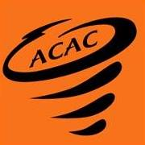

I, , as the parent/legal guardian of , a minor athlete, hereby authorize and consent for said minor athlete to receive individual training sessions from , an Adult Participant, for a time period of one year from the date of this consent.
I understand the following are the guidelines for Individual Training Sessions:
- All sessions must follow the One-on-One interactions policy as found in the Minor Athlete Abuse Prevention Policy.
- A parent/legal guardian can observe the session.
I can withdraw my consent for the individual training sessions at any time.

Parent/Legal Guardian Name Printed:
Parent/Legal Guardian Signature:

Date:

