CONSENT FOR
INDIVIDUAL TRAINING SESSIONS – TRAINING SESSION SPECIFIC
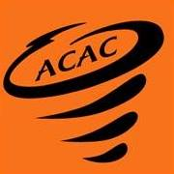

I, , as the parent/legal guardian of , a minor athlete, hereby authorize and consent for said minor athlete to receive individual training sessions from , an Adult Participant, as specified below.
I understand the following are the guidelines for Individual Training Sessions:
- All sessions must follow the One-on-One interactions policy as found in the Minor Athlete Abuse Prevention Policy.
- A parent/legal guardian can observe the session.
I can withdraw my consent for the individual training sessions at any time.
Location of Training Session | Frequency of Training Session  (e.g., weekly, monthly, etc.) | Time Period of Consent  (Not to exceed one year)

Parent/Legal Guardian Name Printed:
Parent/Legal Guardian Signature:

Date:

