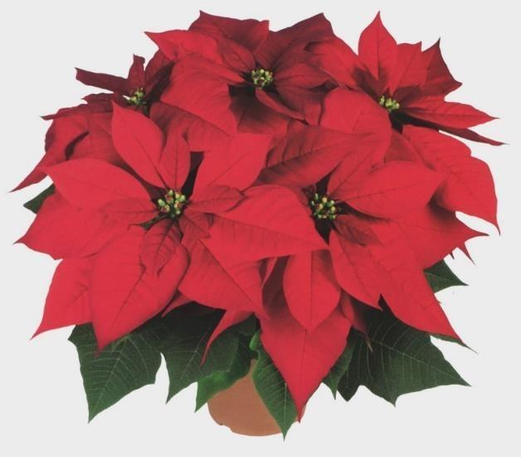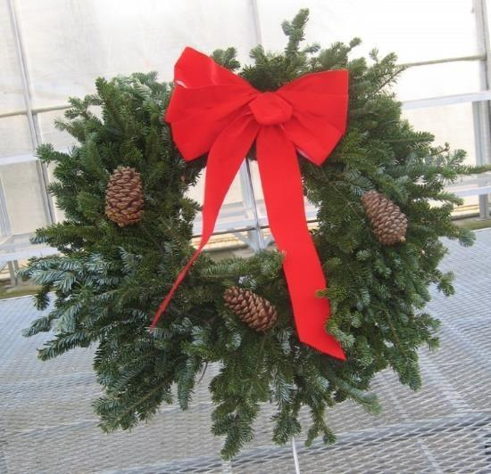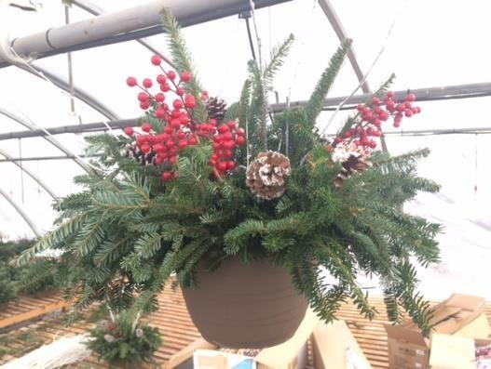
Team DASH has sold premium poinsettias and greenery for over 25 years. Our reputable greenhouse supplier continues to provide beautiful and amazing plants year after year. Red and white poinsettias come in foil-covered pots and paper sleeves. The wreaths come ready to hang and the basket is ready to sit on your porch or hang from a shepherd’s hook. Please email or call davisonk@nicc.edu (563) 564-6086 with any questions.
Each piece sold will give the seller a $3 credit towards their DASH account. Orders, with full payment, are Due on November 10th at the Hempstead Pool during practice. The delivery is scheduled for Sunday November 21st at Finnin Ford. Timing to be determined based on the Meet schedule. DASH families are responsible for distribution of their entire order. It is not recommended to have individuals pick up partial orders unless the ordering family is helping with distribution of their order.

Pot Size | Description | Average Width | Red | White | Family  Credit | Cost
6“ poinsettia | 5 or more flowers | 13” |  |  | $3 | $15
7“ poinsettia | 7-9 or more flowers | 18 “ |  |  | $3 | $20
9” poinsettia | 12 or more flowers | 27 “ |  |  | $3 | $40
12“ poinsettia | 20 or more flowers | 31 “ |  |  | $3 | $60
16“ Fancy mixed outdoor wreath | Fancy mixed greens, natural cones, red velvet bow |  |  | N/A | $3 | $25
24“ Fancy mixed outdoor wreath | Fancy mixed greens, natural cones, red velvet bow |  |  | N/A | $3 | $35
Evergreen hanging basket | Outdoor hanging basket, fir greens, winter decorations |  |  | N/A | $3 | $40

Swimmer Name__________________________ Ph________________________ ⬜ I wish to donate my credits to Dash
Name and Phone number | 6”  Red  $15 | 6”  White  $15 | 7”  Red  $20 | 7”  White  $20 | 9”  Red  $40 | 9”  White  $40 | 12”  Red  $60 | 12”  White  $60 | 16”  Wreath  $25 | 24”  Wreath  $35 | Hanging Basket  $40 | Total number  items | Total  $$$$$
Please Total all rows and columns

