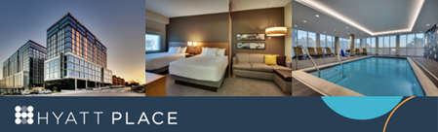

Hyatt Place Iowa City Downtown/University
Stay Dates: July 20-23rd, 2022
King Rooms w/sofa bed: $119/nt.
QQ Rooms: $139/nt.
Last day to make Reservations: June 27th, 2022
Reservation Booking Link: IASI Long Course Championships
Click above booking link > Click BOOK NOW > Enter dates within group block date range > Click BOOK NOW > Scroll down to view available room types within block rate to reserve.
Phone Reservations: call the Central Reservations Office at: 1-800-591-1234 and reference the IASI Long Course Championships or Group Code: G-GIST

Hyatt Place Iowa City Amenities:
- Located Downtown Iowa City near restaurants, Target and entertainment
- Roomy rooms feature comfy Cozy Corner sofa, spacious desk, mini fridge and HDTV
- Complimentary Daily Hot Breakfast Buffet
- Heated Indoor Pool overlooking Downtown Iowa City
- 24/7 Fitness Center
- Complimentary WI-FI Throughout Hotel
- World of Hyatt rewards program

Available for additional cost: Temperature-Controlled Underground Parking $9/nt. (1 vehicle per room, based on availability) City parking also available at $1 per hour (Court Street Ramp) or $7.50/day (Harrison Street Ramp), Meeting Rooms, Coffee to Cocktails Bar and Pet Friendly

