Sunday | Monday | Tuesday | Wednesday | Thursday | Friday | Saturday
 | 1 | 2 | 3 | 4 | 5 | 6
 | C: 6:00-7:30pm  S:7:00-9:00pm | A: 6:00-7:30 pm  S:7:00- 9:00 pm | C: 6:00-7:30pm  S:7:00-9:00pm | POOL CLOSED High School Swim Meet  GO DRAGONS! | POOL CLOSED High School Event  Midwest Challenge  U of I | POOL CLOSED High School Swim Meet  Midwest Challenge  Salute to Veterans  Wellmark YMCA
7 | 8 | 9 | 10 | 11 | 12 | 13
POOL CLOSED High School Event  Midwest Challenge  Salute to Veterans | C: 6:00-7:30pm  S:7:00-9:00pm | A: 6:00-7:30 pm  S:7:00- 9:00 pm | C: 6:00-7:30pm  S:7:00-9:00pm | A: 6:00-7:30 pm  S:7:00- 9:00 pm | C: 6:00-7:30pm  S:7:00-9:00pm | *B: 10-12 pm
14 | 15 | 16 | 17 | 18 | 19 | 20
Intro to Comp I 10-11:45 am  Swim Lessons 12-3:30 pm  Lap swim 10-12 pm Open Swim 3:30–6:30 pm | C: 6:00-7:30pm  S:7:00-9:00pm | A: 6:00-7:30 pm  S:7:00- 9:00 pm | C: 6:00-7:30pm  S:7:00-9:00pm | A: 6:00-7:30 pm  S:7:00- 9:00 pm | C: 6:00-7:30pm  S:7:00-9:00pm | *B: 10-12 pm
21 | 22 | 23 | 24 | 25 | 26 | 27
Intro to Comp I 10-11:45 am  Swim Lessons 12-3:30 pm  Lap swim 10-12 pm Open Swim 3:30–6:30 pm | C: 6:00-7:30pm  S:7:00-9:00pm | POOL CLOSED High School Swim Meet  GO DRAGONS! | Blaze Night 6:30-8:30 pm | POOL CLOSED  Thanksgiving | POOL CLOSED | POOL CLOSED
28 | 29 | 30
POOL CLOSED | C: 6:00-7:30pm  S:7:00-9:00pm | A: 6:00-7:30 pm  S:7:00- 9:00 pm | A=Age Group  C=Challenge  S= Select  Black font=All teams  *optional/subject to cancel due to meet | All practices except weekends need dryland clothes
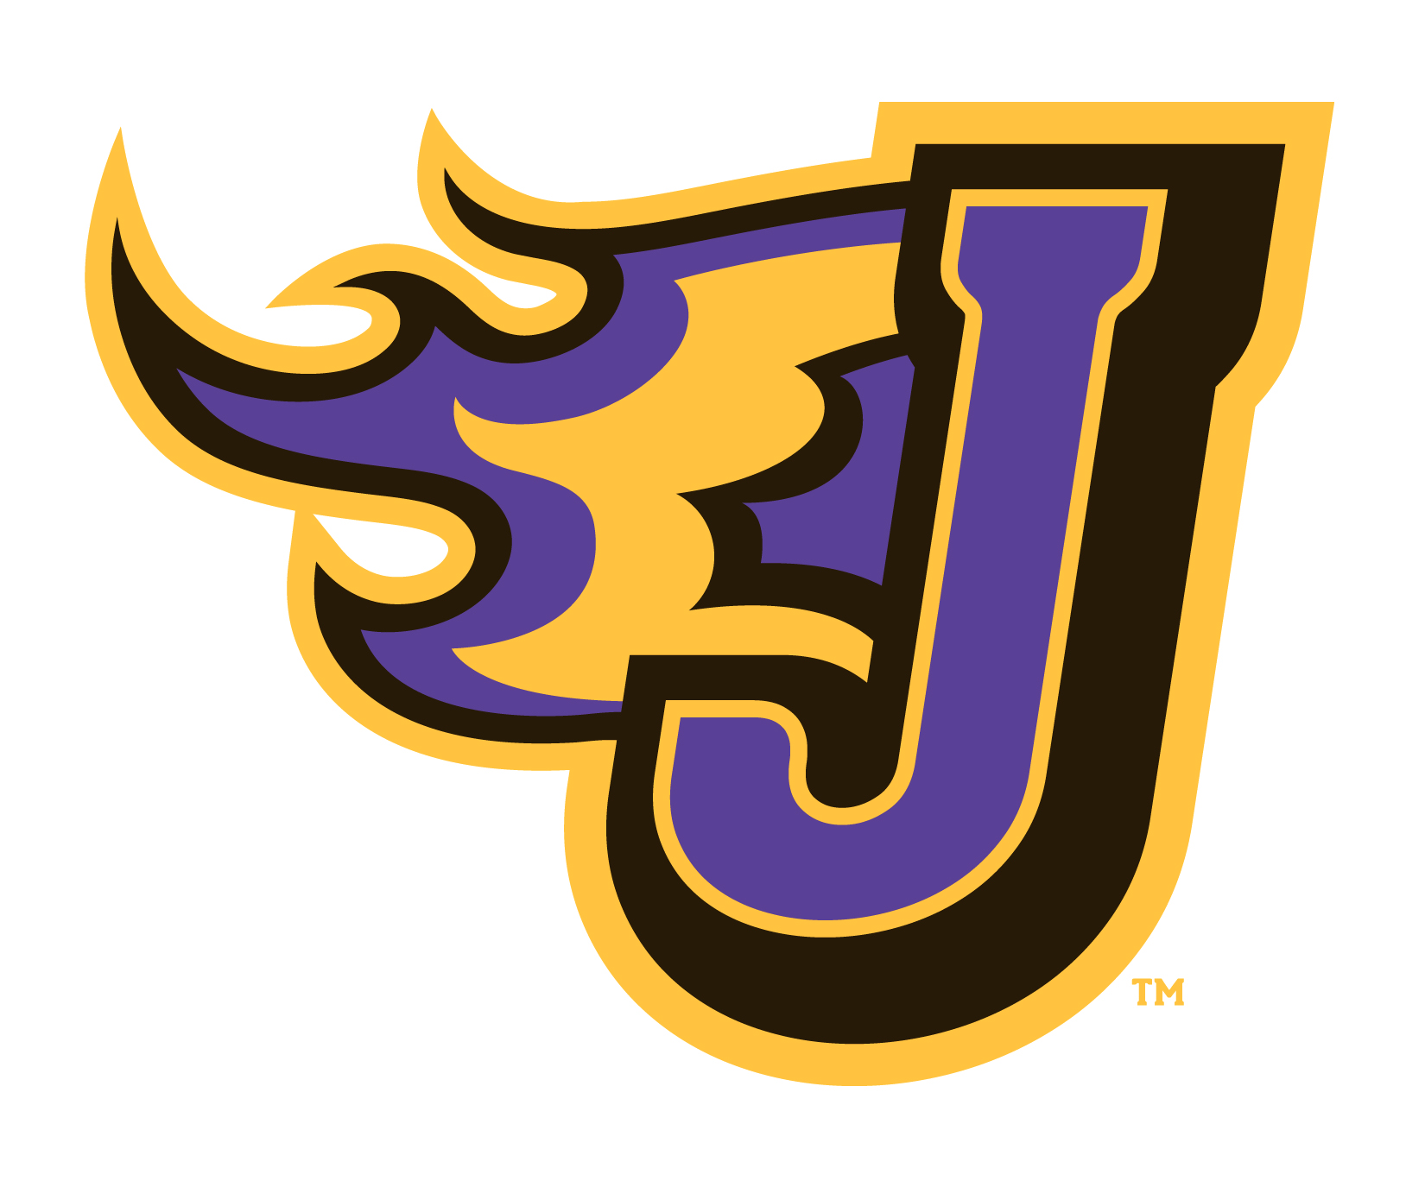
November 2021

BLAZE C A L E N D A R

