**Protocol for officiating a swimmer with a disability**

The coach notifies the Meet Committee/Meet Referee when a swimmer with a disability is entered into a meet and requests the necessary accommodations.

The Meet Referee communicates with the coach and makes any reasonable accommodation(s) for the swimmer.

The Meet Referee is responsible for communicating the swimmer’s events and accommodation(s) to assigned Officials before the meet.

Stroke and Turn Officials observe swims per established meet protocol. If you observe something in violation of the rules, raise your hand.

It is the responsibility of the CJ and/or the Deck Referee to vet any call from an Official for a swimmer with a disability.

LSC LOGO HERE

LSC Officials Chair Name

LSC Officials Chair Title

Email Address

LSC Disability Chair Name

LSC Disability Chair Title

Email Address

*\*This is meant to be a quick reference and not a complete document of rules and regulations governing USA swimmers with disabilities. Please refer to the complete USA Swimming Rules and Regulations for a comprehensive interpretation of Article 105.*



USA Swimming, Inc.

1 Olympic Plaza

Colorado Springs, CO 80909

719-866-4578

usaswimming.org

***USA Swimming National Disability Committee***

***Mission:  USA Swimming encourages people with disabilities to participate in the sport of swimming and facilitates their inclusion in USA Swimming programs through education and collaboration.***

Tina Dessart

USA Swimming Staff Lead

tdessart@usaswimming.org

ARTICLE 105

GUIDELINES FOR OFFICIATING SWIMMERS WITH A DISABILITY IN USA SWIMMING MEETS

Pocket Guide



National Disability Committee

**105.1 General**

Referee authority to modify the rules for the swimmer with a disability.

**Referee Responsibilities:**

* Determining if the requested modifications are appropriate and can be met
* Instructing the Starter and Stroke & Turn officials as to the accommodations to be made for that swimmer

**Modifications:**

* Change in starting position.
* Reassignment of lanes within a heat,
* Allowing the swimmer to have a personal assistant(s)

**105.2 Blind and Vision Loss**

**Start:** A swimmer may require assistance getting to and on the block. An in-the-water start is allowed.

**Turns and Finishes:** A swimmer who is blind or has vision loss is permitted to have personal assistants (“tappers” who use poles with soft-tipped ends to tap the swimmer as notification of turns and the finish). Sound devices shall not be used**.**

**Relay Take-Offs:** A physical touch may be required to signal the relay swimmer when his/her teammate has touched the wall. The specific method may be tailored to the swimmer’s preference so long as it does not aid the swimmer’s take-off or interfere with the timing.

**105.3 Deaf and Hard of Hearing**

**Start:** A deaf or hard of hearing swimmer may require a visual starting signal strobe light and/or starter’s arm signal. The Referee may reassign lanes within the swimmer’s heat, i.e., exchanging one lane for another, so that the strobe light or Starter’s arm signal can more readily be seen by the deaf or hard of hearing swimmer.

**Strobe Light Location:** The Starter shall advise the swimmers about the location of the strobe light and the light shall be located where the swimmers can clearly see it for the start.

**For backstroke starts:** The light should be positioned so that the swimmers don’t have to turn their heads to look backwards.

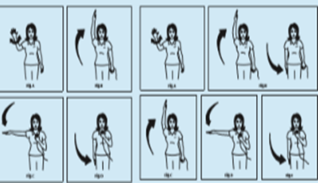

**105.4 Cognitively Disabled**

**Assistance:** A swimmer may be permitted to have an assistant on the deck when necessary. An assistant does not need to be a member of USA-S.

**105.5 Physical Disabilities**

**Start:** Shall use a forward start for freestyle, breaststroke and butterfly.

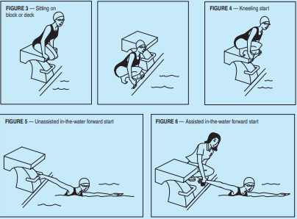

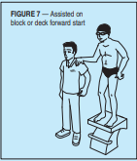

**For breaststroke and butterfly:** After the start and after each turn, a swimmer who is unable to push off with the leg(s) may perform one arm stroke that need not be simultaneous or on the horizontal plane to attain the breast position.

**Stroke/Kick:** If a part of the body is absent or cannot be used, it is not judged; if it is used during the stroke or kick, it should be judged in accordance with the USA Swimming Rules and Regulations. Judgments should be made based on the actual rule — not on the swimmer’s technique. As long as the arm or leg action is simultaneous, For example, the breaststroke swimmer with one arm or leg shorter than the other, may have a non-symmetrical stroke or kick, but as long as the arm or leg action is simultaneous it would meet that portion of the rule. No flotation devices should be permitted.

**Turn/Finishes:** Touches shall be judged in the same manner as strokes and kicks, on the basis of the arm(s) and/or hand(s) that the swimmer can use.

**At the turn and finish of the butterfly:** An athlete with no leg function is permitted to perform a partial stroke with the arm(s) recovering forward under the surface of the water in order to touch the wall.

**Relay:** Swimmers who cannot exit the water immediately may be allowed to remain in the lane until all relays have finished so long as they do not interfere with the other swimmers or the timing equipment.