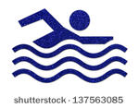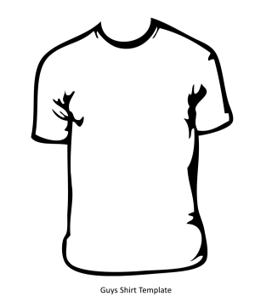
Lewis Clark Neptune Swimming 2019
Summer T-Shirt Sponsorship

Neptunes will be ordering summer t-shirts (and for those who would like to order) on June 14th (Friday), 2019. If we receive enough sponsors, ALL LCN swimmers will receive a free t-shirt. You can support the LC Neptune Swim Team through purchasing a business card size ad to go on the back of our annual t-shirt. Ads are $150 per business or person. Logos will be printed in a single color and art work and payment must be provided be the deadline: June 14, 2019- no exceptions (this includes payment and artwork). This is a great way to advertise as well as support our local swim team. All ads need to be turned into the LCN box or to Nicole Engledow by 06/14/2019 at the latest. Please make sure you send me an email to let me know at nmcraft@aol.com if you are placing an ad in the box at ACFAC.

Call Nicole Engledow (or email) for questions: (208) 553-7143, nmcraft@aol.com. Checks made payable to LCN. Receipts for sponsors are located on our LCN webpage under the booster tab. Please be sure your logo has been emailed to Nicole as soon as possible at nmcraft@aol.com (We will not create logos- the logos must be provided via email to Nicole in Jpeg form before the deadline). Extra Shirts are available at Cost: $8/each, $10 for XXL or larger. Please include note of order and check by deadline 6/22
Swimmer Name:
__________________________________________

Name of Purchaser: Art work included? Paid: Contact #
____________________________________________________________________________________

