LCN PARENT ACKNOWLEDGEMENT OF POLICIES

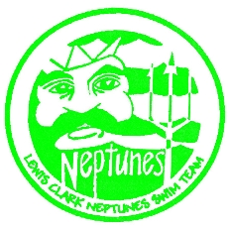

I acknowledge that I have received, read and understood the Minor Athlete Abuse Prevention Policy and/or that the Policy has been explained to me or my family. I further acknowledge and understand that agreeing to comply with the contents of this Policy is a condition of my membership with Lewis Clark Neptune Swimming (USA Swimming member club).

Name:
Signature:
Date:

