LEWIS CLARK NEPTUNE SWIMMING: WRITTEN PERMISSION FOR AN UNRELATED ADULT ATHLETE TO SHARE THE SAME HOTEL, SLEEPING ARRANGEMENT OR OVERNIGHT LODGING LOCATION WITH MINOR ATHLETE

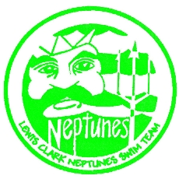

I, , legal guardian of , a minor athlete, give express written permission, and grant an exception to the Minor Athlete Abuse Prevention Policy for (minor athlete), to stay in the same hotel room of, or share a sleeping arrangement or other overnight lodging location
with (unrelated adult athlete)
at (location of hotel room or other overnight lodging location) from to (dates of applicable rooming arrangement). I further acknowledge that this written permission is valid only for the dates and location specified herein.

Legal Guardian Signature:
Date:

