- Introductions:
  - Keith Lambert, IES Admin Vice Chair, running the meeting
  - Coaches: Rachel Millet, SAS and Atiba Wade, VS
  - Chaperones: Jessie Veselka, SWAT and Jenny Reed, formerly GMSC
  - Apologies from Kevin Eddy, Age Group Chair. He is attending a family wedding

- Late Qualifiers:
We have a late qualifier document for you

- 10&U FAQ’s:
Previously qualified families received this. If you are a new qualifier, Keith will have a copy of 2.

- Review of Itinerary:
  - Everyone needs to meet at 4:45 on Monday, Aug 6 at the Roseville Aquatic Center for practice.
  - Hotel: Holiday Inn Express Roseville.
  - New this year: Charge for spectator seating. This money goes to cover traffic control and security for the meet. The meet loses money, and it was losing a lot money, so they needed an additional revenue stream to help with costs. $7 per session, $50 for a meet pass (all 8 sessions).
  - If parents or family members want to attend the post-meet social at Quarry Park Adventures, please email me the number attending. The cost is $35 per person. It is a brand new facility, and they can Google it and check it out.

- Gear and T-Shirts:
  - Gear from NW Swim Shop is being shipped to Kevin Eddy, who will pass it out at the airport on Monday, Aug 6. Not ideal, but, it’s the best we can do. Caps will be included.
  - T-Shirts from Anne Jones will also be passed out at the airport.
  - There will be black t-shirts for sale for $15 for parents and other families. There is a limited amount, with limited size options. First come, first serve basis

- Sign Up for Remind:
If you are planning to apply and attend, please register for the text app “Remind” so you can begin receiving text messages. You will text @2018inl to 81010 to register a parent and swimmer phone.

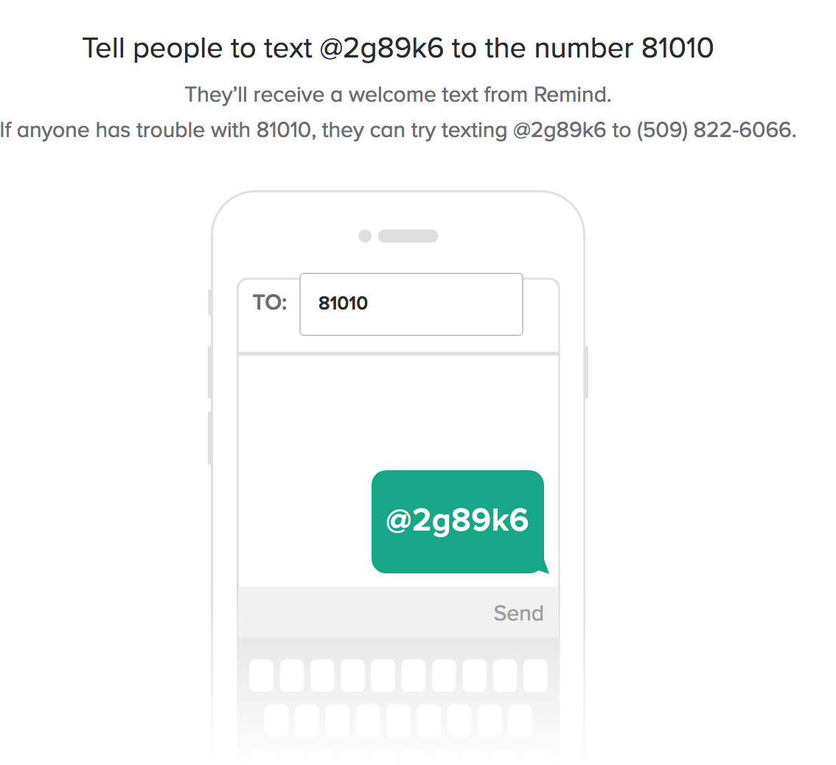

- 14 Year Old Celebration:
Parents of 14-year-old qualifiers – please send 5-6 pictures of your 14 year old to iezonesteam@gmail.com to be included in the Age Group Graduation/Celebration video.

- Payments:
Please be prepared to make final payment of balance due. Your amount due was emailed to you on 7/19

- For any questions, please contact Kevin Eddy (Age Group Chair) ieszonesteam@gmail.com

