1 . Go to https://www.fredmeyer.com/account/communityrewards/
2. Create an account on Fred Meyer
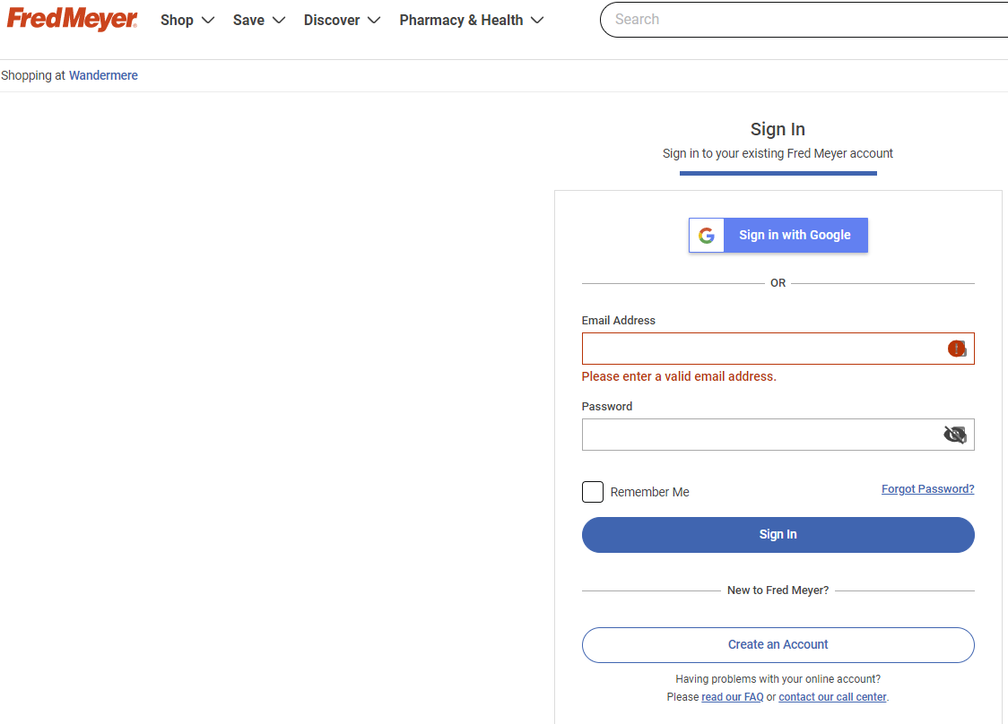
3. Once the account has been created, go ahead and login:

4. After login, click the enroll button
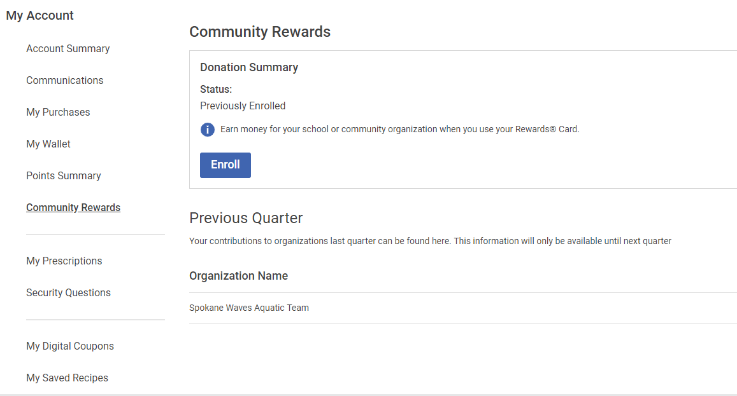

5. Under “Find an Organization” type “Spokane Waves”
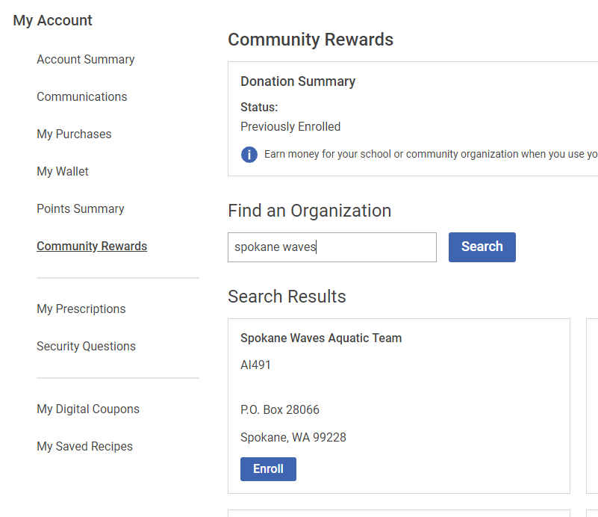

6. Click the Enroll button and you should see the confirmation screen below:

