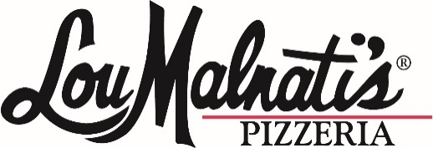

Frozen Pizza Coupon Fundraiser Order Form!
Cost: $13.00 each
Proceeds benefit: Blue Devil Swim Club
Form and money due December 5th
Use this form to track individual coupons sold by organization members
Pizza coupons may be redeemed at any area Lou Malnati’s location for one 9” FROZEN pizza (sausage, pepperoni, cheese, or spinach). Offer subject to restaurant availability. Coupon has no cash value and may not be used toward the purchase of any other items. Coupons will be delivered to customer at a later date. Each coupon is valid for 6 months from the date the order is placed.
Name | Phone Number/Address | # of coupons ordered | Cost | Paid Y/N

