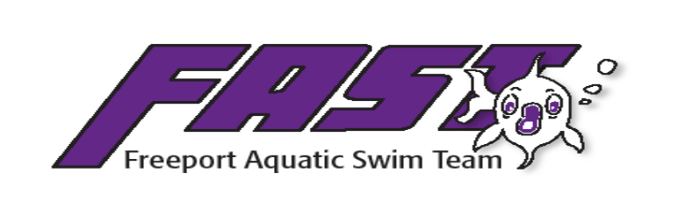
Code of Conduct

This Code of Conduct is to enhance the positive experience of all swimmers and ensure that we are providing a fun, safe, and positive learning environment for all of the participants and spectators.

All members, as well as their parents and/or guardians, of FAST must follow the Code of Conduct as listed below. Failure to comply will result in disciplinary action determined by the guidelines below.

As a Participant/Athlete for FAST, I agree to the following:

- I will adhere to all USA Swimming and Illinois Swimming policies as detailed on their websites, as well as FAST specific policies. This document summarizes key athletic code policies.
- I will not engage in bullying in any way. It will NOT be tolerated.
- I will act in a sportsmanlike manner towards my teammates and fellow competitors.
  - Understand proper lane etiquette and to refrain from behavior that will inhibit the progress of my fellow swimmers.
  - Wait in water for races to finish, unless directed otherwise by meet officials.
  - Shake hands with competitors.
- I will be respectful and supportive of my teammates whenever and wherever possible
  - I will refrain from any/all hurtful behaviors including but not limited to pinching, hitting, kicking, fighting, teasing, name calling, ignoring, etc.
  - I will not use inappropriate language or gestures.
- I will be respectful towards all coaches, officials and meet staff at all times.
  - No talking when they are talking, listen, answer respectfully when spoken to, follow directions/instructions.
- I will bring all necessary equipment, supplies, and unfirom tot each practice/meet and be responsible for my belongings.
- I will arrive on time to all meets and practices.
- I will not use my cell phone, camera, or any other video device in the locker room. I will change into and out of swimwear only in the locker room or other designated area.
- I will not illegally consume or purchase alcohol, tobacco products, or any illegal drugs or substances of any kind, or share prescribed medications while participating in activites as a registered member of FAST. Failure to adhere to this action set forth by USA swimming, Illinois Swimming and FAST will be subject to a review committee and may face suspension or expulsion from the team along with any financial penalties for costs incurred.

As a Parent or Guardian of a participant of FAST, I agree to the following:
- I will ensure that my swimmer(s) understand and adhere to the Athlete Code of Conduct.
- I will read the Registration Agreement and adhere to the stated policies.
- I will keep informed by regularly checking email, the FAST website, bulletin boards, and mail files.
- I will register my swimmer(s) by the stated deadline for meets. I will bring my swimmer(s) to these meets at the time specified by the coach or notify the coach if my swimmer(s) can no longer attend the meet.
- I will keep current on payment of all fees.
- I will be an active part of FAST by:
  - Volunteering at Fast sponsored meets.
  - Participating in fundraisings for the team.
  - Attending parent meetings.
- I will act in a sportsmanlike manner towards members of the team, their family members, fellow competitors, coaches , and officials.
- I will not use inappropriate language or guestures.
- I will refrain from any/all hurtful behaviors including but not limited to pinching, hitting, fighting, teasing, name calling, ignoring, ect.
- I will communicate with our coaching staff only at an appropriate time, which is not on deck, if any questions or concerns regarding a decision made by meet official are made during a competition.

If a swimmer (or parent/guardian) feels that he/she is not being trated in a accordance with the above expectations they should ask to schedule a meeting with the Head Coach or board member of FAST to address their concerns.

If any Coach finds that swimmer or parent/guardian is in violation with the above Code of Conduct, discipline will be handled in the following manner:

1st Offense- Warning to swimmer(s) or parent/guardian. If swimmer meeting with parents will be scheduled.
2nd Offense- Written warning.
- If swimmer – notification to parent(s)/guardian(s) and immediate removal from the current practice or meet and the next day’s practice or meet ( depepending on the day of the week) at a minimum.
- If parent/guardian – parent/guardian will be asked to leave the practice area or swim meet.
- The swimmer or parent/guardian may be suspended for additional practices/meets as warranted by the situation.
3rd Offense – Dismissal from the team for the remainder of the season or indefinitely if merited. NO refunds will be issued.
*** If necessary, a FAST board member will also assist in the disciplinary ruling.

FAST Code of Conduct

Swimmer: I have read and agree to act in accordance with the above Code of Conduct expectations and guidelines. I understand the consequences of not following the Code of Conduct.

___________________________________________________ _________________
Athlete Signature Date

Parent/Guardian: I have read and understand the above Code of Conduct and agree to act in accordance with the above Code of Conduct expectations and guidelines. I understand the consequences that will occur as a result of my child or me not following the Code of Conduct.

____________________________________________________ __________________
Parent (Guardian) Signature Date

