Finding your Best Times and comparing Regional/JO/Zone Cuts

It is always a good idea to know your best times and your goals. You can find your best times and how they compare to regional, JO, and zone cuts online. Here’s how:

1. Sign into your account at www.ppdswim.org.

2. Click on My Meet Results.

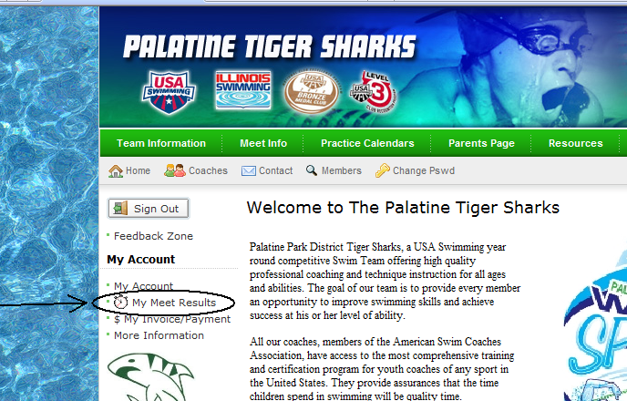

3. Select the current time standards for either boys or girls.
4. To simplify your search, select either SCY (Short Course Yards for the fall/winter) or LCM (Long Course Meters for the Summer). Then choose to view only your best time (Top 1).
5. Since last year’s time are no good this season, it is also best to select the Date of Swim from last year’s championship meets to today’s date.

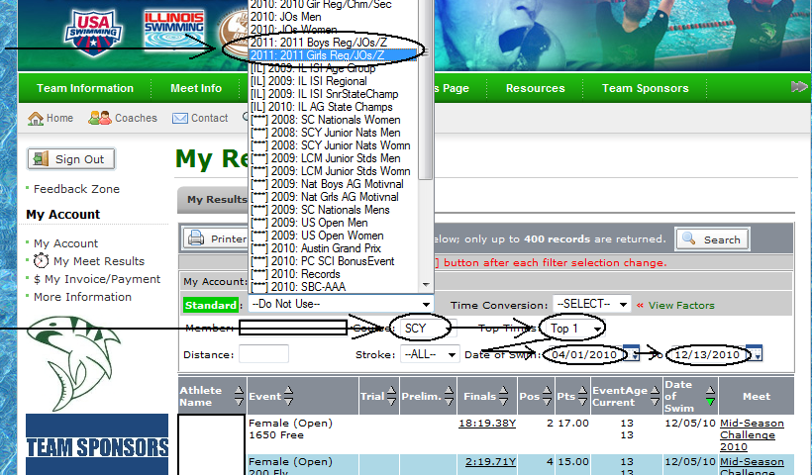

6. Your best times will be listed along with how far under(highlighted in green) or away from(highlighted in orange-brown) a cut you are. In our example below, you can see that in the second event (200 Fly) this swimmer is 4.88 seconds under the JO cut and 3.42 seconds away from a Zone cut. You can also see when and where your best swim was in the right columns.

