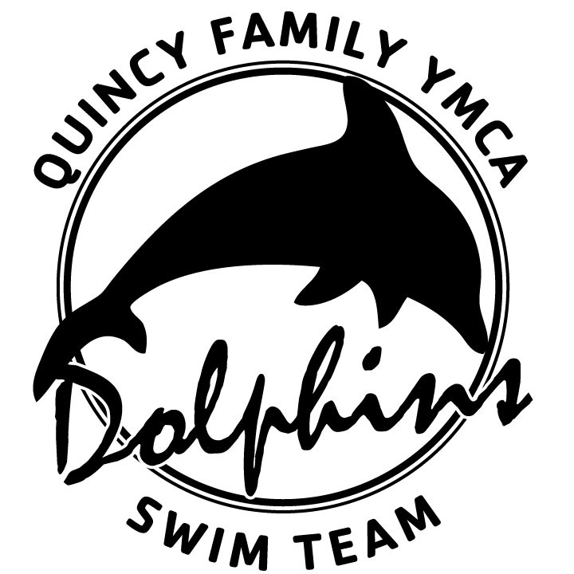 |  |  |  | Quincy Family YMCA Dolphin Swim Team  New Swimmer Info
Please print clearly and complete a separate form for each child
Family Information
Parent Names
Street Address
City |  |  |  |  | Zip
Telephone - mother | (h) |  |  |  | (w) |  |  | (cell)
Telephone – father | (h) |  |  |  | (w) |  |  | (cell)
Email – Primary address for your receipt of team communication
Please provide email address frequently checked by parent
Email – Other email addresses to which
you would like team communication sent
I give permission for our address, phone number, and family email address to be included in a team directory. |  |  |  | Yes No |  | I give permission for photos of my child to be published on the Dolphin team web site. |  |  | Yes No
Swimmer Information
Name, first |  |  | Middle |  |  |  | Last
Does swimmer use a preferred name  different from formal name? If so, what? |  |  |  |  | Swimmer’s T-shirt size? Child size (6-8) (10-12) Adult size S M L XL  (circle one)
Date of Birth  Mo/day/year |  | Boy Girl (circle one) |  |  | Has swimmer previously  been a member of USA Swimming? YES NO (circle one)
Where did your child learn to swim?
(Please list where swim lessons taken)
What other swim teams has your child been a member of?
Health conditions you would like us to know about:
Other Questions
How did you learn about the Dolphins?
Do you know families who are currently
on the Dolphins team? If so, who?
Why do you want your child to
participate in the sport of competitive swimming?
What is it about the Dolphins
that makes you interested in
becoming a team member?
Thank you for taking the time to give us your information.
Please return completed form to Assistant Coach Casey Grave

