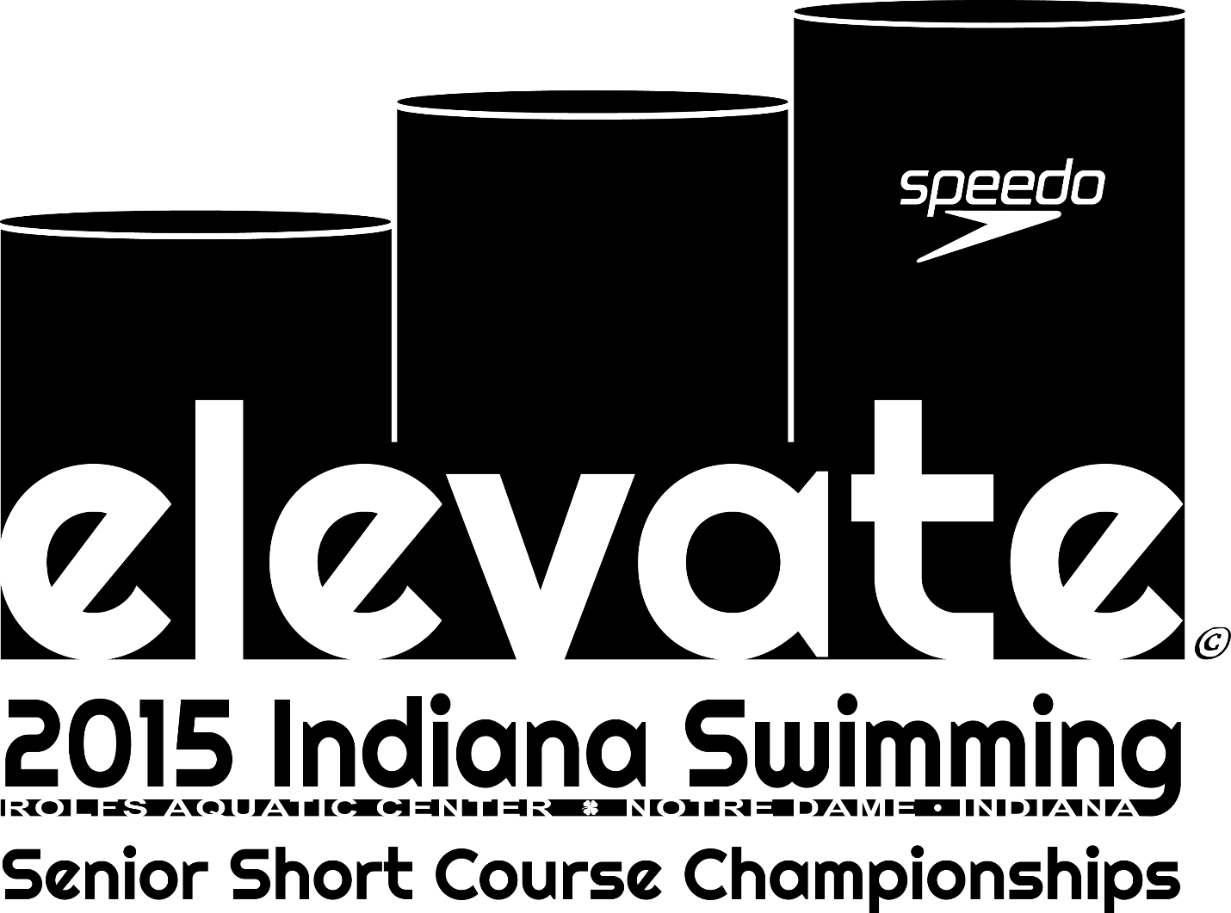

WELCOME PACKET
Irish Aquatics and Concord Swim Club are very excited to have you join us very soon for the 2015 Indiana Swimming Senior Short Course Championships! Our goal with this packet is to give you some basic information about the pool and surrounding area. If after reading this you have questions, please feel free to contact one of the meet directors: David Pruitt (574.904.2844) or Jason Miller (574.343.3434). You can also check the meet website at: http://sites.google.com/site/2015seniorstate/home for updates.
And the Indiana Swimming website may have additional updates: http://www.inswimming.org/SubTabGeneric.jsp?team=czinlsc&_stabid_=104313.
Looking forward to a great meet!
Getting Here
Most of you will either arrive in South Bend via U.S. 31 or from the Toll Road. It is very simple to get to the University of Notre Dame from either of these options.
From the South
Follow U.S. 31 North, which becomes US 933 just south of the South Bend area. Proceed through downtown and continue north.
Turn right (east) on Angela Blvd. (Notre Dame sign and golf course will be on the far right corner). Angela turns into Edison Road.
After the second traffic light, turn left (north) into the Joyce Center Parking Lot (C1).
THERE IS NO CHARGE FOR PARKING. Please note that the University has undertaken a major construction project in the immediate area of the C1 lot and adjacent areas.
From the Toll Road
From the North/East/West (Indiana Toll Road): Take Exit 77 on the Toll Road.
After paying your toll, proceed to the stoplight (Indiana 933/31). Turn right at the stoplight and proceed through 2 stoplights to Angela Blvd. At the third stoplight, turn left on Angela Road. Angela turns into Edison Road.
After the second traffic light, turn left (north) into the Joyce Center Parking Lot (C1).
THERE IS NO CHARGE FOR PARKING. Please note that the University has undertaken a major construction project in the immediate area of the C1 lot and adjacent areas.
Rolfs Aquatic Center
The meet is taking place at the Rolfs Aquatic Center on the campus of the University of Notre Dame. Rolfs is located adjacent to the northeast side of the Joyce Center. To get you oriented where Rolfs is in relation to campus, review the following map:
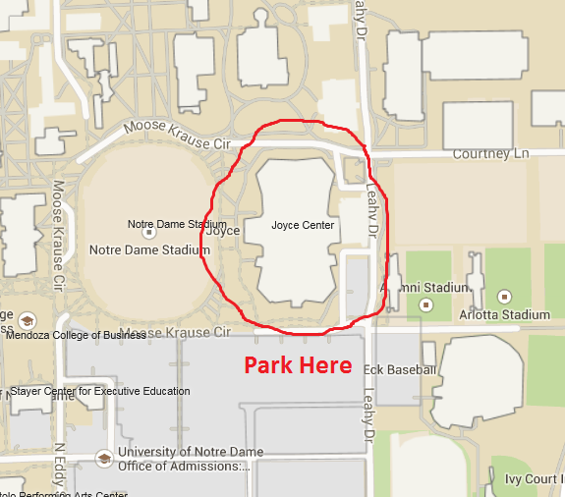
Coaches & Officials: Gate 6
Athletes: Gate 5
Spectators: Gate 1
ROLFS
AQUATIC CENTER
Getting to the pool
In order to get people where they need to be efficiently, there will be different entry procedures for 1) athletes; 2) coaches and officials; and 3) spectators. Please note that if you have attended Irish Aquatics meets in the past, these are different procedures. We plan on posting videos to the meet website that will provide some additional “visual” information to make this process as smooth as possible. For now, please review the following.
ATHLETES: ENTER GATE 5
Athletes will enter Gate 5. Parents are able to drop athletes off near the entry door for Gate 5 but will not be able to park cars in this area. Once entering the Gate 5 doors, athletes will turn left and proceed to get his or her credential. Entry to the pool deck will be monitored by marshals. Due to USA Swimming insurance, only swimmers, credentialed coaches and officials, and meet volunteers will be allowed on deck. There are no exceptions. From the outside, the entry to Gate 5 looks like this:
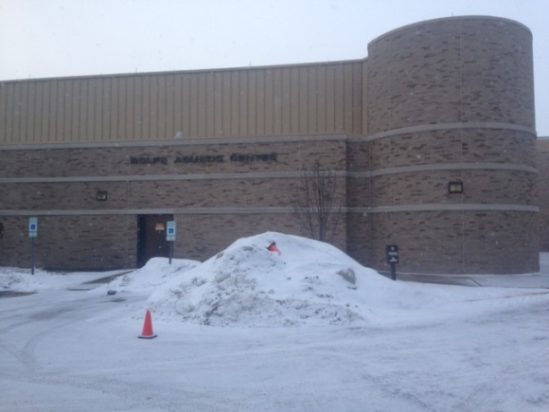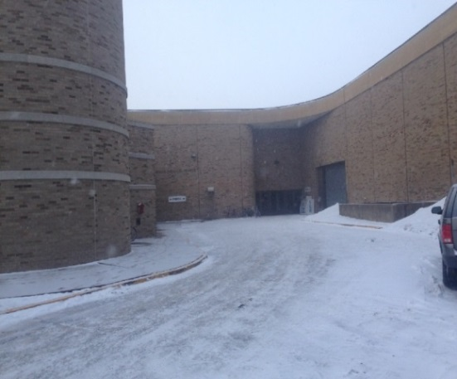
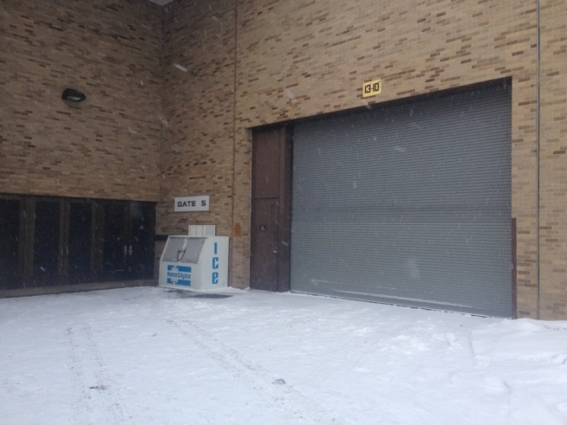
COACHES AND OFFICIALS: ENTER GATE 6
After parking your car in lot C1, coaches and officials will enter Gate 6 and take a quick right once entering the building. There will be a table where coaches and officials will sign in and get checked in. Due to USA Swimming insurance, only swimmers, credentialed coaches and officials, and meet volunteers will be allowed on deck. There are no exceptions. In compliance with University of Notre Dame policy, all coaches, officials and volunteers are required to show a valid government-issued picture ID to attain access to the deck level at this event. To receive meet packets and gain deck access, ALL coaches will also be required to display valid and current USA Swimming membership cards. Officials will be required to show their USA Swimming certification cards. This will be strictly enforced. The meet referee and directors reserve the right to deny access to anyone not in compliance. From the outside, entry to Gate 6 looks like this:
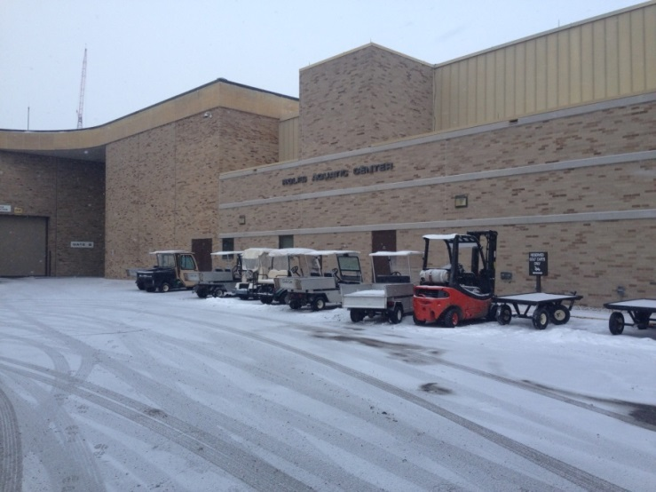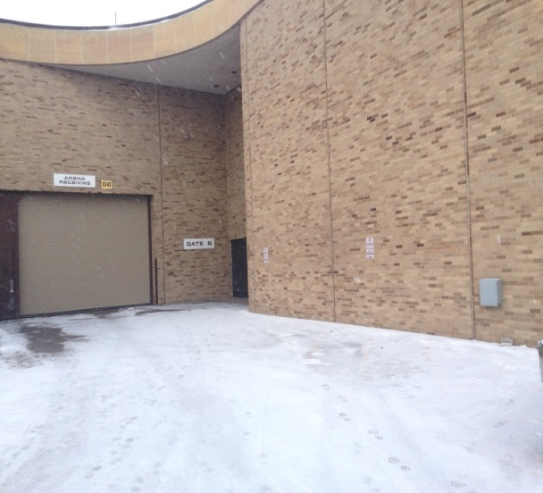
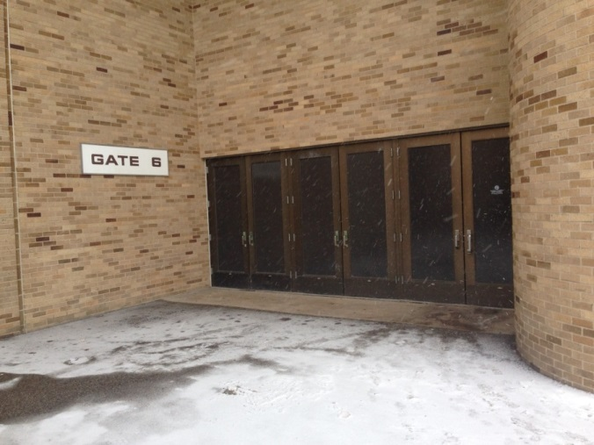
SPECTATORS: ENTER GATE 1
From the C1 parking lot, spectators will enter Gate 1 of the Joyce Center to gain access to the spectator gallery. If you are looking at the Joyce Center and Football Stadium from the C1 parking lot, Gate 1 is on the left side of the Joyce Center.
SPECTATORS ARE STRONGLY ENCOURAGED TO ENTER GATE 1. NOTE THIS IS A DIFFERENT PROCEDURE THAN PRIOR IRISH AQUATICS MEETS.
Once entering Gate 1, spectators will immediately see signage directing them to the second floor.
From the outside, this is what Gate 1 looks like:
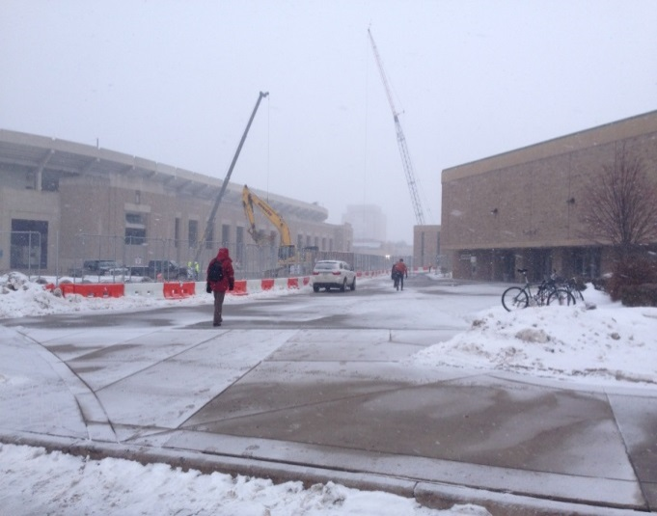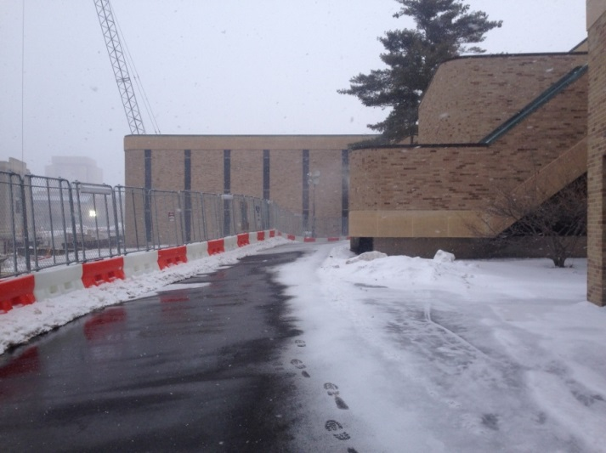
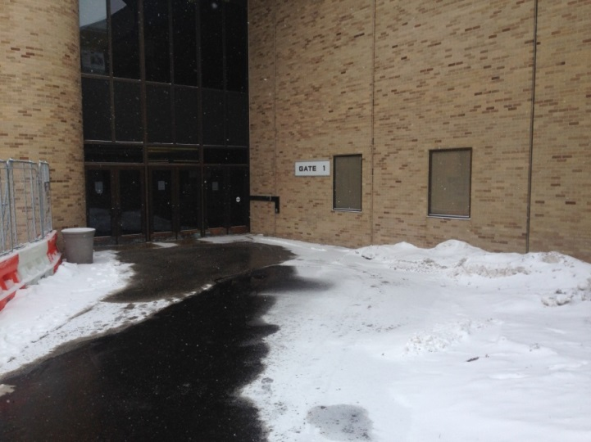
The second floor contains Heritage Hall. This is the area where you will pay for admissions. In addition, all of the vendors will be located in Heritage Hall.
Once you are on the second floor and have paid admissions, you will see signage directing you to the spectator gallery. As a reminder, these are the charges for the weekend:
CHARGES
Psych and Heat Sheets
- Psych Sheets-$10
- Prelim Heat sheets - $4
- Finals Heat Sheet - $1
Admissions
- All Session Pass - $ 20
- Friday or Saturday or Sunday Prelim Pass - $ 8
- Finals - Free
Vendors
At this time, we expect the following vendors to be at the meet offering the following food options. Please note University policy controls concessions offered and neither Irish Aquatics nor Concord Swim Club have any control over these offerings or prices.
From 6:30 a.m. to 7 p.m.
Centerplate Concessions - Gourmet popcorn, dippin dots, fresh made deli sandwiches and salads, fruit cups, coffee, breakfast breads (donuts, muffins), whole fruit, bottled beverages, pretzels, hot dogs, brats, bottled juice.
Additionally, the following vendors are expected to be at the meet from 10 a.m. to 7 p.m.:
Ben's Pretzels - Fresh made dough pretzels made at the location with multiple dipping sauces
Ritter's Frozen Custard - Hand dipped frozen custard with multiple toppings
Nutty Bavarian Roasted Nuts - Fresh roasted nuts, candy, fresh baked cookies
Kast-A-Way Swimwear - will offer swim wear and accessories.
Fine Designs - will offer meet apparel. You may pre-order apparel at the following link: http://www.fdsportswear.com/events.cfm?eventid=140.

SwimHero RA - offers the next level in swim race analysis. The SwimHero app links video to data giving the user easy, inexpensive access to a world of comprehensive race data.
Visit South Bend - will have an information table regarding things to do in South Bend.
We plan on accepting credit cards for admissions, pysch and heat sheets. The nearest ATM is located outside at Gate 10. Spectators will pass this ATM on their way to Gate 1:
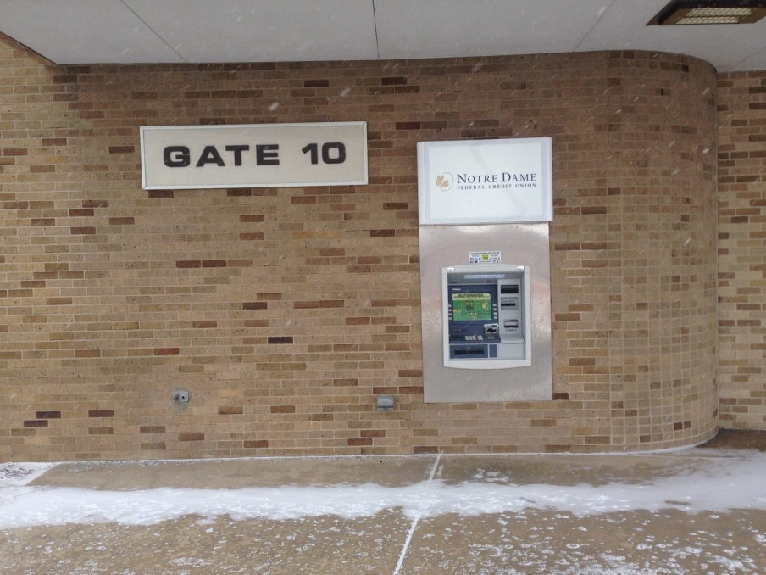
Elevator
Please note there is an elevator to your immediate right after entering Gate 1. This is the only accessible elevator in the building, yet another reason for spectators to enter Gate 1.
Do Not Bring in folding chairs
Do not bring folding chairs with you to the gallery as they will not be allowed in the gallery.
Wifi
We expect there to be “wifi” available in the gallery at ndguest. There is no password.
RESTAURANTS AND GROCERY STORE
Getting food is important to swimmers. In addition to the options provided in Heritage Hall, there are a number of options within two miles of the pool.
Eddy Street Commons is located immediately south of campus and has a number of restaurants. It is less than half a mile from the pool and offers:
- Chipotle: 574.251.0175 (www.chipotle.com)
- McAllister’s Deli: 574.232.8560 (www.mcalistersdeli.com)
- BarBici (fast Italian): 574.251.1330 (www.mybarbici.com)
- Jamba Juice: 574.232.0970 (www.jambajuice.com)
- Five Guys: 574.234.1800 (www.fiveguys.com)
- O’Rourke’s Public House: 574.251.0355 (www.orourkespubhouse.com)
- The Mark (American): 574.204.2767 (www.themarkdineandtap.com)
- Brothers Bar & Grill (bar food): 574.287.2767 (www.brothersbar.com)
- 7-Eleven: 574.234.2571 (www.7-eleven.com)
There is a parking garage at Eddy Street Commons that provides for two free hours of parking. The parking garage is located in the middle of the complex.
Legend’s is a sit down restaurant located in the parking lot near the football stadium. It offers American style food. Phone number: 574.631.2582 (www.legendsofnotredame.org).

Martin’s and other nearby restaurants
There is a Martin’s Supermarket located about a mile from the pool on the corner of State Road 23 and Ironwood Road. This is a full-service supermarket including a deli, salad bar, and Starbucks.
Also near campus are a number of other options including American (Between the Buns) (574.247.9293) (www.betweenthebuns.com), Chinese (J.W. Chen’s) (574-271-2777) (www.jwchens.com) and Mexican (La Esperanza) (574.273.0345).
Rein Juicery recently opened near campus and provides fresh juices and smoothies. (574.520.1874) (www.reinjuice.com).
There is a Starbucks on the corner of South Bend Avenue/State Road 23 and Ironwood.
Finally, a little farther from campus (perhaps two miles) closer to downtown is Rocco’s Restaurant. Rocco’s has been a Notre Dame institution since 1951 serving pizzas and other Italian offerings. It will be open in the evenings. Phone number: 574.233.2464 (www.roccosoriginalpizza.com).
We have included a map with many of these places with this packet.
There are literally hundreds of other options in the area, but this will give you an idea of things near the pool. If you are staying downtown, there are a number of great, unique spots. For example, Fiddler’s Hearth is an Irish bar located downtown for all you Saint Patrick’s Day fans. If you are staying the Mishawaka area, there are dozens of chain restaurants such as Panera, Noodles & Company, and Aladdin’s. Culver’s is a supporter of the meet and is located on Main Street in Mishawaka.
University Park Mall is located about ten minutes from campus and serves as the regional mall for our area. Further information can be found here: http://www.simon.com/mall/university-park-mall.

THINGS TO DO
The University of Notre Dame is nationally recognized and a vibrant university. It is often listed as one of the most beautiful campuses in the country. Hopefully you are able to make some time to explore.
We are offering 4 campus tours for those interested during the weekend. The tours will take place at 11:30 and 1:30 on Friday and Saturday. For those of you interested, plan on meeting at the Visit South Bend informational table located in Heritage Hall.
For those of you unable to attend one of these tours, three places not to miss on campus are the Basilica, the “Golden Dome” (Main Building), and the Grotto. Here are links that will give you some more information on these places:
Basilica: http://campusministry.nd.edu/basilica-of-the-sacred-heart/tour-the-basilica/
Main Building: http://archives.nd.edu/main.htm
Grotto: http://tour.nd.edu/locations/grotto/
Tours may also be available of the football stadium. There is a cost associated with these tours. Check on the availability of tours at the following link:
http://www.und.com/tours/
The Notre Dame Bookstore is located on campus on Notre Dame Avenue. Built in 1998 and adjacent to the Eck Visitors’ Center, it is a major campus destination for fans on football game-day weekends and has all things Notre Dame. The address is Eck Visitors Center, 1 Eck Center, Notre Dame, Indiana 46556. It is expected to be open from 8 a.m. - 9 p.m. Friday and Saturday and 9 a.m. - 7 p.m. on Sunday.
South Bend is also celebrating Saint Patrick’s Day the weekend of the meet. There will be a number of things going on that weekend and there is no shortage of things to do in the area. Visit South Bend has put together a brochure specific to our weekend and we have included it with this packet. You can also visit their website at: http://visitsouthbend.com/.

QUESTIONS?
We hope you have found this information helpful. Check the meet website at: http://sites.google.com/site/2015seniorstate/home for updates. You should also check the Indiana Swimming website for additional updates: http://www.inswimming.org/SubTabGeneric.jsp?team=czinlsc&_stabid_=104313.
You can also ask our meet directors Jason Miller (574.343.3434) or David Pruitt (574.904.2844) about anything discussed here or other questions you may have.
See you soon!

IMMEDIATE AREA AROUND ROLFS AQUATIC CENTER

There is additional parking available on the north side of campus either in the library lot or Bulla Road. You would have a five to ten minute walk to Rolfs. However, we expect there to be enough parking in the C1 lot because Notre Dame students will be on spring break. If there are changes to available parking, updates will be posted to the meet website.

