2016 INDIANA SWIMMING SENIOR SHORT COURSE CHAMPIONSHIPS

Coaches’ Packet

On behalf of Zionsville Swim Club and Pike Township Swim Club we welcome you to experience The New Pike High School Aquatics Center. We are excited to have you join us very soon for the 2016 Indiana Swimming Senior Short Course Championships!

Coaches, please take a few minutes to familiarize yourself with the format of this meet.
- Prelims in short course yards.
- Finals in long course meters.
- Olympic distance events, W800, M1500 distance session Sunday, w/top ten submitted times swimming in finals.
- All relays will be swam in morning prelims session
- 40 athletes will be brought back for finals.

Our goal with this packet is to give you some basic information about the pool and surrounding area. If after reading this you have questions, please feel free to contact Don Cozad –Meet director @(don@zionsvilleswimclub.org) or Thomas Moore- Aquatics Director @ (tpmoore@pike.k12.in.us) for updates.

Indiana Swimming website will also have information on the Championships tab @ www.Inswimming.org.

We look forward to having a great Meet!

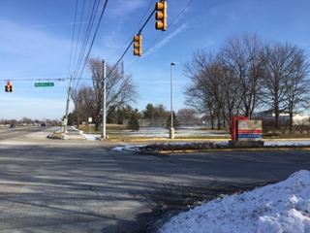
Directions
North Entrance to Pike HS:
71st and Red Devil Drive

Meet location: Pike High School
5401 W. 71st Street
Indianapolis, IN 46268

NOTE: You must use the NORTH entrance off 71st Street on Friday morning. Do not use the west entrances off Zionsville Rd. See directions below.

Directions to Pike High School: Pike HS is located on the northwest side of Indianapolis, near I-465. Follow I-465 to the west side of Indianapolis. Take exit 21 for 71st St. Turn east on 71st St., and turn right at the 3rd stoplight (Red Devil Drive). Follow Red Devil Drive to the indicated parking lots on the maps.

MAP WITH DIRECTIONS TO PIKE HS
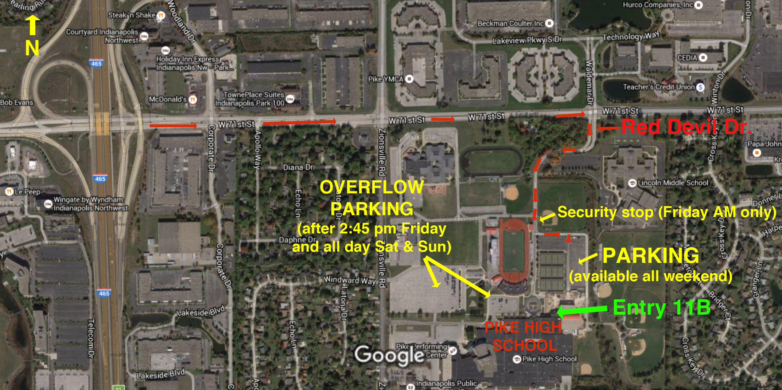

PARKING

MAP WITH PARKING LOTS
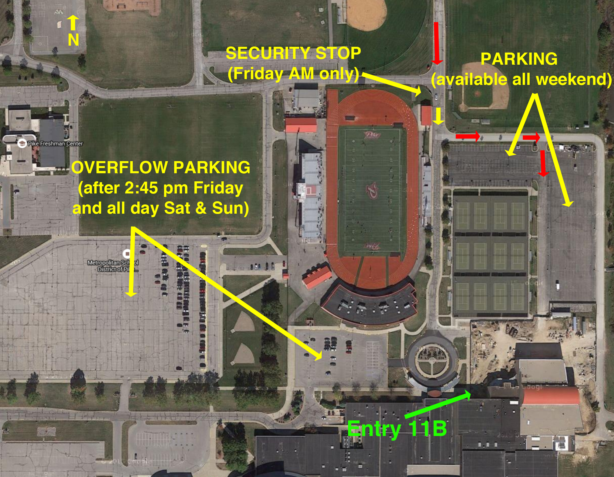

Parking Flyer for Friday: Parking is free all weekend! If you are coming to the Friday morning session, please print the parking flyer to expedite parking. Since school is in session Friday morning, there will be a security vehicle that will need to check each car. If you have the flyer, hold it up for the guard to see as you approach the security vehicle. If you do not have a flyer, just tell the guard that you are at Pike HS for the State Swim meet.

Parking on Friday morning: Since school is in session Friday morning, only the parking lot on the east and north sides of the tennis courts will be open.

Parking Friday afternoon (after 2:30 pm), and all day Saturday & Sunday: Three lots will be open for parking: the lot east and north of the tennis courts, the two lots west of the Pike HS circle drive.

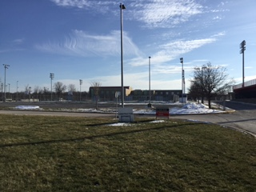
Getting into the Pool
View of pool and Pike HS from north of tennis court parking lot.
Pool entry 11B
Athletes, Coaches, Officials, and Spectators, will all enter the pool via door # 11B shown on the maps and photos.

Athletes –after entering Door 11B, athletes will follow the signs and turn left to proceed through the first set of double doors to athlete check in. Athletes will need to pick up bag tags that will allow deck access.

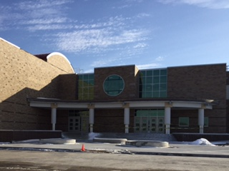
Coaches- after entering Door 11B, coaches will be directed to the pool once they show credentials and sign in. They will also be directed to the head table to pay meet fees, and pick up meet packets.
Pool entry 11B

Officials-after entering Door 11B, officials will be asked to show credentials and sign in before entering the pool area.

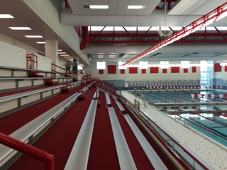
Only swimmers, credentialed coaches, officials, and meet volunteers will be allowed on deck. The meet directors reserve the right to deny access to anyone not in compliance.

Spectators – once entering the facility, spectators will be asked to proceed to tables that will take admissions, and then directed to the second floor for spectator seating, concessions, vendors, and restroom facilities.
Spectator seating at
Pike High School Aquatics Center

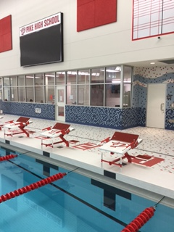
Psych and Heat sheets
- Psych Sheet - $10.00
- Prelims heat sheet- $4.00
- Finals Heat sheet - $1.00

Admissions
- All session pass- $20.00
- Prelims – single day - $8.00
- Finals – free
- 12& under – free
- Coaches and Officials not working will be asked to pay admissions

Restrooms
We intend to keep the lockers rooms designated only for athletes. Coaches, officials, and volunteers will be asked to use the designated restrooms on the pool deck or use the restrooms upstairs near the concessions stand.

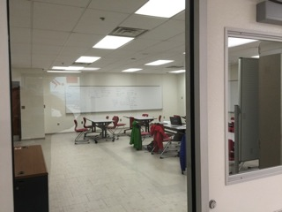
Hospitality
Hospitality Room
We will have hospitality in the classroom located off the pool deck at the south end of the pool. Please follow the signs to the room. Menu plans and hours are included in the packet for your planning.

Wifi
There will be free access to wifi after 2:30pm on Friday. No password is required. There will be no Wifi on Friday morning because Pike HS is in session.

Miscellaneous

Banners. Unfortunately, our venue does not allow banners to be hung.

Pool time. Thursday night pool time for teams is available by contacting Pike Aquatics Director Tom Moore in advance by email at tpmoore@pike.k12.in.us.

Air quality issues. In order to keep the natatorium comfortable and air quality optimal throughout the competition, we ask that you help us to keep the vents behind the bleachers clear.

Time trials. We plan to have time trials on Saturday afternoon after the morning prelim session. More information will be provided closer to the event.

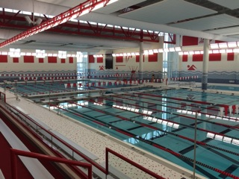
Distance events. We are providing timers, but please note distance swimmers will be required to provide their own lane counters.
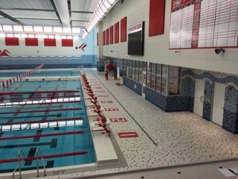

2016 Senior State Hospitality Menu
Friday, March 11th 2016

Breakfast: 6:15-9am
Chick-fil-A Breakfast sandwich
Biscuits and Gravy
Boiled eggs
Bagels and Pastries
Yogurt
Fresh Fruit

Lunch: 11:00-1pm
Assorted Lunchmeat sandwiches
Salad
Veggies and Dip
Chips
Hotdogs
Cookies/Brownies

Dinner: 3:30-6pm
BBQ-
Green Beans/Baked Beans
Potato Salad
Assorted Desserts

Saturday, March 12th 2016

Breakfast: 6:15-9:00 am
Baked French Toast
Egg Casseroles
Boiled Eggs
Bagels and Pastries
Yogurt
Fresh Fruit

Lunch: 11:00am-1:00pm
Italian Pasta Bar
Bread
Salad
Assorted Cookies/Desserts

Dinner: 3:30-6:00pm
El Meson Taco Bar
Chips and Salsa
Assorted Desserts
2016 Senior State Hospitality Menu
Sunday, March 13th 2016

Breakfast: 6:15-9:00 am
Hot Casseroles: Potatoes/Egg/Chesse/Bacon/Sausage
Donuts
Boiled Eggs
Bagels and Muffins
Yogurt
Fresh Fruit

Lunch: 11:00-1:00 pm
Soup and Salad Bar
Baked Potatoes with Toppings
Cookies/Brownies/Bars

Dinner:3:00-6:00pm
Pizza
Salad
Assorted Desserts

