Illinois Swimming Meet Certification Documentation in OTS.

Step 1 –Log on to the USA Swimming Website, and go to the ‘Officials Tracking System’ ‘Meets and Evaluations’ section (this is the ‘normal’ process to record official’s worked sessions).
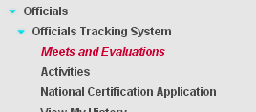

Step 2 - Search for and edit your meet information (this is still the ‘normal’ process):
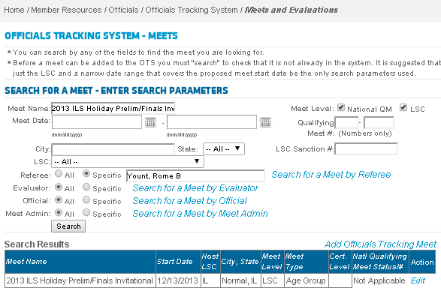

Step 3 – Edit the meet information. Note in the ‘Referee’s Report’ the session start and finish times, the session duration, and an official who was deck referee, starter, stroke and turn, and administrative officials as well as the total number of officials (not including trainees) who worked the session. The ‘Referee’s Report’ is at the bottom of the ‘Meet Information’ page (remember to scroll down as needed).

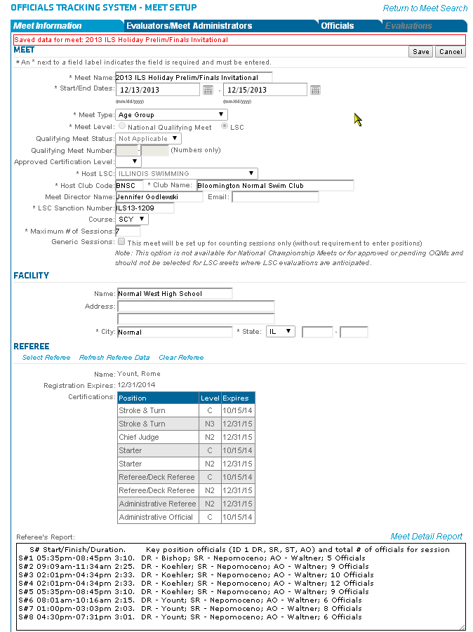

Here is a standard text template you can copy, edit, and paste into the Referee’s Report section:

S# Start/Finish/Duration. Key position officials (ID one DR, SR, AO) and total # of officials for session
S#1 05:35pm-08:45pm 3:10. DR - Name; SR - Name; AO - Name; X Officials
S#2 09:09am-11:34am 2:25. DR - Name; SR - Name; AO - Name; X Officials
S#3 02:01pm-04:34pm 2:33. DR - Name; SR - Name; AO - Name; X Officials
S#4 02:01pm-04:34pm 2:33. DR - Name; SR - Name; AO - Name; X Officials
S#5 05:35pm-08:45pm 3:10. DR - Name; SR - Name; AO - Name; X Officials
S#6 08:01am-10:16am 2:15. DR - Name; SR - Name; AO - Name; X Officials
S#7 01:00pm-03:03pm 2:03. DR - Name; SR - Name; AO - Name; X Officials
S#8 04:30pm-07:31pm 3:01. DR - Name; SR - Name; AO - Name; X Officials

Step 4 – Record officials sessions as you do today and save the information.

You are now done! Monthly reminders will be sent to referees who do not complete this information with the monthly contact report in the same manner as meets with no sessions are noted.

Advantage – one less form to fill out, one consistent location for meet information.

