Woodstock Dolphins 2018-19 Sponsorship
YES!!
We would like to support the Woodstock Dolphins Swim Team by becoming a Sponsor!!
Business Name: _________________________________
Contact: _______________________________________
Phone Number: _________________________________
Email address: __________________________________
Please Circle the Sponsorship Package-
GOLD SILVER BRONZE FRIEND OF DOLPHINS -----------------------------------------------------------------------------We Would Like To Purchase Heat Sheet Advertising

Up to 3 meets- October 2018, February 2019, and June 2019
Cost # of Meets Total:
2x3 Business Card Size $25 x _______ _______
1⁄4 Page Ad $50 x _______ _______
1⁄2 Page Ad $75 x _______ _______
***We can create an advertisement or use an advertisement you submit***
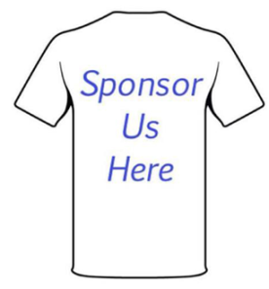
----------------------------------------------------------------------------

We Would Like to Become a T-shirt Sponsor- $200
Your Business Logo on our SC 2018-19 and LC 2019 Team T-shirts
Checks can be made payable: Woodstock Dolphins Swim Team Logos can be emailed to jgooden@woodstockdolphins.com

