Jan. 30th Freeze Out
SANCTION:

This meet is sanctioned by USA Swimming and Indiana Swimming. Sanction #
HOST:
Mt. Vernon Swim Team (MTV)
LOCATION:
Mt. Vernon Jr. High School 701 Tile Factory Road Mt. Vernon, IN 47620
FACILITY:
The pool is 25 yards long with 6 lanes and anti-turbulent lane lines. The pool length has not been certified in accordance with 104.2.C(4). The Daktronics Electronic Timing equipment and six-lane scoreboard displays all splits and final times with touch pads located on east side of the pool. The pool is all 13 to 4 1⁄2 feet in depth and the guttering system provides excellent wave dissipation. The seating area for the swimmers will be on our elevated observation deck and coaches on the pool deck. Spectator seating will not be for this meet. Parents/spectators will not be allowed in the building. No camping in hallway will be permitted. A separate warm down area will be provided. Parking is available at no charge to the north of the building. Concessions will be available. NO SMOKING is allowed in the building and/or premises.
MEET TYPE: This is an open meet, with timed finals.
RULES:
102.8 SWIMWEAR
.1 Design
F. No Technical Suit may be worn by any 12 & Under USA Swimming athlete member in competition at any Sanctioned, Approved or Observed meet.

1) A Technical Suit is one that has the following components:
a. Any suit with any bonded or taped seams regardless of its fabric or silhouette; or
b. Any suit with woven fabric extending past the hips.

202.5.3 – At a sanctioned competitive event, USA Swimming athlete members must be under the supervision of a USA Swimming member coach during warm-up, competition, and warm-down. The Meet Director or Meet Referee may assist in making arrangements for such supervision, but it is the swimmer’s responsibility to make such arrangements prior to the start of the meet.
202.4.9 D – Any swimmer entered in the meet, must be certified by a USA Swimming-member coach as being proficient in performing a racing start or must start each race from within the water. When unaccompanied by a member-coach, it is the responsibility of the swimmer or the swimmer’s legal guardian to ensure compliance with the requirement.
202.4.9 H – Use of audio or visual recording devices, including a cell phone, is not permitted in changing areas,
restrooms or locker rooms.
202.4.9 I – Deck changes are prohibited.
202.4.9 J – Operation of a drone, or any other flying apparatus, is prohibited over the venue (pools, athlete/coach areas, spectator areas and open-ceiling locker rooms) any time athletes, coaches, officials and/or spectators are present. Exceptions may be granted with prior written approval by the Program Operations Vice Chair.
2.2.4.9 E & 205.2.2 & 202.4.9 F – Swimmer(s) must be registered with USA Swimming to be accepted into this meet. Age as of Jan 30, 2021 shall determine the swimmer’s age for the entire meet. Indiana Swimming does not process on site membership.
Coaches and Officials MUST display their current USA Swimming coach credential of Deck Pass to gain deck access. The meet referee and/or meet director reserves the right to ask for coach credential or Deck Pass and/or deny deck access of coach does not comply or card is no longer valid/current.
In swimming competitions, the competitor must wear only one swimsuit in one or two pieces except as provided in USA Swimming rule 205.10.1. All swimsuits shall be made from textile materials. For Men, the swimsuit shall not extend above the navel nor below the knees, and for women, shall not cover the neck, extend past the shoulder, nor extend below the knee.
The meet referee reserves the right to ask for coach credential display and/or deny deck access if coach does not comply or card is no longer valid/current.
An inherent risk of exposure to COVID-19 exists in any public place where people are present. COVID-19 is an extremely contagious disease that can lead to severe illness and death. According to the Centers for Disease Control and Prevention, senior citizens and individuals with underlying medical conditions are especially vulnerable.

USA Swimming, Inc., cannot prevent you (or your child(ren)) from becoming exposed to, contracting, or spreading COVID-19 while participating in USA Swimming sanctioned events. It is not possible to prevent against the presence of the disease. Therefore, if you choose to participate in a USA Swimming sanctioned
event, you may be exposing yourself to and/or increasing your risk of contracting or spreading COVID-19.

BY ATTENDING OR PARTICIPATING IN THIS COMPETITION, YOU VOLUNTARILY ASSUME ALL RISKS ASSOCIATED WITH EXPOSURE TO COVID-19 AND FOREVER RELEASE AND HOLD HARMLESS USA SWIMMING AND [THE LSC] AND EACH OF THEIR OFFICERS, DIRECTORS, AGENTS, EMPLOYEES OR OTHER REPRESENTATIVES FROM ANY LIABILITY OR CLAIMS INCLUDING FOR PERSONAL INJURIES, DEATH, DISEASE OR PROPERTY LOSSES, OR ANY OTHER LOSS, INCLUDING BUT NOT LIMITED TO CLAIMS OF NEGLIGENCE AND GIVE UP ANY
CLAIMS YOU MAY HAVE TO SEEK DAMAGES, WHETHER KNOWN OR UNKNOWN, FORESEEN OR UNFORESEEN, IN CONNECTION WITH EXPOSURE, INFECTION, AND/OR SPREAD OF COVID-19 RELATED TO PARTICIPATION IN THIS COMPETITION.

Safe Sport 360: The Minor Athlete Abuse Prevention Policy prohibits Applicable Adults (as defined) from having one-on-one interactions with minor athletes which are not within an observable and interruptible distance from another adult. Applicable Adults are required to abide by this policy in full during this meet.

§ Pursuant to USA Swimming Rules and Regulations and federal law, it is every member’s responsibility to immediately (i.e., within 24 hours) report any incident of child abuse, including physical or sexual abuse, to law enforcement and the U.S. Center for SafeSport. Reporting must occur when an individual has firsthand knowledge of misconduct or where specific and credible information has been received from a victim or knowledgeable third party. A report to the U.S. Center for SafeSport may be made via telephone at 720-531-0340 or online at www.uscenterforsafesport.org/report-a-concern. Various state laws may also require reporting to law enforcement or to a designated child protection agency.

§ All athletes age 18 and older must complete Athlete Protection Training in order to be a USA Swimming registered member in good standing. Any athlete who turns 18 on or after [insert date that is 30 days prior to the last date of the actual competition], who has not completed Athlete Protection Training by the first day of competition, will be prohibited from participating in the competition until such time as all membership requirements are completed. Times achieved by an athlete who turns age 18 on or after [insert same date], who competes in this USA Swimming sanctioned event without completing this membership requirement, will NOT count for qualification or recognition. This includes participation as a member of a relay.

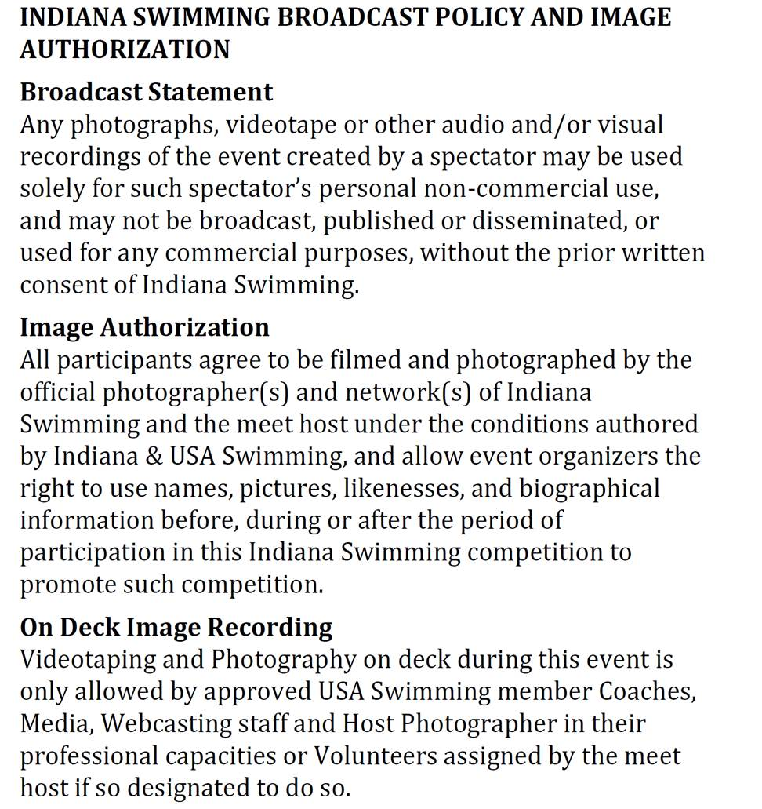

FEES:
All fees are due at the start of the meet or a team’s entries will be scratched. Fees are $5.00 per individual event, $6.00 per relay. There is also a $7.00 Indiana Athlete Surcharge per swimmer. Please make checks payable to MTV Swim Team. Entries will be accepted on a “first come, first served” basis until the heats are filled and the Meet Director reserves the right to limit the number of heats in an event if there are time constraints.
REFUNDS:
In any meet sanctioned by Indiana Swimming other than Championship Meets, the host team shall limit the number of swimmers in any one or more events to maintain a reasonable length of the meet. In the event that entries are limited, the host club must return the entry fees to the club(s) whose swimmers are not allowed to compete in the specific event(s).
ENTRY INFO:
All entries are to be submitted in yard times. Include age of swimmer in all events. The meet will be run with Hytek’s Meet Manager Software, so electronic entries are highly encouraged. The Meet Setup file will be posted on the Indiana Swimming website for your convenience.
DEADLINE:
Entries will begin being accepted on Monday, Jan 11th and must be received by Monday, Jan 25th.
Email to: mtvswimteam@gmail.com
Estimated and “No Times” will be accepted. Any corrections to the seed times must be made by Monday, Jan 25th. Each swimmer will be limited to five (5) individual events. If an entry is submitted with an individual entered in more events than allowed, the entry will be made by order of events, starting with Event 1, until the limit is exceeded.
AWARDS:
Will not be given for this meet.
HOSPITALITY: A Hospitality Suite will be provided for all coaches and officials.
MEET DIRECTOR:
For additional information or assistance, please contact:
Jessica Anselman
Jess.anselman@gmail.com
PLEASE NOTE:
Please advise your parents of the following:
- We would appreciate it if officials from each team would help with officiating. Please contact the Meet Director if you are willing to officiate.
- NO SPECTATORS ALLOWED AT THIS MEET.
- We reserve the right to expel for the remainder of the meet, with no refund of entry fees, any swimmer or person, who is disorderly, destructive, not wearing a mask or in any unauthorized area. The Southern Indiana Swim Conference and MTV are grateful to the Metropolitan School District of Mt. Vernon for the use of their facilities. Coaches and parents are expected to monitor their swimmer’s behavior at all times. Mt. Vernon Swim Team is not responsible for missing or damaged personal items. All swimmers are advised to leave valuables with parents or guardians.
- THERE WILL BE NO CAMPING IN THE HALLWAY PREMITTED!
- Hand sanitizing stations will be placed around for frequent hand washing.

COVID POLICY:
Preparing to come:
*wash your hands with soap and water before leaving your house for 20 sec.
*please check temp at home
*please come and leave in your suit. Locker rooms will not be used for changing, locker rooms will be used as a wet bathroom no changing area.
*arrive no more than 30 mins early and stand 6 feet apart entering school and pool area.
*do not attend meet if you, or a member of your household does not feel well

Swimmers:
*follow directions for spacing and stay at least six feet apart from others
* do not make physical contact with others, such as shaking hands or giving high fives
*avoid touching your face as much as possible
*avoid sharing food, drinks, towels, and other equipment
*wear your suit to and from meet
*sit upstairs unless called to swim, or cooling down.
*swimmers will enter the pool area from the west doors and staircase and exit to the blocks from the east staircase.
*swimmers are not permitted to crawl under designated walk path to reenter pool to blocks.
*Must wear masks unless actively swimming.
*leave the facility as soon as reasonably possible after meet
*wash your hands thoroughly or use hand sanitizer after leaving the pool
*DO NOT use the locker room or changing area
>shower at home, wear your suit to and from pool
*no extra-curricular or social activity should take place
>no congregation after swimming
*Please bring zip lock bag to put mask in when on the block
*swimmers are expected to remain in the pool area the duration of them meet
*if they exit the pool area they will need to be rescreened and temp taken again
*swimmers are NOT permitted in the gym for any reason

Parents:
NO PARENTS OR FANS PERMITTED
The meet will be broadcasted live.

There will be no concession
There are no drinking fountains available

Pool Deck:
*Masks will not be required while actively coaching
*Masks will be required for timers
*Swimmers may remove masks when in the next heat behind the blocks
*Please make sure your athlete has a Ziploc bag with their name on it to put their mask in when behind the blocks
*Officials are advised to wear masks
*Starter is not required to wear mask while actively starting races
*Volunteer workers will be required to wear masks
*Swimmers are not permitted to hang out on pool deck.
*Swimmers will enter balcony from west staircase and exit balcony to pool deck from the east staircase.
*After swimmers race they will exit pool to the south follow around the pool deck and enter balcony from west staircase.

PLEASE NOTE ANYONE ENTERING THE POOL DECK OR WORKING ON POOL DECK WILL BE REQUIRED TO SCREENING AND TEMP CHECK.

SESSION 1 – SATURDAY Jan 30th WARM-UPS: 8:00 AM CST MEET STARTS 9:30 am CST
GIRLS EVENT # AGE EVENT BOYS EVENT # 1 OPEN 200 IM 2
3 OPEN 100 BACK 4
5 OPEN 200 FLY 6
7 OPEN 100 FREE 8
9 OPEN 200 BACK 10
11 OPEN 100 BREAST 12
13 OPEN 200 FREE 14
15 OPEN 200 BREAST 16
17 OPEN 100 FLY 18
19 OPEN 50 FREE 20
SESSION 2 – SATURDAY Jan 30 th WILL START PROMPTLY AFTER SESSION 1.
21 OPEN 1650 FREE 22
23 OPEN 400 IM 24
SESSION 3 – SATURDAY Jan 30th WARM-UPS: 2:00 PM CST MEET STARTS 3:30 PM CST
25 12 & UNDER 100 BACK 26
27 12 & UNDER 50 BREAST 28
29 12 & UNDER 100 FREE 30
31 12 & UNDER 100 BREAST 32
33 12 & UNDER 50 FLY 34
35 12 & UNDER 50 BACK 36
37 12 & UNDER 100 FLY 38

