How to Register for a CGAC Swimming Team
Note: These directions are for anyone registering for a team located at Center Grove High School, University of Indianapolis, or at Mooresville High School. These directions are for any swimming team in the club except for Sharks & Minnows, Masters, Lessons, and the 2-week trial.
Step 1: Go to the CGAC website - https://www.teamunify.com/Home.jsp?team=incgac
It may be easier to search for “Center Grove Aquatic Club” in google.
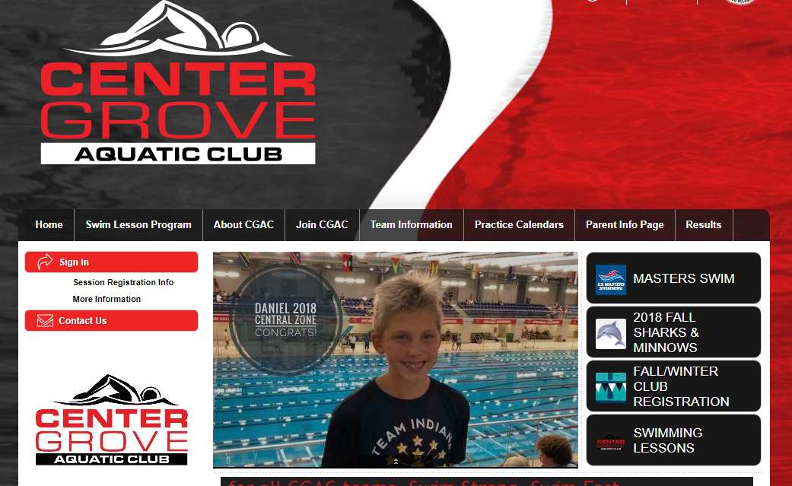
Step 2: If you have never logged in before, you will click on the button that says Fall/winter Club Registration. If you are a returning swimmer, then you already have an account and will sign in. Notice the two arrows on the picture above showing where to click.
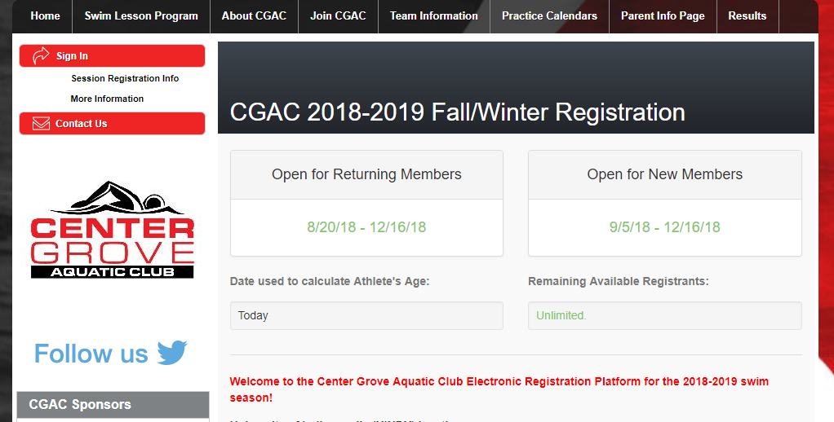

Step 3: After clicking on the registration button, you will be taken to this page as seen in the picture above. There is important information to read through as you scroll down the page. Scroll all the way to the bottom and you will see a green button to start registration. See the picture below.
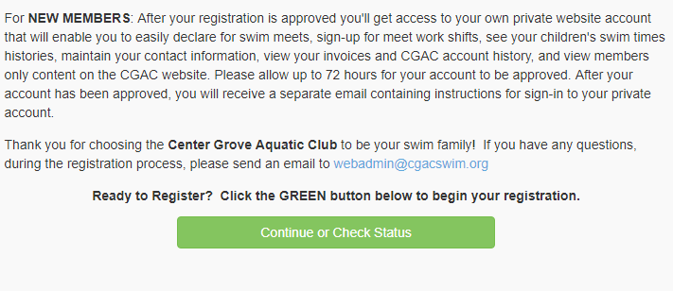
Step 4: After clicking the green button to start registration, you will see the screen below. New swimming parents will create a new account. Returning parents need to use their existing account. If you ever forget your username and/or password, please click on the forgot password option.
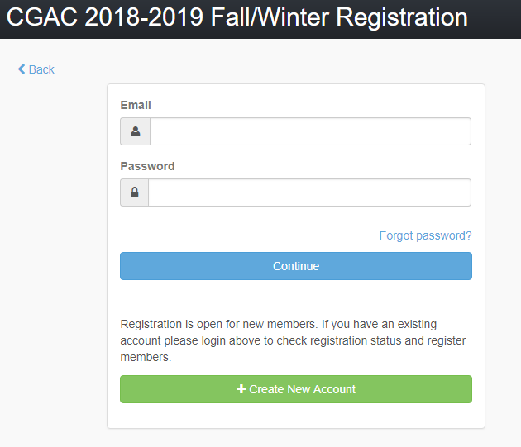
Step 5: If you clicked on the “create new account” button, then you will be prompted to complete all the required fields marked with a red asterisk.
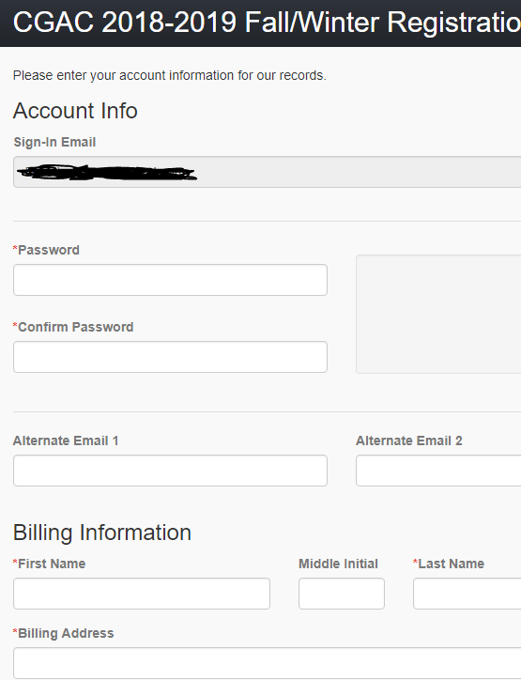
Step 6: After completing the account information part, you will then see a screen that looks like this:
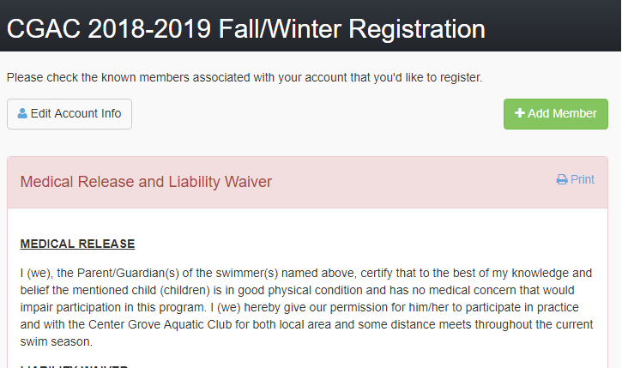
The green button shown by the arrow is where you will add a “member”. A member is your child/swimmer. Parents who have more than one child will add each child as a new member. There are required fields to complete for each member.
Step 7: See the picture below. When adding a new member, the top of the screen will look like this. Complete all required fields.
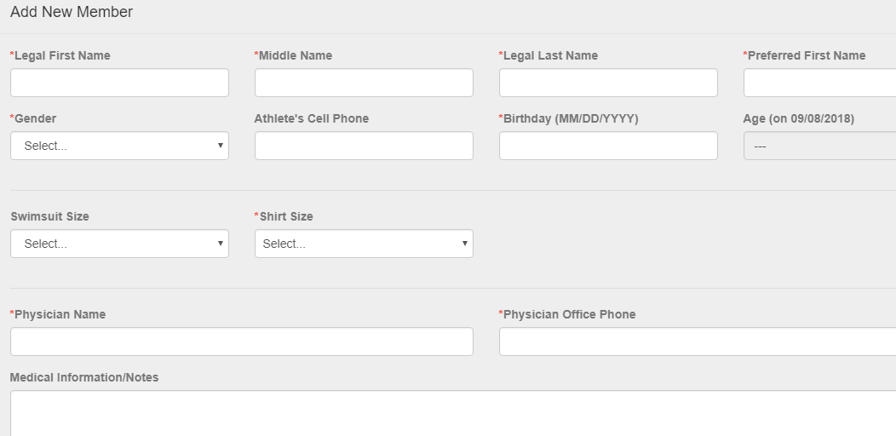
The bottom part of the screen will look like the next picture. It is extremely important that you select the correct location and team for your swimmer. If you are a swimmer at UIndy, then make sure you select the UINDY Pool as your location and select UINDY Team as your group. If you are a Mooresville swimmer, select Mooresville as your location and choose the Mooresville group. All other groups are for the Center Grove Location only. Then you will be prompted to complete all of the USA Swimming registration questions. USA Swimming is the governing body of all swimming programs, and your child will have a unique ID created with USA Swimming.
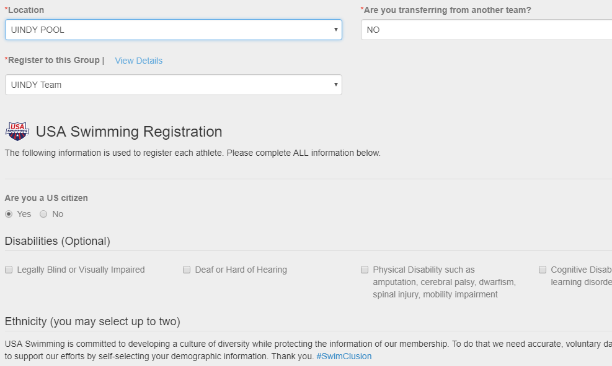

Step 8: After adding a member or members if you have more than one child, then you will see 5 agreements that parents need to read. There is a checkbox for each agreement that you must check. See below for an example:
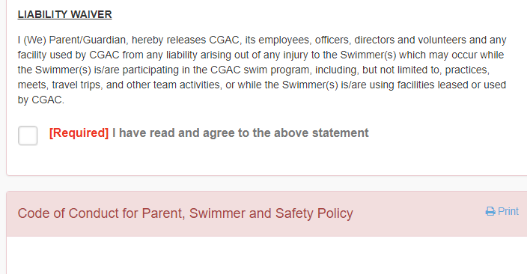

Step 9: After checking all the agreements and clicking the continue button, you will be prompted to enter a credit or debit card information. The system requires you to enter a card number for billing. Checks are not accepted. After entering this information, you will be able to finish up registration. Within the next 72 hours, our registration chair will approve it and then your account will be active.

Registration questions: michele@inswimming.org or webadmin@cgacswim.org

